BODY WATER DISTRIBUTION AND NUTRITION STATUS OF END STAGE RENAL DISEASE PATIENTS UNDERGOING HEMODIALYSIS AT MOI TEACHING AND REFERRAL HOSPITAL (MTRH)

BY

DR. BAJABER ABDALLA ALI
REG.NO. SM/PGM/03/10
DEPARTMENT OF MEDICINE

A thesis submitted to the school of medicine in partial fulfillment for an award of the degree of Master of Medicine in Internal Medicine of Moi University
©2014

DECLARATION

Student Declaration
This thesis is my original work and has not been presented for a degree in any other university. No part of this thesis may be reproduced without prior written permission of the author and or Moi University.
DR. BAJABER ABDALLA ALI ____________________ _________________
Signature Date
Declaration by the supervisors
This thesis has been submitted with our approval as university supervisors.

Dr.M.O.G Owiti __________________ _________________
Senior Lecturer Signature Date

Prof. S.N. Kimaiyo _____________________ ________________
Associate Professor of Medicine Signature Date

DEDICATION

I dedicate this work to all renal patients and physicians handling kidney diseases.

BODY WATER DISTRIBUTION AND NUTRITION STATUS OF END STAGE RENAL DISEASE PATIENTS UNDERGOING HEMODIALYSIS AT MOI TEACHING AND REFERRAL HOSPITAL (MTRH)
ABSTRACT
Background: Fluid balance management among hemodialysis patients is necessary in preventing both under and over hydration. Fluid imbalance has been associated with the development of both cardiovascular complications and Intradialytic morbidity. Currently, dry weight assessment is clinical and has been found to be inaccurate. Recent studies have shown that the use of bioimpedance analysis (BIA) is a more objective way of assessing body water distribution and can accurately determine dry weight and nutritional status. The ability to accurately assess dry weight is necessary in managing fluid balance, reducing cardiovascular complications and improving a patient’s quality of life.
Objective: To determine the body water distribution among patients on hemodialysis at Moi Teaching and Referral Hospital.
Methodology: This was a descriptive cross sectional study conducted at the Moi Teaching and Referral Hospital in Eldoret Kenya, among 51 end-stage renal disease patients on hemodialysis. The inclusion criteria were: adult over the age of 18, who were on regular maintenance hemodialysis for more than 3 months and had achieved their dry weight regarded as adequate according to the patients’ responsible doctor or nurse. The exclusion criteria included patients who had heart failure, those who had neoplastic conditions, those who were on regular steroids, patients with limb amputation and patients with metallic devices, like pacemakers and artificial joints. Following hemodialysis, each patient was weighed using a calibrated weighing scale to assess the clinical dry weight. The height of each patient was taken before conducting BIA procedure using Body Composition machine where reactance and resistance values were obtained. All the results were entered into the Cyprus 2.7, a Body Composition Analysis software, to determine the body composition. Data was analyzed using STATA statistical software version 12 where the descriptive statistics were presented in terms of mean, median and inter-quartile range. The test of difference was determined using one sample t-test.
Results: The 51 participants had a mean age of 47 years; 32 (63%) were males. 28 (55%) were attending 2 dialysis sessions a week while the rest had a single session. The average excess extracellular fluid (ECF) among all the participants was 1.5 litres(std:3.0), p-value <0.005; however, only 35 (69%) had excess ECF after clinical assessment with a mean of 3.0 liters(std:2.03).p-value<0.001. 42(82%) participants were malnourished(Body Mass Index<22kg/m² and phase angle<5). There was no statistically significant differences in Extracellular Fluid, Total Body Water, Body Mass Index, Body Cellular Mass, Free Fat Mass and phase angle between participants who had one dialysis session and those who had two.
Conclusion and Recommendation: The clinical method underestimated the excess ECF and this could predispose dialysis patients to complications associated with fluid imbalance. Most of the patients were also found to be malnourished. This study recommends the incorporation of BIA in the assessment of dry weight and nutritional status among hemodialysis patients in the clinical set-up.

TABLE OF CONTENTS
DECLARATION ii
DEDICATION iii
TABLE OF CONTENTS v
LIST OF TABLES ix
LIST OF FIGURES x
ACKNOWLEDGEMENT xi
LIST OF ABBREVIATION xii
DEFINITION OF TERMS xiii
CHAPTER ONE: 1
INTRODUCTION 1
1.1 BACKGROUND INFORMATION 1
1.2 PROBLEM STATEMENT 6
1.3 RESEARCH QUESTION 6
1.4 JUSTIFICATION 6
1.5 OBJECTIVES 7
1.5.1 Main Objectives 7
1.5.2 Specific Objectives 7
CHAPTER TWO: 8
LITERATURE REVIEW 8
2.1 Body water composition 8
2.2 Nutrition in hemodialysis 14
CHAPTER THREE 19
_{METHODOLOGY} 19
3.1 STUDY DESIGN 19
3.2 STUDY SITE 19
3.3 STUDY POPULATION 19
3.4 ELIGIBILITY CRITERIA 20
3.4.1 Inclusion Criteria 20
3.4.2 Exclusion Criteria 20
3.5 STUDY METHODS 20
3.5.1 Sample Size Determination 21
3.5.2 Sampling Technique 22
3.6 DATA COLLECTION, MANAGEMENT AND ANALYSIS 22
3.6.1 Data Collection Procedure 22
3.6.2 Data Management 23
3.6.3 Data Analysis 23
3.7 Data Validity and Reliability 24
3.8 LIMITATIONS OF THIS STUDY 24
3.9 ETHICAL CONSIDERATIONS 25
CHAPTER FOUR 26
RESULTS AND ANALYSIS 26
4.1 DEMOGRAPHICS 26
4.1.1 Characteristics of excluded participants 26
4.2 BODY WATER DISTRIBUTION OF THE HEMODIALYSIS PATIENTS USING BIA 29
4.2.1 ECF determined using BIA after clinical dry weight assessment 29
4.3 RENAL HEMODIALYSIS SESSIONS 33
4.4 The nutritional status of the patients on hemodialysis by bioelectric impedance analysis (BIA) 35
CHAPTER FIVE 41
DISCUSSION 41
5.1 Demographics characteristics 41
5.2 Body water Distribution in Hemodialysis 41
5.3 Nutritional status of Patients on Hemodialysis 44
CHAPTER SIX 48
CONCLUSION AND RECOMMENDATIONS 48
6.1 CONCLUSION 48
6.2 RECOMMENDATIONS 49
REFERENCES 50
APPENDIX I: BIA Testing Procedure 55
APPENDIX II: Sample Data Collection Form 57
APPENDIX III: Sample of Informed Consent 59
KIAMBATISHO III: MFANO WA RIDHAA 60
APPENDIX IV: ETHICAL APPROVAL 61

LIST OF TABLES
Table 1 Body water compartment 8
Table 2 Distribution of the demographic characteristics (n=51) 28
Table 3: Body Water Distribution (n=51) 29
Table 4: Test for the presence of excess extracellular fluid in the body (n=51) 30
Table 5: Test for the presence of excess extracellular fluid in the body (n=35) 32
Table 6: Test for the amount excess total body water (n=23) 33
Table 7: Nutritional Status of Patients on Hemodialysis 36

LIST OF FIGURES

Figure 1: Reactance and Resistance Curve 16
Figure 2: Gender Distribution 28
Figure 3: Frame size 28
Figure 4: Extracellular fluid levels Graph 30
Figure 5: Extracellular fluid levels chart 31
Figure 6: Distribution of the excess extracellular fluid 32
Figure 7: Average excess extracellular fluid stratified by the number of sessions attended by the participants (n=51) 34
Figure 8: Average excess extracellular fluid stratified by the number of sessions attended . 35
Figure 9: Free Fat Mass 36
Figure 10: Patients with grouped phase angle values 38

ACKNOWLEDGEMENT
I wish to thank my supervisors Dr. M.O.G Owiti and Prof S. Kimaiyo for their continued support, input and guidance in this thesis; the Chairman and the academic staff of the Internal Medicine department of Moi University for their academic guidance through the entire Masters programme and my fellow registrars for their moral support.
I would further wish to thank the renal department staff, the nurses, nutritionists and biostatisticians at the Moi Teaching and Referral Hospital who supported me in this project and all the renal patients who accepted to participate in this study.
Finally, I am grateful to my family and friends for the support they accorded to me in the course of my study.
Thank you all.

LIST OF ABBREVIATION
BIA Bioimpedance Analysis
BMI Body Mass Index
BMR Basal Metabolic Rate
BP Blood Pressure
CK Creatinine Kinetics
CKD Chronic Kidney Diseases
DEXA Dual Energy X-Ray Absorptiometry
ECF Extracellular fluid
ESRD End Stage Renal Disease
FFM Free Fat Mass
HD Hemodialysis
ICF Intracellular Fluid
LBM Lean Body Mass
LVH Left Ventricular Hypertrophy
MTRH Moi Teaching and Referral Hospital
R Resistance
SKF Skin Fold Thickness
TBW Total Body Water
UF Ultrafiltration
USRD US Renal Data System
WT Weight
XC Reactance

DEFINITION OF TERMS
End-stage renal disease – This is when kidneys permanently fail to work
Euvolemia – The presence of adequate amount of blood in the body.
Hemodialysis – The process of filtering wastes, salts and fluid from the blood when the kidneys are no longer healthy enough to do this work adequately. It is the most common way of treating advanced kidney failure.
Hypertension - Blood pressure level above 140/90mmHg
Hypervolemia – Too much volume in the vascular space as shown with the presence excess extra cellular fluid.
Hypovolemia – Low volume in the vascular space as shown by low sum of total body water
Malnutrition - A serious condition that occurs when a person’s body does not get enough nutrients.
Phase Angle - Phase angle is an indicator based on direct measures of reactance and resistance obtained from bioelectrical impedance analysis (BIA) that can be used to assess nutritional status has and prognosis.
Prognosis- Prediction of the probable course and outcome of a disease
Reactance – A body function measured by BIA of how well a cell membrane can hold a charge.
Resistance – The ease or difficulty for electric current to pass from the hand to the foot. Cell membranes are areas in the body with high electrical resistance and resistance; the lesser the fluid the higher the resistance. The body’s free fat mass is directly proportional to resistance.

CHAPTER ONE:

INTRODUCTION

1.1 BACKGROUND INFORMATION
Fluid overload and electrolyte imbalance is a cardinal feature of end stage renal disease (ESRD). Fluid removal to achieve fluid balance is an important component of hemodialysis as both under and over hydration is associated with increased morbidity and mortality. There have been considerable advances in the assessment of dialysis adequacy with solute removal; however, presently there is no standard measure of adequacy for fluid removal. Fluid removal is often achieved by ultrafiltration to obtain a clinically derived value of dry weight. In most centers, dry weight is clinically determined and usually reflects the lowest weight a patient can tolerate without intradialytic symptoms and hypotension in the absence of overt fluid overload. This trial and error method is imprecise and does not account for changes in nutritional status and lean body mass. Consequently, it is difficult to determine whether a patient is over hydrated or under hydrated which could result in cardiovascular complications.
Currently, there is limited information on the effect of ultrafiltration on fluid shifts in the extracellular fluid (ECF) and intracellular fluid (ICF) spaces. Several new methods are now being developed to assess changes in different compartments during hemodialysis. Different techniques have now emerged for measuring volume changes during Hemodialysis (HD). These include:
(a) Single or multifrequency Bioimpedance Spectroscopy (BIS) which allows computation of extracellular fluid, intracellular fluid and total body water.
(b) Continuous hematocrit monitor (Critline) which allows evaluation of blood volume (BV) changes. It is very helpful in preventing hypotension but does not measure water overload accurately as it is affected by autonomic changes.
(c) Ultrasonic measurement of the inferior vena cava diameter (IVCD) to determine the state of hydration. However it is expensive and measure water in intravascular space but does not measure extracellular fluid or intracellular fluid. These methods have previously been used separately however in combination provide more information.
(d) Dual Energy X- ray Absorptiometry (DEXA) can also be used to assess fat mass, free fat mass and bone mineral mass with high precision yet with minimal exposure of radiation. DEXA has the disadvantage of being expensive and does not measure body water distribution.
(e) Biochemical markers of water overload include: atrial natriuretic peptide (ANP) and brain natriuretic peptide (BNP), these are found to be elevated in end stage renal disease (ESRD) patients before hemodialysis and are markedly reduced after hemodialysis. However the levels remain high in altered left atrial and ventricular hemodynamics, such as in heart failure.
(f) Deuterenium double water (D₂O) A radioimmunoassay method which is accurate in assessing the total body water and has been used as a gold standard but is not suitable for the clinical setup.
(g) Computerized Tomography (CT) scan Body water density can be measured by evaluation of attenuation of an electron beam with computed tomography (CT). This technique has been shown to be sufficiently reliable and sensitive to distinguish different types of fluids although it is expensive and requires advanced training and cannot be done at the patient’s bedside.
Bioelectric impedance analysis (BIA) is a simple, reliable, cost effective tool that can be used on the bedside. It is also a better method for assessing the volume status in the dialysis patient in order to minimize common problems related to inaccurate volume determination. It has been compared to the gold standard Deuterenium double water (D₂O) for total body water, DEXA for body cell mass and Sodium Bromide (NaBr) for extracellular fluid and found to have a positive correlation. Although it has not been validated in the African population, it has been researched in Europe, Latin America and Asia.
Principles of BIA
The basic assumption of BIA is that the body is a cylinder where minute electric current of 50 Hz is passed from the hand to the foot. It assesses the body’s composition by impedance which is composed of resistance, reactance and the cell’s phase angle.
The resistance (R) of a homogeneous material of uniform cross-sectional area is proportional to its length (L) and inversely proportional to its cross sectional area (A).

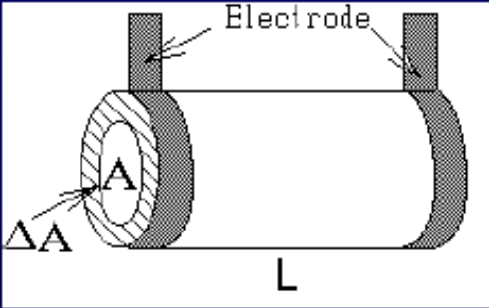
The body offers two types of R to an electrical current: capacitative R (Reactance), and resistive R (simply called Resistance).
Reactance : is a measure of how well cell membranes can hold electric charge while resistance is the ease or difficulty of electric current to move from the hand to the foot.
Impedance: Relation between Reactance and Resistance
Phase Angle (PA): This is a measure of cell integrity. The lower the phase angle, the lower the cell integrity and nutrition status.
One major application of BIA is in the prescription and monitoring of the adequacy of dialysis, for which urea kinetic modeling has become the common standard. BIA is a means to determine extracellular volume (ECV) and intracellular volume (ICV) and has been validated by applying dilution methods as the gold standard. Body composition analysis by BIA have also been compared to magnetic resonance imaging (MRI) and found to be as accurate in measuring different body compartments.
The state of hydration of an organism can be assessed by measuring total body water (TBW) and lean body mass (LBM). Researchers used isotopes and underwater weighing to measure the two parameters, but currently data suggests that Bioimpedance analysis (BIA) can non-invasively measure TBW, intracellular fluid (ICF) and extracellular fluid (ECF). ESRD patients accumulate water in the extracellular space and can be considered to be hypervolemic if there is excess extracellular fluid.
Malnutrition is common in chronic kidney disease (CKD) and is one of the factors increasing morbidity and mortality in the patients. Monitoring body composition is therefore important for prescription of adequate nutrition therapy. Skin fold thickness (SKF) is very useful as it is non invasive and cost effective method of measuring malnutrition,but is not very accurate and has high inter-observer variations. Creatinine (CK) method can also be routinely used to estimate free fat mass. It is based on creatinine excretion and has the advantage of being little influenced by hydration status of the body; however it has the disadvantage of 24 hours urine collection and together with SKF uses predictive equation derived from specific population and may not be applicable to everyone.
The various methods mentioned above have both advantages and disadvantages on features such as cost, ease of use, accuracy and availability; however, BIA is the most reliable and can be easily implemented in resource constrained set-ups such as those in the developing countries like Kenya.
This study therefore seeks to use the BIA method to determine the amount of excess extra-cellular water retained in the body after clinical dry weight assessment and nutritional status of end stage renal disease patients undergoing hemodialysis at Moi Teaching and Referral Hospital (MTRH).

1.2 PROBLEM STATEMENT
Chronic kidney disease is a serious public health problem in Kenya, associated with high morbidity and mortality rates. The management of ESRD patients is by maintenance hemodialysis which is a costly intervention in developing countries.
To assess the efficacy of hemodialysis, clinicians need to determine a patient’s dry weight. Currently, this dry weight is assessed clinically through a process which is prone to inaccuracy and errors. Lack of accurate dry weight assessment methods could lead to fluid overload resulting in hypertension and malnutrition which could lead to poor prognosis. Hence, better and more accurate methods employing innovative techniques could be used to improve the management of hemodialysis patients.

RESEARCH QUESTION
1. What is the body water distribution of end stage renal disease patients undergoing hemodialysis in Moi Teaching and Referral Hospital?
- What is the amount of excess extracellular fluid retained in the body after clinical dry weight assessment?
3. What is the nutritional status of end stage renal disease patients undergoing hemodialysis?

1.4 JUSTIFICATION
As clinical assessment is not the best way to assess dry weight because of several confounders, it is important to use other methods to assess required dry weight. Dialysis patients require tight volume control to avoid cardiovascular complications. Good nutrition status is important in hemodialysis patients and so there is need to get reliable nutritional measures and information to help assess nutrition status.

1.5 OBJECTIVES

1.5.1 Main Objectives
To determine the body water distribution among end-stage renal disease patients on hemodialysis at Moi Teaching and Referral Hospital.

1.5.2 Specific Objectives
- To use the bio-impedance analysis (BIA) method to determine excess extra-cellular fluid retained in the body after clinical dry weight assessment among end stage renal disease patients undergoing hemodialysis.
- To determine the nutritional status of patients on hemodialysis by bio-impedance analysis (BIA).

CHAPTER TWO:

LITERATURE REVIEW

Body water composition
The healthy human body at steady state is composed of several water and solid compartments as shown in table 1[1], which are maintained within tight boundaries.
Table 1 Body water compartment

Compartments | Percentage (%) of Total Body Water | Percentage of Total Body Weight
 |  | Normal Adult Man | Normal Adult Woman
Intracellular fluid | 55 | 33 | 27.5
Extracellular fluid | 45 | 27 | 22.5
Interstitial fluid | 20- | 12 | 10
Plasma | 7.5 | 4.5 | 3.75
Bone | 7.5 | 4.5 | 3.75
Connective tissue | 7.5 | 4.5 | 3.75
Transcellular | 2.5 | 1.5 | 1.25
Total body water | 100 | 60 | 50

An accurate assessment of a patient’s fluid volume status requires knowledge of three factors:
- The capacity of body compartments such as ECF, ICF and TBW
- The amount of fluid in each compartment
- Solute content which affects fluid shifts between compartments.
End-stage renal disease (ESRD) is a common clinical condition world over.[2] The Kenyan ESRD population is often associated with hypertension and there is need for adequate control to determine the outcome. Currently, the dry weight is assessed based on clinical examination, weight and blood pressure measurements which are largely dependent on the experience of the hemodialysis staff. There have been major developments in the hemodialysis techniques; however, technicians still have problems in maintaining the stability of hemodynamics during hemodialysis. These problems may lead to patients suffering from adverse effects of both hypervolemia (pulmonary edema and ventricular hypertrophy) and hypovolemia. [3, 4]
There are several complications resulting from over hydration and under hydration during hemodialysis practice in the attempt to achieve true dry weight; and these may leave the patient either hypertensive or hypotensive respectively. In the course of clinical probing for dry weight, hypotension may frequently occur resulting in uncomfortable events such as muscle cramps, dizziness and fatigue.[5]
Overestimation of dry weight results in excessive fluid accumulation which may lead to cardiovascular complications such as hypertension and left ventricular hypertrophy (LVH) in chronic kidney disease patients.
Maintaining the fluid status of hemodialysis patients within acceptable limits remains a challenge. This is because dialysis patients are usually oliguric or anuric and their tendency to accumulate fluid must be managed through limiting salt and fluid intake and by ultrafiltration during dialysis sessions. Achieving a balance between avoiding hypovolemia during dialysis and developing fluid overload between dialysis sessions is complicated by patient adherence and limitations on the length of dialysis sessions.[6, 7] Reports suggest that fluid overload is relatively common in dialysis patients and may result in cardiovascular complications such as hypertension, arterial stiffness and left ventricular hypertrophy.
Unfortunately, there is no easily applicable method to determine extra cellular volume and consequently estimate dry weight (DW). Thus DW has to be clinically defined by several indirect methods.[8]
Excess volume is thought to be important in the pathogenesis of hypertension among hemodialysis patients. The reduction of dry weight is a simple, efficacious, and well-tolerated maneuver to improve blood pressure (BP) control in hypertensive hemodialysis patients. Long-term control of BP will depend on continued assessment and maintenance of dry weight. [9] This indicates that the current clinical techniques available to help the clinician attempt to achieve euvolemia are insufficient and additional tools, such as the Body Composition Machine using BIA technique, can be useful in the diagnosis of over hydration as a practical and innovative method.
Most studies indicate that at least 80% of all hypertension in patients undergoing hemodialysis is due to chronic hypervolemia. [10, 11] In a study conducted by Charra and his colleagues among patients treated with long slow hemodialysis; less than 2% remained hypertensive off hypertensive agents. [12, 13] Fish-bane et al used plasma atrial natriunetic peptide (ANP) - a marker of intravascular hypervolemia and showed that dialysis patients were actually fluid overloaded at the end of dialysis. Lins et al on the other hand found that post dialytic blood pressure correlated with total body water as measured by Bioimpedance spectroscopy.[14] It is thus evident that chronic volume overload is the major cause of hypertension in ESRD and dialysis population. This indicate that better methods which are in practice can be used to determine dry weight and can help in managing fluid overload in patients on hemodialysis.
According to the United States Renal Data (USRDS), the complications associated with hypertension resulting in increased mortality in hemodialysis patients include: cardiovascular disease and stroke which have been linked to markers of fluid overload comprising left ventricular hypertrophy (LVH) and Left ventricular dysfunction.[15]
Charra et al in their study conducted among younger dialysis patients showed that with a good dry weight, patients on hemodialysis had 75% 10 year survival rate. This shows that the control of blood pressure (BP) remains the most compelling evidence for beneficial effects of dry weight. It is thus evident that dry weight is the major component of hypertension (a major predictor of death in dialysis patients), and this should lead to a greater focus on dry weight to reduce the associated complications.[13] In another study by Agarwal et al,he demonstrated removing a liter of fluid by hemodialysis reduces blood pressure by 6mm Hg.[16]
Hypervolemia is also an important and modifiable cause of hypertension, and this improves with probing dry weight. Echocardiography parameters of inferior vena cava and left atrial diameters reflect excess volume, and these can be used in probing dry weight. However, they are poor determinants of interdialytic blood pressure and do not measure extravascular volume.[9] Furthermore, they are costly and time consuming.
Risk factors for development of Left ventricular hypertrophy (LVH) include: increased age, diabetes mellitus, anemia and hyperparathyroidism. There is now consistent evidence that left ventricular hypertrophy (LVH) has an important prognostic value in patients with end-stage renal disease (ESRD). LVH in ESRD is a disorder of multi-factorial origin and hypertension, anemia, hyperparathyroidism has been implicated in this alteration.[17] Studies have also shown a little increase in fluid overload results in cardiac strain, and accumulation of excess fluid more than 2.5 litres results in cardiovascular complications such as LVH and left ventricular dysfunction.[18]
These disorders are present at initiation of dialysis. However, regressions of left ventricular dilation and LVH have been shown in studies in normal population[19], and in a study on hypertensive ESRD patients on continuous ambulatory peritoneal dialysis.[20] It is therefore possible that aggressive control of volume overload may lead to regression of left ventricular abnormalities. Other studies have shown that a strict volume control strategy decreases blood pressure (BP) without drugs and causes regression of LVH and prolongs survival. According to USRDS, about half the deaths in dialysis patients are attributed to cardiovascular diseases. As fluid overload is a contributing factor, it suggests that volume control is neglected in most hemodialysis centers, despite the fact the treating physicians may consider that Dry Weight (DW) of their patients has been reached.
Another complication that arises from poor dry weight assessment is intradialytic hypotension. Hypotension associated with hemodialysis is estimated to occur in 20% of hemodialysis (HD) sessions[5] and this can lead to serious vascular complications such as cerebral infarction and cardiac and mesenteric ischemia [21, 22]. It may also contribute to chronic over hydration due to an inability to reach dry weight and may lead to under-dialysis as physician take precautions to prevent hypotension[5, 21, 23]. Prevention of dialysis hypotension, therefore, is an important challenge to the dialysis staff.
Dry Weight
The concept of dry weight in dialysis patient is defined as the patient having no excess fluid volume at post dialysis weight with no intradialytic symptoms of hypotension. However, body weight consists of different components, such as fat and muscle with variability of fluid content so that if body composition changes, the body hydration does not proportionally follow this change. The main question in the determination of dry weight is how to quantitate the degree of fluid overload?
Methodologies of measuring fluid overload include inferior venacava diameter (IVCD), Biochemical markers like Peptides such as ANP and BNP; Bioimpedance analysis (BIA) and relative blood volume measurement (RBV) and chest x-ray. BIA phase angle bioimpedance at 50 kHz technique also provides multi information about state of hydration and nutrition. Measurements, such as biochemical or IVCD methods, cannot indicate the hydration of extravascular space directly; therefore they are not reliable in detecting degree of fluid overload. Relative blood volume measurement (RBV) displays change in plasma volume but it cannot provide direct information about fluid overload in the interstitial compartment. Bioelectric impedance analysis (BIA) represents a different approach to the assessment of water status and this analytic technique mainly uses electrical properties of biological cells and waters.[24] BIA is a simple method in which low amplitude alternating electrical current is applied to analyze the body composition indirectly.[25] Many studies tried to use new technology to achieve more reliable results that are not operator dependent. Hence, different novel methods such as bioelectrical impedance analysis (BIA) were developed.[26]

2.2 Nutrition in hemodialysis
The prevalence of Protein energy malnutrition is 23% to 76% among persons on maintenance dialysis as shown by some studies. The wide variation in malnutrition prevalence in patients on HD may be attributed to the different assessment methods, and to the multiple factors contributing to its development. [27]
Nutritional status strongly relates to morbidity and mortality in dialysis patients.[28] Patients with fluid overload may have poor nutritional status yet look normal or overweight. BIA based measurements of muscle mass, subcutaneous total adipose tissues, have been validated by magnetic resonance imaging (MRI) and can now be done on a routine basis. BIA estimates of body cell mass and TBW have also been highly correlated with DEXA and Deuteroneum oxide(D₂O) respectively.[29]
The physiopathology of protein-energy malnutrition in patients with renal disease is complex and involves a great number of factors that contribute to anorexia and catabolism. It may be secondary to deficient nutritional ingestion, severe dietary restrictions, hormonal and gastrointestinal disorders and metabolic acidosis.[30, 31]
Body weight, dietary assessment, and anthropometry are crude methods of nutritional assessment and are relatively ineffective at identifying malnutrition in population, especially early in its course. This is because of limited test discrimination and the lack of reliable standards of comparison.
Serum albumin, pre-albumin, creatinine, transferrin and cholesterol are useful biochemical markers of nutrition in identifying high-risk groups but are time consuming and in our set up may be expensive and also can be confounded by concomitant liver disease, iron-deficiency anemia, and chronic inflammation.[31]
There are other sophisticated methods of body composition analysis and this include neutron activation analysis or total body potassium that can be used to quantify body cell mass (BCM) and other body compartments [32] but are costly and not widely available. A convenient method that could assist in the diagnosis of malnutrition in the chronic dialysis unit setting early in its course would be desirable, so that various resources such as dietary counseling, social supports, and enteral or parenteral nutrition therapies could be aimed at high-risk patients before malnutrition-related complications develop.
Phase Angle
Phase angle is a measure of cell integrity needed in the assessment of malnutrition and mortality risk. Low phase angle below four indicates malnutrition and cellular damage while a high phase angle of between 6-9 indicates good nutrition state and intact cell membrane.
Phase angle is an indicator based on direct measures of reactance and resistance obtained from bioimpedance analysis (BIA) and has an important prognostic role. Reactance is a body function measured by BIA of how well a cell membrane can hold a charge while Resistance is how easy or difficult it is for the electric current to get from the hand to the foot. Lower resistance to the current occurs when there is a greater amount of fluids in the body. The lesser the fluid, the harder it is for the current to travel (higher resistance). (Figure 1)

Figure 1: Reactance and Resistance Curve
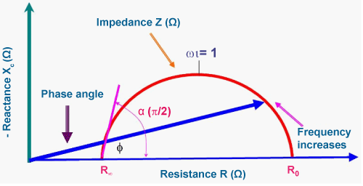
Higher phase angles appear to be consistent with large quantities of intact cell membranes and body cell mass (BCM). Phase angle has been found to be a marker of nutritional status and a prognostic marker in several conditions, such as HIV infection, liver cirrhosis, hemodialysis, chronic obstructive pulmonary disease and cancer.
Dumler et al, in the journal of physics evaluated the significance of a low phase angle value on nutritional status and mortality in 285 chronic dialysis patients during a longitudinal prospective observational study. He found that patients in the lower phase angle quartile had decreased body weight, body mass index, fat free mass, body cell mass, and lower serum albumin concentrations than those in the higher quartile (P<001). He also found significantly low mortality rates (P=0.05) among the highest quartile patients.[33] Maggiore et al. studied 131 hemodialysis patients with phase angle in the lowest quartile (men less than 4.51, women less than 4.21) had a signiﬁcantly lower 2-year survival (51.3% versus 91.3%).[34]
BIA has proven to be a useful tool in assessment of dry weight and nutrition, and can also be used for assessing risk of mortality in hemodialysis patients. It has shown excellent correlation to the ultrafiltrate removed and change in weight. Kouw et al [35] validated BIA by comparing ECF and ICF in 29 hemodialysis and 31 control subjects. Hemodialysis patients had markedly expanded ECF compartment pre-dialysis, which were reduced to control values after dialysis.
Chertow et al compared total body water and BCM obtained by use of BIA with the methods of deuterium oxide (D₂O) and sodium bromide dilution and dual-energy X-ray Absorptiometry (DEXA).[36] He further standardized the BIA parameters (resistance, reactance, phase angle) for hemodialysis. In another assessment, Chertow et al. reported an increase in the relative risk of death for patients with a phase angle lower than 4 degrees.[37]
The main limitation of this method is the alteration in the hydration status, because if the patient is hyper-hydrated, lean mass will be overestimated, however other BIA-derived measures of malnutrition such as reactance and phase angle, can be less affected by alterations in blood volume.[33] BIA would be an ideal tool for dry weight and nutritional assessment because it can be done with ease at the bedside, its cost effective, non invasive, reproducible and requires minimal training. It also evaluates fluid and nutritional status at the same sitting.

CHAPTER THREE

METHODOLOGY

3.1 STUDY DESIGN
This was a descriptive cross-sectional study involving the use of quantitative methods. Data was collected at a particular point in time after patients have been dialysed using both Clinical assessment and bioimpedance analysis methods carried out separately by both the nurses and the clinical investigator.

3.2 STUDY SITE
The study was conducted at the renal unit of Moi Teaching and Referral hospital (MTRH). MTRH is the second largest public referral hospital in Kenya and has several departments including renal unit. Renal unit serves patients with various kidney ailments and is housed under department of Medicine.

3.3 STUDY POPULATION
The study population was made up of all ESRD patients who were undergoing maintenance hemodialysis at Moi Teaching and Referral Hospital. There were 70 hemodialysis patients that were recorded at renal unit in 2012 at the time of the study.

3.4 ELIGIBILITY CRITERIA

3.4.1 Inclusion Criteria
- Patients on hemodialysis for the last 3months.
- Age above 18years
- Dry weight regarded as adequate according to the patients responsible doctor or nurse. (In our centre the doctors and nurses do the ward round together and the doctor inform the nurses which patient is not at dry weight).

3.4.2 Exclusion Criteria
- Patients with bilateral amputation
- Patients on steroids or cytotoxics, according to history and medical records.
- Patients with heart failure confirmed from medical records.
- Patients with metallic devices, like pacemaker .prosthetic valves, coils or artificial joints

3.5 STUDY METHODS
Recruitment was carried out among all patients aged above 18 years, undergoing dialysis and accepted to participate in the research. Out of the 70 patients, 12 did not meet the inclusion criteria, while 7 did not consent. Most ESRD patients undergo dialysis two times a week. There were approximately 8 patients on dialysis in the morning between 7.00a.m to 11.00.am while 6 patients on dialysis from 2p.m to 6p.m. Each dialysis session took about 4 hours, after which, the nurses weighed the patients to confirm the dry weight. The investigator proceeded on with measuring the patient’s height then conducted a bioimpedance analysis (BIA) using Body Composition Machine. The BIA testing procedure is shown in Appendix I.

3.5.1 Sample Size Determination
In order to achieve a 95% confidence, with a probability of 80%, that the clinical dry weight of hemodialysis patients recorded by nurses is 0.5 kilograms (litres) higher than the clinical dry weight recorded by the bioelectric impedance (BIA) machine; a sample size was determined using the following Hulley S formula. [38]
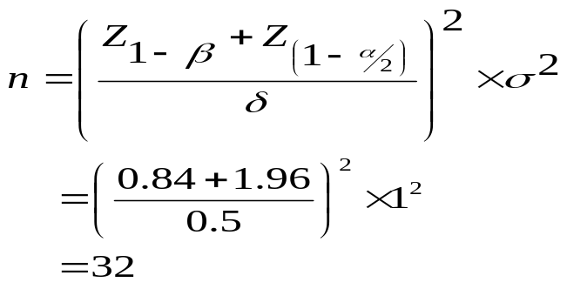
Where is the difference between subjects standard deviation assumed to be 1, and is the effect size which is 0.5 litres (kg) in this case. This target was chosen for representing the median timed average fluid overload (TAFO) of >17,000 patients from Fresenius Nephrocare centers in 18 different countries.[39] This sample size is sufficient to answer the hypothesis that the clinical dry weight recorded by nurses is higher than that recorded by the bioelectric impedance machine.
Each patient was weighed by the nurses and then subjected to bioelectric impedance machine. Thus one sample of size 32 is required.
Given that the procedure is not invasive, a higher sample is acceptable since such a sample size will be sufficient to test a hypothesis when the amount of excess water is less than 0.5 kilograms. Additionally, a larger sample size would enhance the level of precision, hence 51 was obtained. This is close to Claudio Maria’s study which used a sample size of 58 participants.[38]

3.5.2 Sampling Technique
The sampling procedure was consecutive sampling technique to select the study participants until the target sample size was achieved. Repeat hemodialysis patients were not sampled during their subsequent visits. This was carried out for a period of three months between January to March, 2012.

3.6 DATA COLLECTION, MANAGEMENT AND ANALYSIS

3.6.1 Data Collection Procedure
All the 51 participants were interviewed and their demographic information were recorded on arrival. Their participants’ weight and height were then taken from the participants standing in an upright position using a calibrated weighing scale and ruler after hemodialysis; and the results obtained were recorded. The BIA values for reactance and resistance were taken using bioimpedance analysis machine and the results entered into the RJL Software (Cyprus TM) to determine the body composition. The dry weight difference and nutritional status measurements were then obtained from this information. All these information was recorded in the data collection form, which is shown in Appendix III and the results as from RJL software as shown in Appendix II.

3.6.2 Data Management
The clinical assessment and BIA data collected were entered into a Microsoft Access 2007 database. The hard copy data collection forms were then stored in locked cabinets to ensure participants’ privacy and confidentiality. The database was then exported to STATA version 12 statistical software for statistical analysis.

3.6.3 Data Analysis
Data analysis was done using STATA version 12 Special Edition (STATA/SE) to assess the difference between clinical assessment and BIA dry weight assessment methods. Categorical variables were summarized as frequencies and corresponding percentages. Continuous variables that were normally distributed were summarized as mean and standard deviation (SD) while the continuous variable that had skewed distribution were summarized as median and inter quartile range (IQR). The test for normality was performed using Shapiro-Wilk and Shapiro-Francia normality test. The bioelectric impedance machine outputs the limits of its output for every patient. Therefore it was established that a patient having a BMI reading that was below the acceptable limits using the corresponding limits output by the bioelectric impedance machine. This was also true for other variables such as extracellular fluid and the free fat mass. There were other parameters (such as Phase angle, Intra Cellular Water and Fat Mass) that were also output alongside their acceptable limits. The nutritional status was analyzed from the BIA readings; and a patient was also said to be malnourished if s/he had a phase angle less than 5, and BMI less than 22 Kg/m². The lean body mass was computed as the difference between the free fat mass and the total body water. The difference in dry weight between the patients was determined by measuring the extracellular fluid. The excess extracellular fluid was computed as the difference between the upper limit of the extracellular fluid and the actual extracellular fluid, (the actual readings of the extracellular fluid minus the upper limit among those who had excess water). The test of hypothesis for excess extracellular fluid was conducted using a one sided t-test. The average and the corresponding 95% confidence limits (95% CL) of the excess extracellular fluid were reported.

Data Validity and Reliability
The investigator and study staff were trained by registered nutritionists on how to use the BIA machine to assess the dry weight.
The BIA machine values for reactance and resistance were always maintained at zero (neutral) before conducting the procedure on each participant.

3.8 LIMITATIONS OF THIS STUDY
- There are no BIA prediction equations for the African population. The existing BIA prediction equations for dry weight are for the western population hence difficult to get the right estimation.
- Some patients fed during dialysis and this could have increased the weight of study participants, hence interfering with the data collected.
- Urea reduction ratio ,a measure of dialysis adequacy was not performed due to high cost associated.

3.9 ETHICAL CONSIDERATIONS
- The proposal was approved by Institutional Research Ethics regulatory body (IREC) of Moi University before the study was conducted.
- Permission to carry out the study at MTRH was sought from the hospital management before the study commenced
- Informed consent was obtained from all participants before being enrolled into the study. Sample shown in Appendix III.
- Participants’ details were kept strictly confidential.
- The procedure is non invasive, the electrical current used is very small and has minimal side effects.

CHAPTER FOUR

RESULTS AND ANALYSIS

4.1 DEMOGRAPHICS
There were a total of 51 patients in the study. Of these 32(63%) were male while 19 (37%) were female (Figure 2). A total of 46(90%) out of 51 had medium frame size (Figure 3). Only 1(2%) and 4(8%) had small and large frame sizes respectively (figure 3). There were 28 (55%) patients undergoing hemodialysis twice a week while 23 (45%) had a single session of hemodialysis a week.
The mean age, height, and weight of all the 51 patients were 47(std: 15.5) years, 1.7(std: 0.08) meters, and 62.1(std: 11.1) kilograms, respectively (Table 2). The median BMI was 21(IQR: 18.8-23.1) kilograms per square meter. The average target weight of the patients was 65.4(std: 10.7) kilograms. This is the weight that the patients ought to be weighing when the parameters such as height and weight were input into the bioelectric machine.

Characteristics of excluded participants
Eight (8) of the participants had not achieved the desired dry weight; four (4) had ascites (fluid in the third space) while seven declined to participate in the study by not consenting though they had achieved the desired dry weight.

Figure 2: Gender Distribution
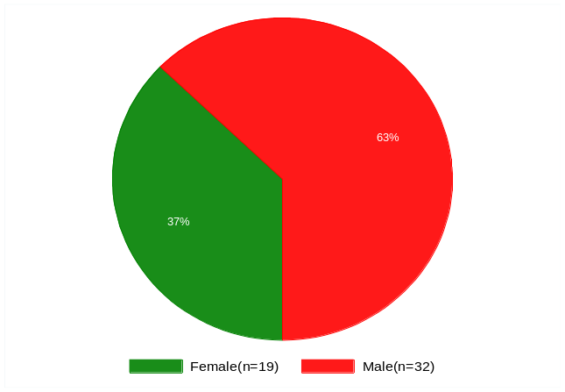
Figure 3: Frame size

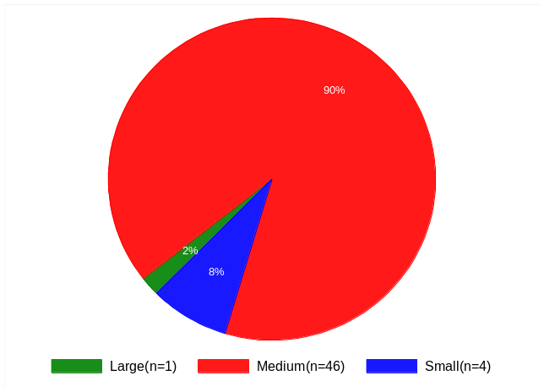
Table 2 Distribution of the demographic characteristics (n=51)
Variable | Mean(std) or Median(IQr)
Age (Years) | 47(15.5)
Height (Meters) | 1.7(0.08)
Weight (Kilograms) | 62.1(11.1)

4.2 BODY WATER DISTRIBUTION OF THE HEMODIALYSIS PATIENTS USING BIA
The body water distribution can be explained by Intracellular fluid (ICF), Extracellular fluid (ECF) and Total Body water (TBW). The mean TBW, ECF and the excess ECF were 36.9(std: 7.0) liters, 16.8(std: 3.6) liters, and 1.5(std: 3.0) liters respectively; while the median ICF of all the patients was 20.4 (IQR: 16.0-23.0) liters as shown in table 3.
Table 3: Body Water Distribution (n=51)
Variable | Mean(std) or Median(IQR)
Total body water (TBW) (liters) | 36.9(7.0)
Extracellular fluid (ECF) (liters) | 16.8(3.6)
Excess Extracellular fluid (liters) | 1.5(3.0)
Intracellular fluid (ICF) (liters) | 20.4(16.0-23.0)

4.2.1 ECF determined using BIA after clinical dry weight assessment
A total of 50(98%) patients had the extracellular fluid within or above the normal range as determined by BIA. This study was meant to establish whether the clinical method for assessing dry weight overestimates the dry weight. A quantity of 0.5 liters of the extracellular fluid was considered excess. Therefore, this study delved to find out whether the retained excess extracellular fluid was equal or less than 0.5. The average excess fluid among the 51 patients was 1.5(std: 3.0) liters. The test for normality was conducted and found that this variable follows the normal distribution without any outliers (Figure 4).

Figure 4: Extracellular fluid levels Graph
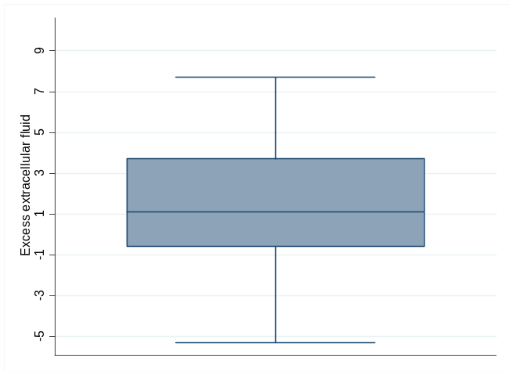
Based on the above evidence we conducted a one-sided t-test to establish if the average excess extracellular fluid is greater than 0.5 liters as shown in Table 4.
Table 4: Test for the presence of excess extracellular fluid in the body (n=51)
Variable | Sample size | Mean(std) | Standard error | P-value | 95% Confidence limits
 |  |  |  |  | Lower Limit | Upper Limit
Excess extracellular fluid | 51 | 1.5(3.0) | 0.41 | 0.005 | 0.6 | 2.3
t-statistic = 2.7, degrees of freedom=50, p-value=0.009
The average excess extracellular fluid was 1.5 (std: 3.0) liters with 95% confidence limits of (0.6-2.3) liters around the mean is significantly higher than 0.5liters, p-value=0.005.

Figure 5: Extracellular fluid levels chart
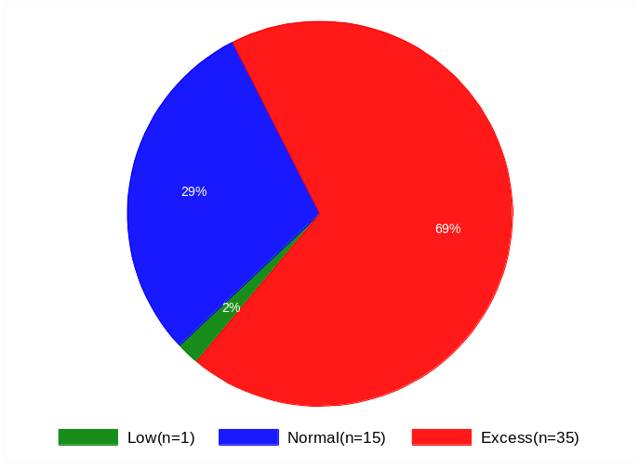
A total of 35(69%) patients had the extracellular fluid above the normal range as shown in figure 6 above. The average excess fluid among the 35 patients was 3.03(std: 2.03) liters with the corresponding 95% confidence limits of 2.33-3.72. 15 (29%) had ECF levels within their normal ranges; however, 1 (2%) patient had ECF level below the normal range(Figure 5).. The Shapiro-Wilk test for normality was conducted and it found that this variable follows the normal distribution (p-value=0.068) without any outliers.

Figure 6: Distribution of the excess extracellular fluid
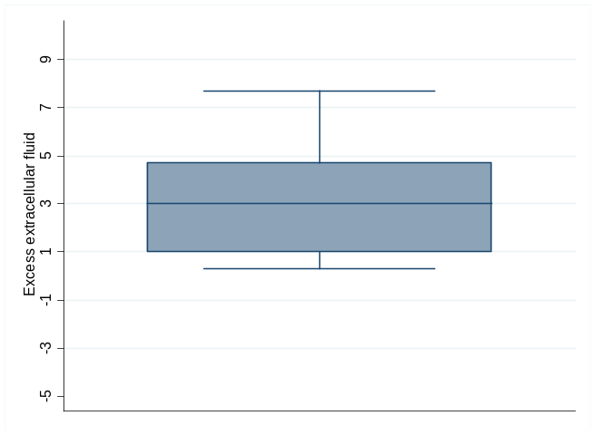
Figure 6 shows that the 35 patients with excess ECF had a similar mean (3.03 liters) and median (3.0 liters) of excess extra cellular fluid and this shows that there were no indications of outlying values.
Based on the above evidence, a one-sided t-test was conducted to establish if the average excess extracellular fluid is greater than 0.5 liters (Table 5).
Table 5: Test for the presence of excess extracellular fluid in the body (n=35)

Variable | Sample size | Mean(std) | Standard error | P-value | 95% Confidence limits
 |  |  |  |  | Lower Limit | Upper Limit
Excess extracellular fluid | 35 | 3.03(2.03) | 0.34 | 0.001 | 2.33 | 3.72
t-statistic = 7.35, degrees of freedom=34, p-value=0.000
This test showed that average excess extracellular fluid of 3.03(std: 2.03) liters with 95% confidence limits of (2.33-3.72) liters around the mean is significantly higher than 0.5 liters, p-value=0.001. This confirms that the clinical method underestimates the amount of excess extracellular fluid in the body.
Similarly a test for the amount of the excess total body water among the patients (Table 6) and there were 23(45%) patients with excess total body water.
Table 6: Test for the amount excess total body water (n=23)
Variable | Sample size | Mean | Standard error | P-value | 95% Confidence limits
 |  |  |  |  | Lower Limit | Upper Limit
Excess TBW | 23 | 3.24(2.81) | 0.59 | 0.0001 | 2.03 | 4.46
t-statistic = 4.68, degrees of freedom=22, p-value=0.0001
The results show that the average excess total body water is 3.24(std: 2.81) with 95% CL of 2.03-4.46. This average is significantly higher than 0.5 liters of total body water (p-value=0.0001).

4.3 RENAL HEMODIALYSIS SESSIONS
There were 28(55%) participants who were dialyzed twice a week while the rest (45%) had dialysis once a week. The average excess extracellular fluid detected by BIA among those who had two hemodialysis sessions was 1.63(95% CL: 0.33, 2.94) while the average excess extracellular fluid among those who had hemodialysis once a week was 1.28(95% CL: 0.22, 2.34) as shown in Figure 7. The two sample t-test for equality in the two averages revealed that the two groups of patients had equivalent average amount of excess extracellular fluid (P=0.676).
Figure 7: Average excess extracellular fluid stratified by the number of sessions attended by the participants (n=51)
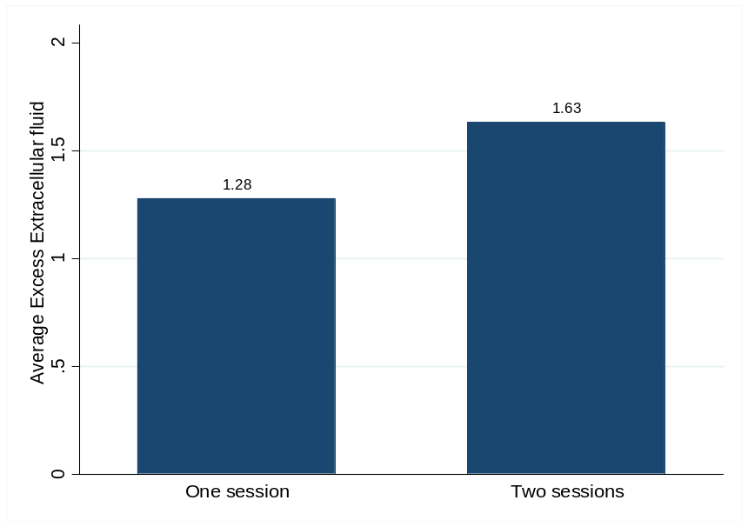
Among the 35 participants who had extracellular fluid that was above the upper limit of their acceptable range; 20(57%) of them had two dialysis sessions per week. The average excess extracellular fluid for these participants was 3.28(95% CL: 2.23, 4.32) while the average excess extracellular fluid in those who had one dialysis session per week was 2.69(95% CL: 1.73, 3.66) as shown in figure 8. The two sample t-test for equality of these two averages revealed that the two groups had equal average excess extracellular fluid (P=0.411).
The variable capturing excess extracellular fluid was tested for normality using the Shapiro Wilks test and it was confirmed that the variable followed a Gaussian distribution. This means that the parametric t-test for hypothesis was the appropriate test.

Figure 8: Average excess extracellular fluid stratified by the number of sessions attended .
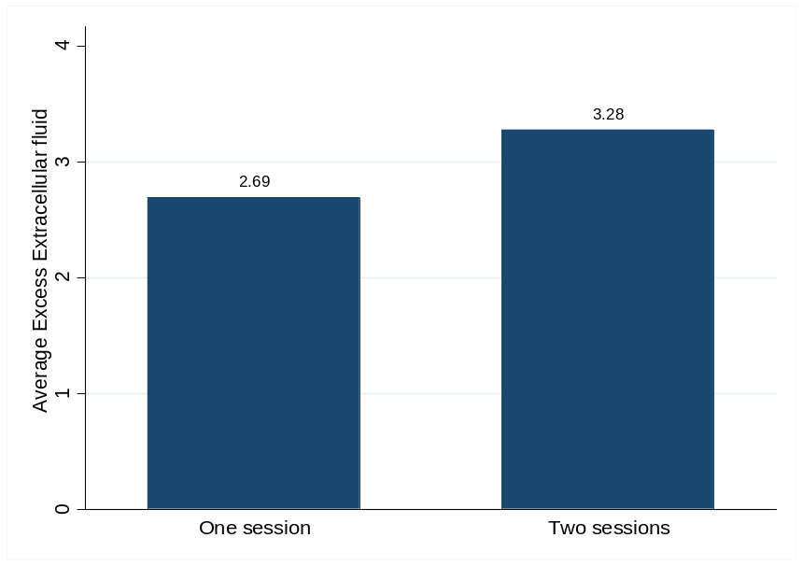

4.4 The nutritional status of the patients on hemodialysis by bioelectric impedance analysis (BIA)
The nutritional status could be explained by Body Cellular Mass (BCM), phase angle, Fat Mass (FM), free fat mass (FFM) and lean body mass (LBM). The median BCM, Fat Mass were 22.3 (17.6-25.2) and 8.6 (5.4-12.1) respectively. The mean Phase Angle, FFM and LBM were 4.9 (1.5), 51.1 (9.9) and 14.3 (3.3) respectively as shown in table 7.
Table 7: Nutritional Status of Patients on Hemodialysis
Variable | Mean(std) or Median(IQR)
BCM | 22.3(17.6-25.2)
Phase Angle | 4.9(1.5)
Fat mass (kilograms) | 8.6(5.4-12.1)
Free fat mass (kilograms) | 51.1(9.9)

There were a total of 32(63%) patients who had BMI below the lower limit of the acceptable range of BMI. The remaining had their BMI within the acceptable limits. Similarly, there was a total of 24(47%) patients who had their free fat mass below the lower range of the acceptable limits of free fat mass (Figure 9). Twenty one patients, representing 41%, had BCM below the lower range of the acceptable limits while 8(16%) had BCM above the upper limit of the acceptable range. There were a total of 32(63%) patients who had BMI less than 22 Kg/m² and a total of 30(59%) patients who had their phase angles below 5.
Figure 9: Free Fat Mass
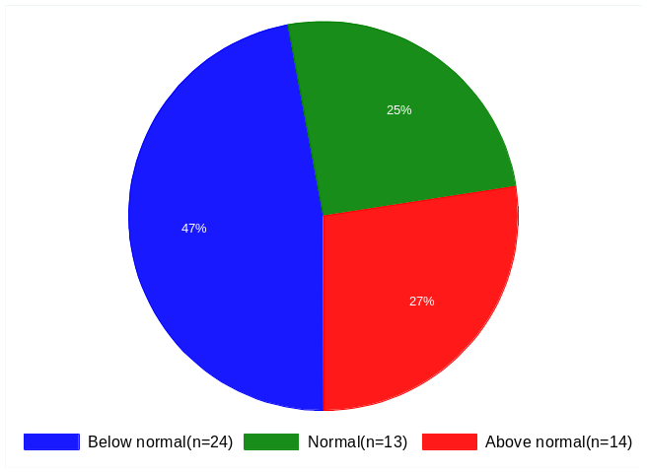
There were a total of 46(90%) patients who had their phase angle (PA) below the lower range of the acceptable limits, an indication of poor health status. Only two patients had the phase angle above the upper limit of the acceptable range. The rest were normal.
The phase angle values output by the bioelectric machine were grouped as above average (AA), average (A), below average (BA), significant below average (SBA), extremely below average (EBA) for each patient. There were 4(8%) patients with average phase angle values, 6(11%) with phase angle values below average, 10(20%) patients with significantly below average phase angle and 30(59%) with extremely below average values. However, only 1 (2%) patient had a phase angle above average. (Figure 10).
Figure 10: Patients with grouped phase angle values

Table 8: Association between the patient demographic, clinical characteristics and the body composition and the number of dialysis sessions per week
 |  |  | Dialysis sessions per week
Variable | Sample | Levels | One | Two | Overall | P-value
Gender | 51 | Female | 6(26%) | 13(46%) | 19(37%)
 |  | Male | 17(74%) | 15(54%) | 32(63%) | 0.135
Frame size | 51 | Large | 1(4%) | 0 | 1(2%)
 |  | medium | 20(87%) | 26(93%) | 46(90%) | 0.788^{f}
 |  | Small | 2(9%) | 2(7%) | 4(9%)
ECW | 51 | Below Normal | 0 | 1(4%) | 1(2%)
 |  | Normal | 8(35%) | 7(25%) | 15(29%) | 0.752^{f}
 |  | Above Normal | 15(65%) | 20(71%) | 35(69%)
ICW | 51 | Below Normal | 11(48%) | 10(36%) | 21(41%)
 |  | Normal | 8(35%) | 13(46%) | 21(41%) | 0.759^{f}
 |  | Above Normal | 4(17%) | 5(18%) | 9(18%)
TBW | 51 | Below Normal | 4(17%) | 5(18%) | 9(18%)
 |  | Normal | 10(43%) | 9(32%) | 19(37%) | 0.758^{f}
 |  | Above Normal | 9(39%) | 14(50%) | 23(45%)
BMI grouped | 51 | Below Normal | 13(57%) | 19(68%) | 32(63%) | 0.405
 |  | Normal | 10(43%) | 9(32%) | 19(37%)
BMI<22 | 51 | Above | 8(35%) | 11(39%) | 19(37%) | 0.741
 |  | Below | 15(65%) | 17(61%) | 32(63%)
Grouped Phase Angle | 51 | Below Normal | 20(87%) | 26(93%) | 46(90%)
 |  | Normal | 2(9%) | 1(4%) | 3(6%) | 0.788^{f}
 |  | Above Normal | 1(4%) | 1(4%) | 2(4%)
Phase angle<5 | 51 | Above | 10(43%) | 11(39%) | 21(41%)
 |  | Below | 13(57%) | 17(61%) | 30(59%) | 0.762
BCM | 51 | Below Normal | 11(48%) | 10(36%) | 21(41%)
 |  | Normal | 9(39%) | 13(46%) | 22(43%) | 0.695^{f}
 |  | Above Normal | 3(13%) | 5(18%) | 8(16%)
FFM | 51 | Below Normal | 10(43%) | 14(50%) | 24(47%)
 |  | Normal | 7(30%) | 6(21%) | 13(25%) | 0.762
 |  | Above Normal | 6(26%) | 8(29%) | 14(27%)
FAT | 51 | Below Normal | 14(61%) | 19(68%) | 33(65%)
 |  | Normal | 3(13%) | 3(11%) | 6(12%) | 0.917^{f}
 |  | Above Normal | 6(26%) | 6(21%%) | 12(24%)

From the results in Table 8 there is no evidence of any association between the demographic, clinical characteristics, the body composition parameters and the number of dialysis per week.
Table 9: Summary of the main highlights (n=51)
Variable | Below Normal | Within Normal range | Above normal
ECF | 1(2%) | 15(29%) | 35(69%)
ICF | 21(41%) | 21(41%) | 9(18%)
TBW | 9(18%) | 19(37%) | 23(45%)
BMI (Kgs/m² ) | 32(63%) | 19(37%) | -
BCM | 21(41%) | 22(43%) | 8(16%)
Phase Angle | 46(90%) | 3(6%) | 2(4%)
Fat | 33(65%) | 6(12%) | 12(24%)
Free Fat mass | 24(47%) | 13(25%) | 14(27%)

CHAPTER FIVE

DISCUSSION

5.1 Demographics characteristics
Majority of the participants (90%) had a medium frame size with a mean age was 47, mean height of 1.7 meters and mean weight of 62 kilograms. This falls under the normal body vital ranges. Although the majority of the sampled participants were men (63%), the BMI measurements had no significant differences among gender. The mean age of 47 years shows that majority of the patients with chronic kidney diseases are in their economic productive years and there could be a great societal and familial cost appertaining to the management of this condition. The mean BMI (21kg/m²) falls under the normal range which is 18-24 kg/m². Also the mean weight (62.1kg) falls under the normal weight standards for healthy adults. These results could be misleading in the interpretations of the actual patient vital signs since its measures the weight with excess extracellular fluid.

5.2 Body water Distribution in Hemodialysis
There was no significant statistical difference in excess extracellular fluid between those who had one dialysis session per week and those who had two sessions. The average excess extracellular fluid among all the 51 participants was 1.5 liters. The dry weight by clinical method was found to be higher than BIA. The BIA method found that majority (69%) of the patients had extracellular fluid above normal ranges. The standard set for this study is that anything greater than 0.5 liters of extracellular fluid was considered excess. The mean dry weight (DW) difference in this study is similar to Chamney et al. in which the difference was reported to be about 1.58 while this study it was mean of 1.5.[40] It is also similar to the Nedan et al., Iranian study which found mean dry weight difference of 1.92±0.30 kg (range: -8.07–11.92 kg) among all cases.[41]
The study found that the average excess fluid among the 69% patients with excess extracellular fluid was 3.0 liters; therefore, it suggests that the dry weight by clinical method is inaccurate in that excess fluid estimation could be up to 6 times more than the BIA method. It also showed that dialysis patients were actually fluid overloaded at the end of dialysis and this is consistent with Fish Bane et al findings which actually found excess extracellular fluids among patients who had dialysis.[42] It is also consistent with Kouw et al., study findings which compared ECF and ICF in 29 hemodialysis and 31control subjects and validated the BIA. He found that hemodialysis patients had markedly expanded ECF compartment pre-dialysis, which were reduced to control values after dialysis.[35]
Some studies have showed that up to 80% of all hypertension dialysis patients is due to chronic hypervolemia [10, 11] among patients treated with long slow hemodialysis.[12] A study by Fishbane et al. using plasma atrial natriuretic peptide (ANP) - a marker of intravascular hypervolemia - also showed that dialysis patients were actually fluid overloaded at the end of dialysis.[42] Various studies have consistently showed that BIA is a better tool for use among hemodialytic patients since not only can it indicate more accurate body water composition, but could also show the nutritional status. Another study by Moisll et al., showed that removing 1 litre of excess fluid, as measured by BIA spectroscopy, reduced blood pressure by 10mmHg. [39]. This proves that it is possible to reduce the complications associated with fluid overload by knowledge of body composition.[6] In a similar study by Agarwal et al, they showed that removing a liter of excess fluid reduced blood pressure by 6mmHg. [8]
This study shows that since fluid overload is related to complications, renal patients undergoing dialysis at MTRH are at risk of developing complications as majority of the patients (69%) had excess fluid with a mean of 3.0 liters after hemodialysis. The very high amount of excess ECF shows dialysis patients are predisposed to cardiovascular complications and increased mortality. This shows that dry weight assessment by clinical methods is inaccurate and objective ways of assessing dry weight are necessary. A study by Wabel et al showed that a fluid overload of more than 2.5 litres is linked to a two fold increase in mortality risk.[43] This was also revealed in a study by Adams et al, where he followed 502 maintenance hemodialysis patients using BIA to assess ECF. He established that high ECF is an independent predictor of both cardiovascular and overall mortality in hemodialysis patients. [44] Therefore, the clinical status of the patients can be improved significantly if the fluid status is assessed objectively and frequently and corrective actions are taken on the basis of the normo-hydration targets.
Single frequency (SF) BIA is a cheaper and cost effective method for assessing body water distribution and dry weight; however, it has been shown not to be as accurate as multifrequency BIA in differentiating extracellular from intracellular fluid. In the Kenyan set up, SF BIA can be used alongside the conventional clinical dry weight assessment method in estimating a patients dry weight and reduce fluid overload complications. SF BIA has been found to be able to assess total body water with accuracy.

5.3 Nutritional status of Patients on Hemodialysis
It is difficult to assess the nutritional status of patients on hemodialysis due to the lack of a single criterion for identification and this may delay the diagnosis of malnutrition. Assessment of malnutrition among dialysis patients has been suggested to be based on multiple assessment indicators of the nutritional status such as clinical, anthropometric, biochemical indicators and bioelectrical impedance analysis method.
The number of dialysis sessions did not have a marked influence on malnutrition as there was no significant statistical difference in nutritional parameters between those who were dialysed once per week or those who were dialysed twice. In this study, the occurrence of malnutrition ranged between 41% to 63% using BCM, FFM, Phase angle and BMI. This is similar to studies done by Ikizler et al. and Blumenkrantz MJ et al. which they found a prevalence of malnutrition ranging from 23% to 77%.[27, 45] Other studies have found malnutrition varying greatly between 25% to 80% depending on method used.[27, 46, 47] The results obtained were also similar to a study by Claudia Maria et al. which used different methods for nutrition assessment such as Patient Generated Subjective Global Assessment (PG-SGA) as well as BIA and found the prevalence of malnutrition to be between 17-94%.[48] This wide range could be attributed to the different variables used to assess malnutrition.
The study showed that malnutrition is common in chronic kidney disease (CKD) and this could contribute to increased morbidity and mortality as well as poor quality of life in these patients. Majority of the patients (63%) had BMI below the lower limit of the acceptable range of BMI. Similarly, almost half (47%) of the patients had their free fat mass below the normal lower range while majority (59%) of the patients had their phase angle below the lower range and this was an indication of poor health status and outcome. Studies suggest that patients who have a high BMI and a high FFM do better in hemodialysis, but in our study majority had low BMI, and almost half had low FFM, which may result in poor outcome. [49]
An ideal nutritional marker should be associated with morbidity and mortality, and identify patients who should undergo nutritional intervention. The choice of a BMI cutoff point of 18.5 kg/m² which is the World Health Organization (WHO) cut off for malnutrition for the general population; can be questioned if used in the hemodialysis population. This is because hemodialysis patients with a BMI lower than 22 kg/m² already seem to be at a greater risk of mortality. Some authors have shown that, in dialysis, a high BMI is associated with a better prognosis. Leavey et al. have reported that a BMI lower than 23.9 kg/m² is associated with an increased mortality[50].Tokunaga et al reported that BMI associated with lower morbidity was 22.2 kg/m² for men and 21.9 kg/m² for women.[51] He has further suggested that the ideal body weight would be the one associated with a BMI of 22.0 kg/m².[48] In this study a BMI below 22 kg/m² was used to assess malnutrition.
The median BMI in this study was 21.0 kg/m², which is lower than the Claudia Maria et al study, which found a mean of 22.89 kg/m²,and also lower than the Tzamaloukas et al Nigerian study which had BMI mean of 22.3.There was a high number of patients (63%) with a BMI below 22 kgs/m².[52] This was also higher compared to the same study by Claudio Maria et al which found prevalence of malnutrition at 43% when using BMI of 22 kg/m². This indicates a poor nutritional status and could attribute to mortalities. [48]
In this study up to 41% had BCM below their lower range of the acceptable limits while 16% had BCM above upper limit of the acceptable range. The advantage of assessing nutritional status based on BCM and not on lean mass is that lean mass includes extracellular fluid , which is a typically increased compartment in patients with chronic kidney failure, and can overestimate the nutritional status; and in this study 47% had low free fat mass. A reduction in visceral or somatic protein mass can be concealed by the concomitant increase in extracellular fluid. This shows poor nutritional status that could be attributed to the disease, poor feeding or the process of hemodialysis. The estimation of BCM is an important aspect of BIA as nephrologists are currently using physical examination and serum proteins to assess malnutrition and this could result in underestimating malnutrition or late detection of malnutrition. In our study 41% of patients had a low BCM , which is similar to Claudio Maria et al study which found 43.9%.[48]
In this study, a phase angle below 5.0 was considered malnourished [53] and there were 59% of patients who had phase angle below 5.0. This is higher than Claudia Maria et al findings which showed that 17.5% of patients had phase angle below 5.0. Since phase angle is a measure of cellular integrity, the value of reactance and phase angle have been shown to have a good correlation with nutritional markers. Clinical studies have associated the phase angle with morbidity and mortality of hemodialysis patients.[33, 34]
This study showed that most patients had a phase angle below their normal range and that 33% of them had a very low phase angle of less than 4.0 which indicates poor prognosis. This is supported by a study by Francis Dumler et al, which found that phase angle is also a useful method for identifying dialysis patients at high risk for malnutrition and increased mortality.[33] This is also supported by Mushnik R et al in their study among 48 peritoneal dialysis patients which showed a close relationship between phase angle and mortality.[54] Another study by Chertow GM et al involving a large multicentre group, showed that there is a direct relationship between phase angle and survival in hemodialysis patients.[55]

CHAPTER SIX

CONCLUSION AND RECOMMENDATIONS

6.1 CONCLUSION
The findings from this study show that the clinical dry weight assessment method underestimated the participants’ fluid level compared to the bioelectric impedance assessment method. This underestimation of fluid levels predisposed two thirds of the participants to fluid overload complications such as hypertension and cardiac failure. Nearly half of the participants were at an increased mortality risk as they had extracellular fluid levels greater than 2.5 liters after hemodialysis.
Malnutrition was found to be common in majority of the ESRD patients on hemodialysis and this varied depending on the nutrition assessment method used. A third of the participants were found to be at an increased mortality risk with critically low phase angle levels below four.

6.2 RECOMMENDATIONS
- BIA can be used alongside conventional method for better outcomes of hemodialysis to improve the sensitivity of dry weight assessment and reduce fluid overload complications.
- Serious interventional measures to reduce dry weight, like increasing duration of hemodialysis session, advising patients to be observant on restricting fluids and salt, are necessary.
- Longitudinal studies are needed to establish if routine monitoring of hydration and the maintenance of the patients at normal hydration using this approach translates to improved cardiovascular status and improved treatment outcome.
- Nutrition intervention measures should be put in place to improve the patients nutrition status.
- Further studies need to be done to compare BIA with SGA and also laboratory markers, such albumin, prealbumin and creatinine in assessing malnutrition in hemodialysis patients.

REFERENCES
1. Edelman IS, L.J., Anatomy of body water and electrolytes Am I Med 1959. 27: p. 256 -277.
2. Jovanovic DB, Cardiovascular morbidity and mortality risk factors in peritoneal dialysis patients. pubmed, 2008. 136(5-6): p. 313-8.
3. Ortega Marcos O, R.I., Gallar P, Oliet A,, Importance of dry-weight assessment in well-being, appetite, nutritional status, and anaemia correction in haemodialysis patients. . Vigil ANephrol Dial Transplant, 1998. 13(9): p. 2424
4. Grassman IU, B.S.E., Vienken J, Composition and management of hemodialysis fluids. Jacobs C. Book Review. Nephrol Dial Transplant, 2001. 16(646).
5. Daugirdas JT, Pathophysiology of dialysis hypotension. Am J Kidney Dis, 2001. 38: p. 11-17.
6. Wabel P, C.P., Moissl U, Jirka T, Importance of whole-body bioimpedance spectroscopy for the management of fluid balance. Blood Purif, 2009. 27(1): p. 75-80.
7. Lindberg M, P.K., Lindberg P, Wikstrom B, Interdialytic weight gain and ultrafiltration rate in hemodialysis: Lessons about fluid adherence from a national registry of clinical practice. . Hemodial Int 2009. 13: p. 181–188.
8. Jaeger JQ, M.R., Assessment of dry weight in hemodialysis: an overview. J Am Soc Nephrol, 1999. 10: p. 392–403.
9. Agarwal, e.a., Dry-weight reduction in hypertensive hemodialysis patients (DRIP): a randomized, controlled trial. . Hypertension 2009. 53(3): p. 500-7.
10. Cheigh IS, M.C., Sullivan iF, Rubin AL, Stenzel KH, Hypertension is not adequately controlled in hemodialysis patients. Am I Kidney Dis 1992. 19: p. 453 -459.
11. Vertes ‘I, C.I., Berman IS, Gould A, Hypertension in end stage renal disease N Eng J Med, 1969. 280: p. 978 -981.
12. Charra B, C.C., Volume control, blood pressure and cardiovascular function. Lessons from hemodialysis treatment. . 2003;93:94–101. Nephron Physiol.
13. Charra B, C.E., Cuche M, Laurent G, Control of hypertension and prolonged survival on maintenance hemodialysis. Nephron, 1983. 33: p. 96-99.
14. Lins RI, E.M., Rogiers P, Van Hoeywegen Ri, De Raedt H, Zachee 9, Daemans RA, Importance of volume factors in dialysis-related hypertension. . din Nephrol, 1997. 48(29): p. 13.
15. USRDS, U.S.R.D.S.U.S.R.D.S., Annual Data Report Atlas of Chronic Kidney Disease 2006 & End-Stage Renal Disease in the United States. , in Am J Kidney Dis. 2007. p. 1-296.
16. Agarwal, e.a., Dry-weight reduction in hypertensive hemodialysis patients (DRIP): a randomized, controlled trial. . Hypertension, 2009. 53(3): p. 500-7.
17. Middleton RJ, P.P., Foley RN J, Review Left ventricular hypertrophy in the renal patient. Am Soc Nephrol, 2001. 12(5): p. 1079-84.
18. Machek P, J.T., Moissl U, Wabel P, Chamney PW. , Optimal fluid status assessed with bioimpedance spectroscopy reduces IMES and hospitalisation in hemodialysis patients. . NDT plus. , 2008. 1(suppl 2): p. ii322-ii322. (the mortality risk of overhydration.by wizemann)

19. Leenen FH, S.D., Khanna R, Oreopoulos,changes in left ventricular hypertrophy and function in hypertensive patients started on continuous ambulatory peritoneal dialysis. . Am Heart 1985. 1110: p. 102-106.
20. Harnett JD, K.G., Barre PE, Taylor R, Parfrey PS Risk factors for the development of left ventricular hypertrophy in a prospectively followed cohort of dialysis patients. . J Am Soc Nephrol, 1994. 4: p. 1486-1490.
21. Schreiber MJ Jr, Clinical dilemmas in dialysis: managing the hypotensive patient. Setting the stage. . Am J Kidney Dis, 2001. 38: p. 1-10.
22. John AS, T.S., Kerstein MD. , Nonocclusive mesenteric infarction in hemodialysis patients. J Am Coll Surg, 2000. 190: p. 84-88.
23. Ronco C, B.A., Milan M et al. , Impact of biofeedback-induced cardiovascular stability on hemodialysis tolerance and efficiency. . Kidney Int 2000. 58: p. 800-808.
24. Jaffrin MY, M., Review Body fluid volumes measurements by impedance: A review of bioimpedance spectroscopy (BIS) and bioimpedance analysis (BIA) methods. HMed Eng Phys, 2008. 30(10): p. 1257-69.
25. Guida B, D.N.L., Pecoraro P, Trio R, Di Paola F, Iodice C, Bellizzi V, Memoli B, Abnormalities of bioimpedance measures in overweight and obese hemodialyzed patients Int J Obes Relat Metab Disord 2001. 25(2): p. 265-72.
26. Stall SH, G.N., DeVita MV, Zabetakis PM, Lynn RI, Gleim GW, Wang J, Pierson RN Jr, Michelis MF, Comparison of five body-composition methods in peritoneal dialysis patients. Am J Clin Nutr, 1996. 64(2): p. 125-30.
27. Blumenkrantz MJ, K.J., Gutman RA et al. , Methods for assessing nutritional status of patients with renal failure. . Am J Clin Nutr 1980. 33: p. 1567-85.
28. D Fouque, K.K.-Z., J Kopple, N Cano, A proposed nomenclature and diagnostic criteria forprotein–energy wasting in acute and chronic kidney disease. Kidney Int, 2007. 73: p. 391–398.
29. Chertow U M, L.E., Wilmore DW,, Nutritional assessment with BIA in maintenance hemodialysis patient AM Soc Nephrol, 1995. 6: p. 75-85.
30. Guarnieri G, A.R., Biolo G, Mechanisms of Malnutrition in uremia. . J Renal Nutr, 2003. 13: p. 153-7.
31. Bergström J, Why are dialysis patients malnourished. Am J Kidney Dis, 1995. 26: p. 229-41.
32. Nelson EE, H.C., Pesce AL. Peterson DW, Singh S. Pollack VE, Anthropometric norms for the dialysis popuhation Am J Kidney Dis, 1990. 16: p. 32-37.
33. Dumler, F., A low impedance phase angle predicts a higher mortality and lower nutritional status in chronic dialysis patients. J.Phys. conf, 2010. 224(012).
34. Maggiore Q, N.S., Ciccarelli C, Grimaldi C, Rossi GA, Michelassi C, Nutritional and prognostic correlates of bioimpedance indexes in hemodialysis patients. Kidney Int 1996. 50: p. 2103-8.
35. Kouw PM, O.C., ter Wee PM, Oe LP, Donker AJ, Schneider H, de Vries PM, Assessment of post-dialysis dry weight: An application of the conductivity measurement method. . Kidney lnt, 1992. 4: p. 440-444.
36. Chertow GM, L.E., Wilmore DW et al. , Nutritional assessment with bioelectrical impedance analysis in maintenance hemodialysis patients. . J Am Soc Nephrol, 1995. 6: p. 75-81.
37. Chertow GM, L.J., Lew NL, Ma L, Lowrie EG, Bioimpedance norms for the hemodialysis population Kidney Int, 1997. 52: p. 1617-21.
38. Hulley S. B., C.S.R., Browner W. S., Grady D. G. and Newman T. B., Designing Clinical Research. 3rd Edition ed. 2007: Lippincott Williams and Wilkins.
39. Moissl U, A.-G.M., Wabel P, Fontseré N, Carrera M, Campistol JM, Maduell F, Bioimpedance-guided fluid management in hemodialysis patients. Clin J Am Soc Nephrol, 2013. 8(9): p. 1575-82.
40. Chamney PW, K.M., Rode C, Kleinekofort W, Wizemann V. , A new technique for establishing dry weight in hemodialysis patients via whole body bioimpedance. . Kidney Int, 2002.
41. Neda Alijanian, A.E.a.R.R., The comparative evaluation of patients’ body dry weight under hemodialysis using two methods: Bioelectric Impedance analysis and convectional method. J Res Med Sci., 2012. 17(10): p. 923-27.
42. Fishbane S, N.E., Maesaka Role of volume overload in dialysis-refractory hypertension. . Am I Kidney Dis, 1996. 28: p. 257-261.
43. Peter Wabel, T.J., Volker Wizemann, Wojciech Zaluska, Pedro Ponce, Ulrich Moissl, Sebastian Wieskotten, Paul Chamney,, PREVALENCE OF FLUID OVERLOAD IN EUROPEAN HD PATIENTS, in Cardiovascular disease 1. 2009: Medical University Lublin, Poland.
44. Adams SM, B.A., Dermirci C,Dermirci M,Hur E,Ok E,Ozkahya M,Toz H,, BANTAO Journal, 2009. 7(1): p. 6.
45. . Ikizler TA., H.R., Nutrition in ESRD. Kidney Int, 1996. 50: p. 343-57.
46. Lowrie EG, L.N., Death risk in hemodialysis patients: the predictive value of commonly measured variables and an evaluation of death rate differences between facilities. Am J Kidney Dis 1990. 15: p. 458-82.
47. Owen WF Jr, L.N., Liu Y, Lowrie EG, Lazarus JM. , The urea reduction ratio and serum albumin concentration as predictors of mortality in patients undergoing hemodialysis. N Eng J Med 1993. 329: p. 1001-6.
48. Claudio, M.C.d.O., Malnutrition in Chronic Kidney failure: what is the best diagnostic method to assess? J Bras Nefrol, 2010. 32(1).
49. Brunella Guida, R.L., Rossella Trio, Alfredo Procino, Giuseppina Romano and Bruno Memoli, Body mass index and survival differences in dialysis patients. Kidney International, 2005. 67: p. 1637–1637.
50. Leavey SF, S.R., Jones CA, Port FK, Held PJ, Simple nutricional indicators as independent predictor of mortality in hemodialysis patients. Am J Kidney Dis 1998. 31: p. 997-1006.
51. Tokunaga K, M.Y., Kotani K et al., Ideal body weight estimated from body mass index with the lowest morbidity. . Int J Obes Relat Metab Disord 1991. 15: p. 1-5.
52. A H Tzamaloukas, E.I.A., A Onime, D J VanderJagt, I Ma, A Lopez, R Martinez, R A Tzamaloukas, R H Glew, Evaluation of Nutritional Status and Hydration in Patients on Chronic Hemodialysis by Bioelectrical Impedance Analysis. Highland Medical Research Journal 2007. 5(1): p. 9-19.
53. Barbosa-Silva MCG, B.A., Post CLA, Waitzberg DL, Heymsfield SB, Can bioelectrical impedance analysis identify malnutrition in preoperative nutrition assessment? . Nutrition 2003. 19 p. 422-6.
54. Mushnick R, F.P., Mittman N, Goel N, Chattopadhyay J and Avram MM Relationship of bioelectrical impedance parameters to nutrition and survival in peritoneal dialysis patients. Kidney Int, 2003. 64: p. 53-6
55. Chertow GM, J.K., Lew N, Lazarus JM and Lowrie EG Vintage, nutritional status, and survival in hemodialysis.patients. Kidney Int t, 2000. 57: p. 1176-81

APPENDIX I: BIA Testing Procedure
Preparation of the Examination Area
The exam area should be comfortable and free of drafts and electrical source heaters.
The exam table surface must be non-conductive and large enough for the subject to lie supine with their arms 30 degrees from their body and legs not in contact with each other.
The analyzer and patient cable clips should be cleaned with an alcohol dampened cloth as needed
The analyzer battery should be a new 9 volt battery.
The analyzer calibration and patient cables should be checked regularly (as shown in BIA machine manual).
Subject preparation
The subject should not have exercised or taken a sauna within 8 hours of the study.
The subject should refrain from alcohol intake for 12 hours prior to the study.
The subject’s height and weight should be accurately measured and recorded.
The subject should lie quietly and without motion during the entire test.
The subject should not be wet from sweat or urine.
The subject should not have a high temperature or be in shock.
The study and testing procedure should be explained to the subject.
Testing procedure
The subject should remove their right shoe and sock (generally the study is completed on the right side of the body), whichever side is used should always be used subsequently. The subject should lie supine with their arms 30 degrees from their body and legs not touching and remove jewelry on the electrode side. The electrode sites may be cleansed with alcohol, particularly if the skin is dry or covered with lotion. Attach the electrodes and patient cables as shown in the illustration.
Turn the analyzer on and make sure the subject refrains from moving when the measurements have stabilized, read the displayed Resistance (R) and Reactance (Xc) and record with the name, age, gender, height, weight, ID number (or IP no).
Remove and dispose of the electrodes so as to not injure the subject’s skin or contaminate the operator. The entire testing time is less than 5 minutes: the BIA analyzer is on for less than one minute. The results are available immediately from the software program. The study may be repeated as often as necessary.
Operator/examiners must demonstrate the following level of proficiency:
Two consecutive measurements made on a single, stable subject must result in values within one percent. There have never been any reports of morbidity or mortality associated with the study.
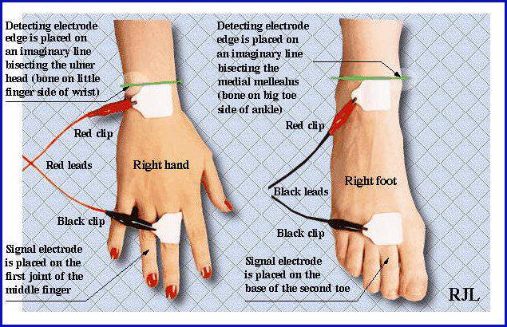

APPENDIX II: Sample Data Collection Form
Body Composition Report
Subject ID: MOGI
Name: A.N. Other Sex: Male
Age: 55
Height cm: I79
Weight kg: 74.
Actual BMI: 23.17 Date: 28 Feb 2012 12:12:26
Chosen Goal Weight 76.6 kg Record date: 28/02/2012 13:51:15
Equation Set: NHANES-1ll
Resistance: 508 Reactance: 33 ohms
Phase angle: 3.7 Impedance: 509.1
Test Comments: Post Dialysis
Estimated BMR: 1612
% ideal FAT: 18.6
% estimated FAT: 22.5
Wt estimated FAT: -16.7
% estimated FFM: 77.5
Wt estimated FFM: 57.5
% WT estimated TBW: 57.4
Liters estimated TBW: 42.6
% TBW estimated ICF: 52.8
Liters estimated ICF: 22.5
% TBW estimated ECF: 47.2
Liters estimated excess ECF: 2

APPENDIX III: Sample of Informed Consent
CONSENT TO PARTICIPATE IN A RESEARCH STUDY ON BODY WATER DISTRIBUTION AMONG HAEMO DIALYSIS PATIENTS AT MOI TEACHING AT MOI TEACHING AND REFERRAL HOSPITAL (MTRH)
INVESTIGATOR: Dr. Bajaber Abdalla Ali
Moi University, School of Medicine, Department of Internal Medicine, AMPATH Centre, Eldoret
You are being requested to participate in a study to determine body composition of hamodialysis patients in this hospital. You have been select because you are a patient with chronic kidney on hemodialysis management. This study is being conducted by Dr. Bajaber Abdalla Ali. It will comprise of l5 minutes of taking details and measurements.
Your participation in this study is entirely voluntary and there will be no direct benefit to you from the study. However it will help in better management of hemodialysis patients. If you decline to participate in this study, it will not affect or jeopardize your future medical care.
There is no risk involved if you participate in this study and the information obtained from this study will be treated as confidential. The data will be stored in a secure place that is only accessible to the investigator. The findings will be disseminated, published for scientific purposes and made available to the relevant authorities. If you have any further questions, comments or complaints relating to this study, please feel free to contact the investigator on the above address.
Consent
I have read this form and understood its contents and therefore I agree to participate in this study.
Signature…………………………………Date…………………………………..

KIAMBATISHO III: MFANO WA RIDHAA
IDHINI YA KUSHIRIKI KATIKA UTAFITI JUU YA USAMBAZAJI WA MAJI MWILINI MIONGONI MWA WAGONJWA WANAOSAFISHWA FIGO KATIKA HOSPITALI YA MAFUNZO NA RUFAA YA MOI (MTRH), ELDORET.
MPELELEZI : Dr Bajaber Abdalla Ali
Chuo Kikuu cha Moi, Shule ya Tiba, Idara ya Tiba, AMPATH Centre, Eldoret
Unaombwa kushiriki katika utafiti wa kuamua usambazaji wa maji mwilini katika wagonjwa wanaosafishwa damu katika hospitali hii. Umechaguliwa kushiriki katika utafiti huu kwa sababu wewe ni mgonjwa wa figo sugu na unapatiwaa huduma ya usafishaji wa figo. Utafiti huu unafanywa na Dk Bajaber Abdalla Ali na itachukua muda wa dakika l5 kuchukua maelezo na vipimo vya uzani na mwili.
Ushiriki wako katika utafiti huu ni wa hiari kabisa na hakutakuwa na faida ya moja kwa moja na kutokana na utafiti huu. Hata hivyo, matokeo yatasaidia katika matibabu bora ya wagonjwa wa figo. Kama hutakubali kushiriki katika utafiti huu, haita athiri huduma utakayopata siku zijazo.
Hakuna hatari zitakayotokea ukishiriki katika utafiti huu na taarifa utakazotoa zitahifadhiwa kwa njia ya siri. Majibu yatahifadhiwa katika mahali salama ambayo itafikiwa na mchunguzi peke yake. Matokeo yataelezewa na kuchapishwa kwa madhumuni ya kisayansi na kupeanwa kwa mamlaka husika. Kama una maswali zaidi, maoni au malalamiko yanayohusiana na utafiti huu, tafadhali jisikie huru kuwasiliana na mchunguzi kwa anwani iliyo juu ya ukurasa.
Ridhaa
Nimesoma fomu hii na kueleweka yaliyomo na kwa hivyo nakubali kushiriki katika utafiti huu.
Sahihi ....................................... Tarehe .........................................

APPENDIX IV: ETHICAL APPROVAL