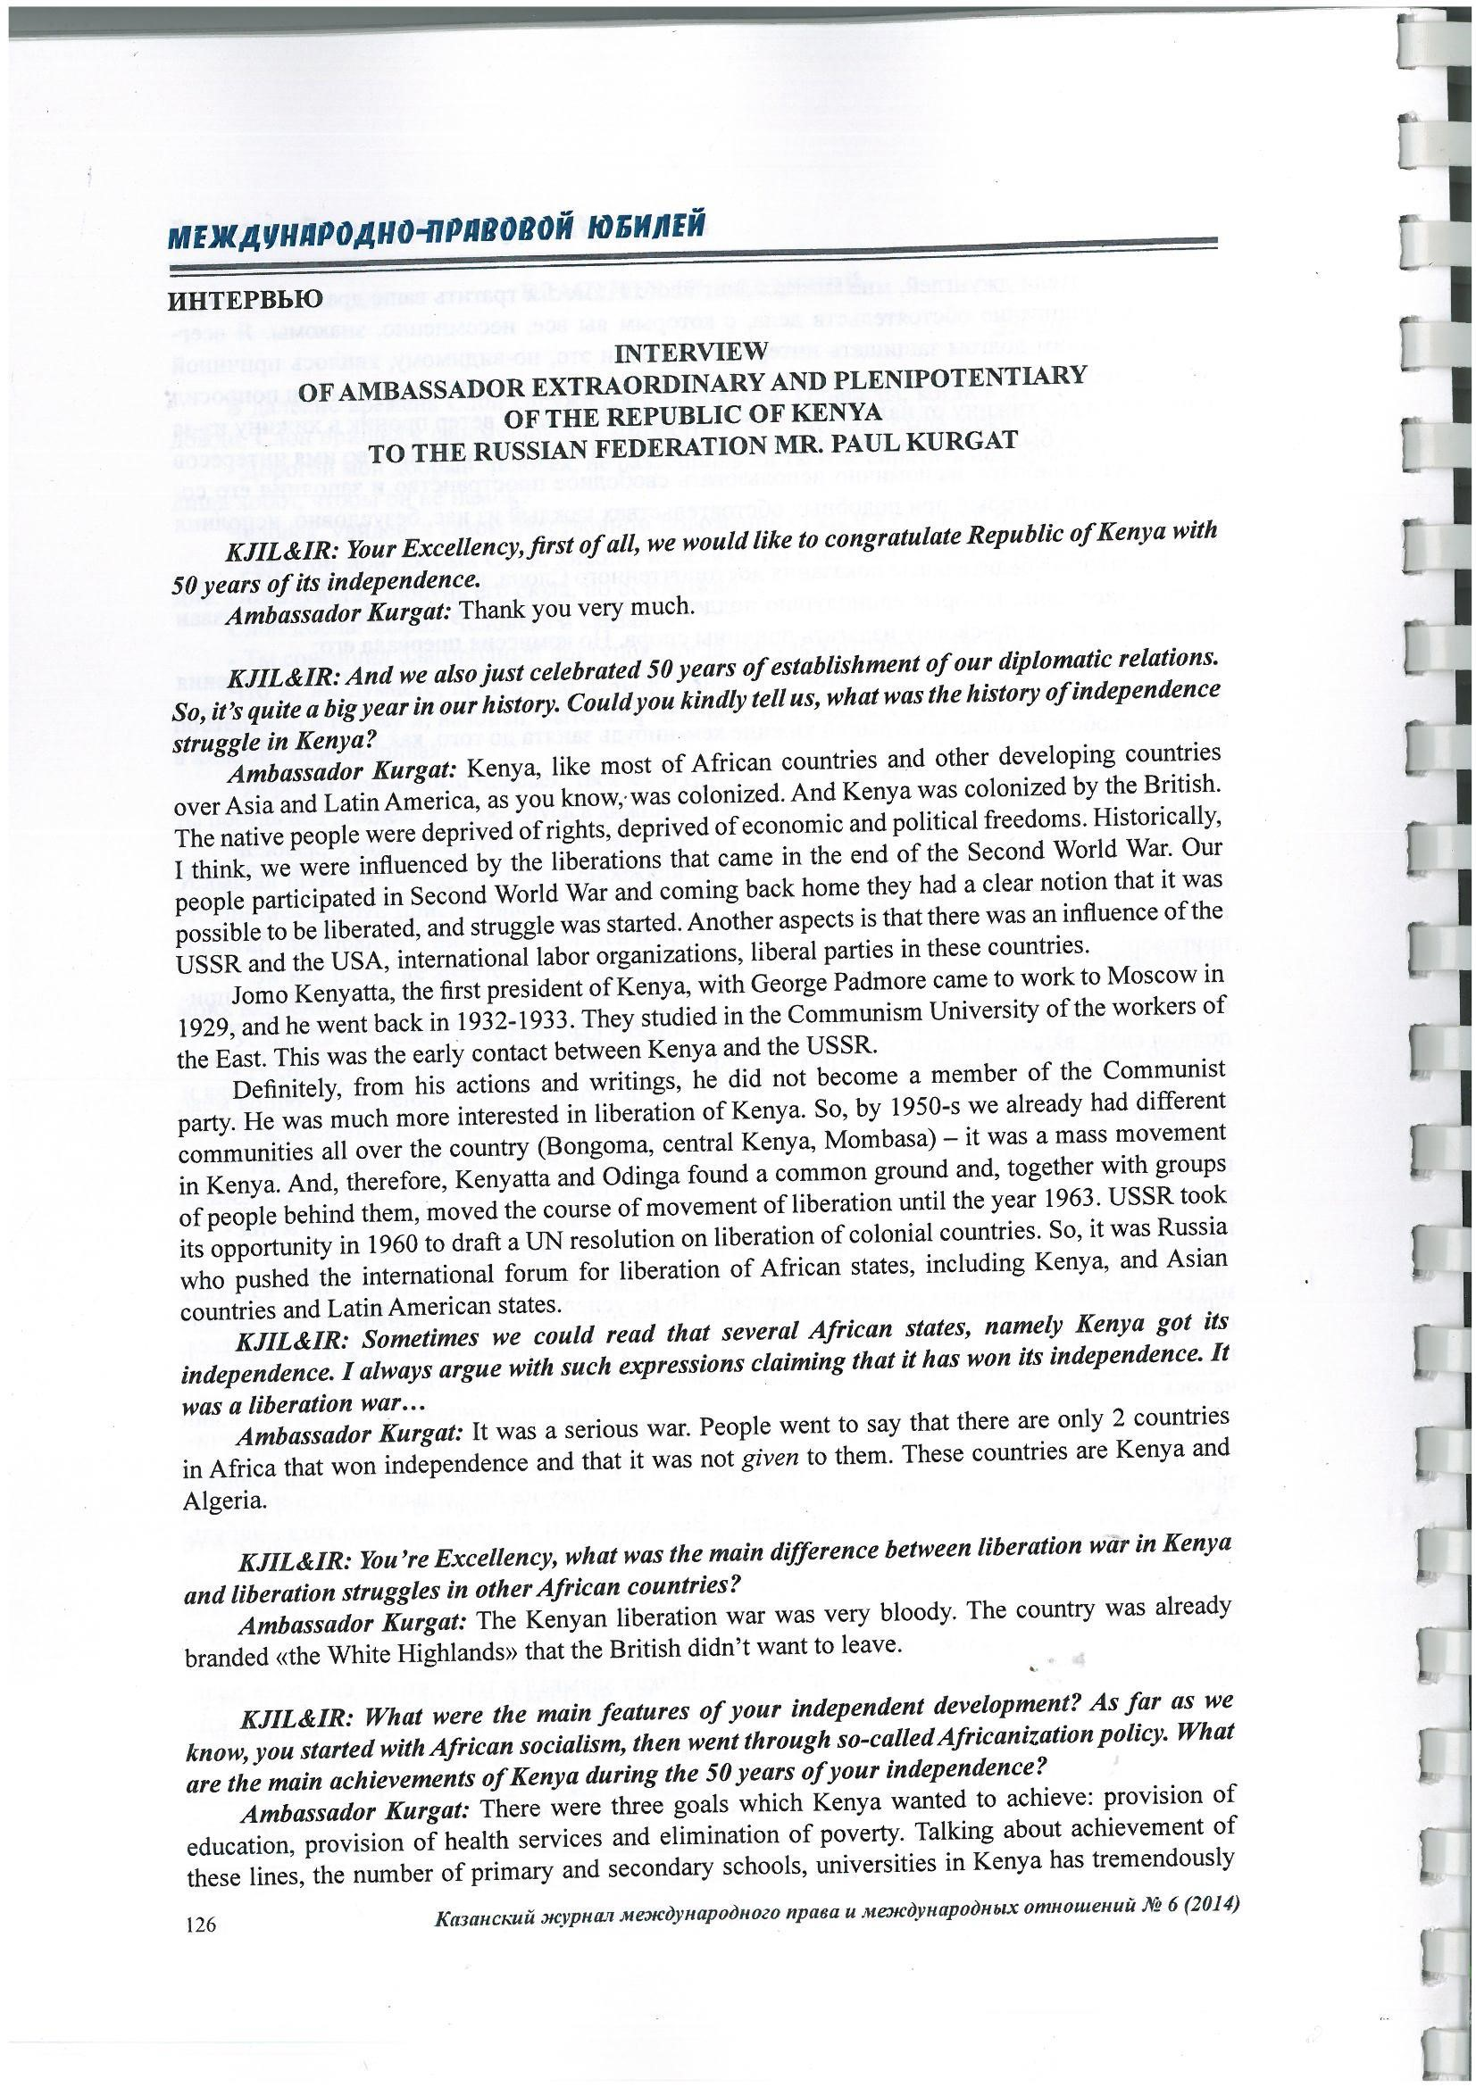
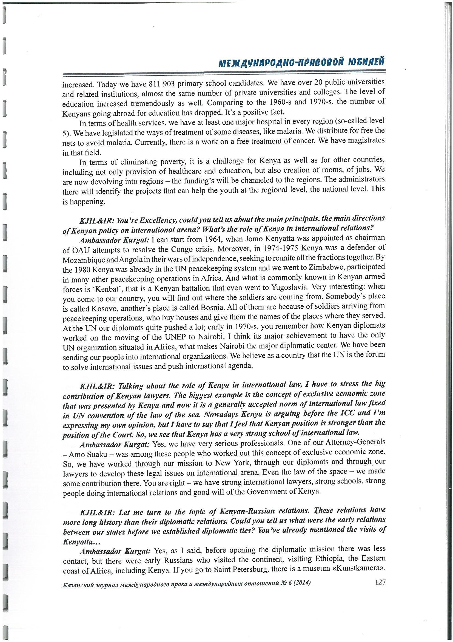
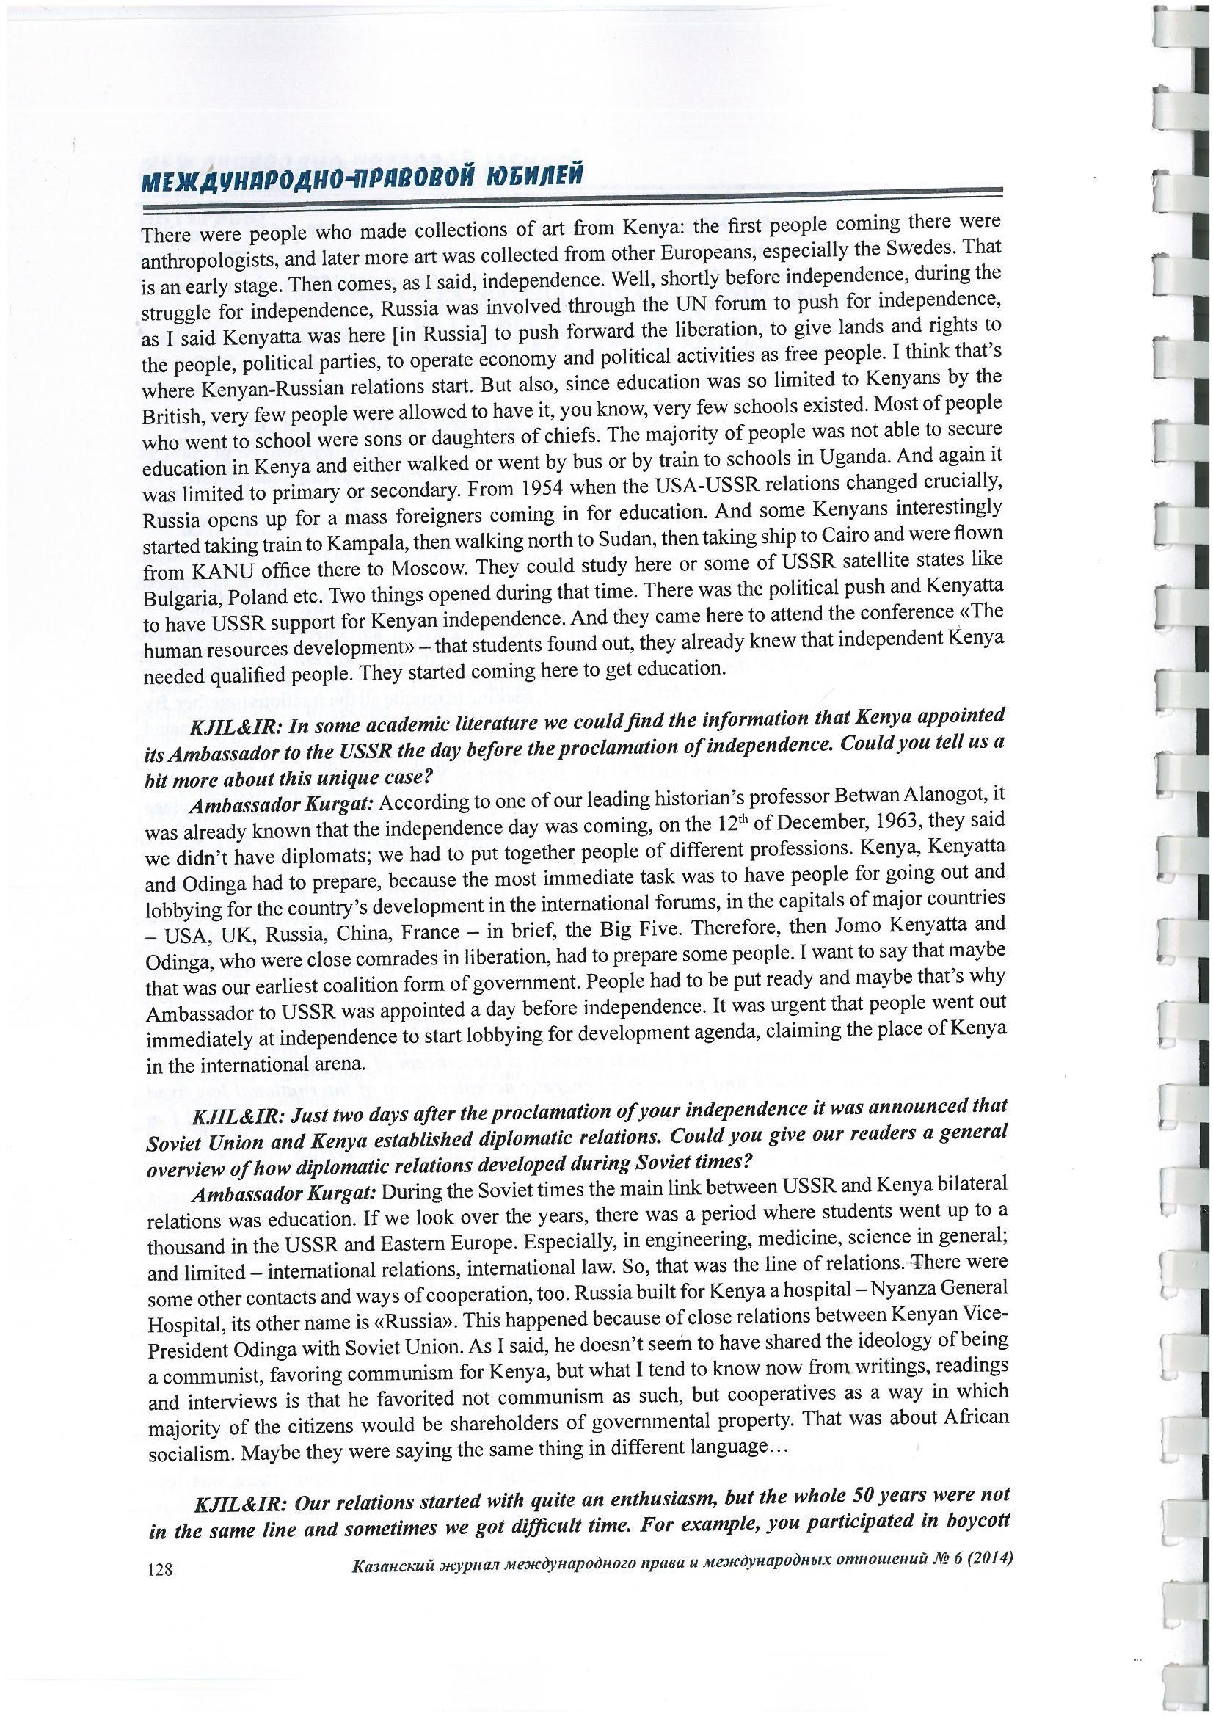
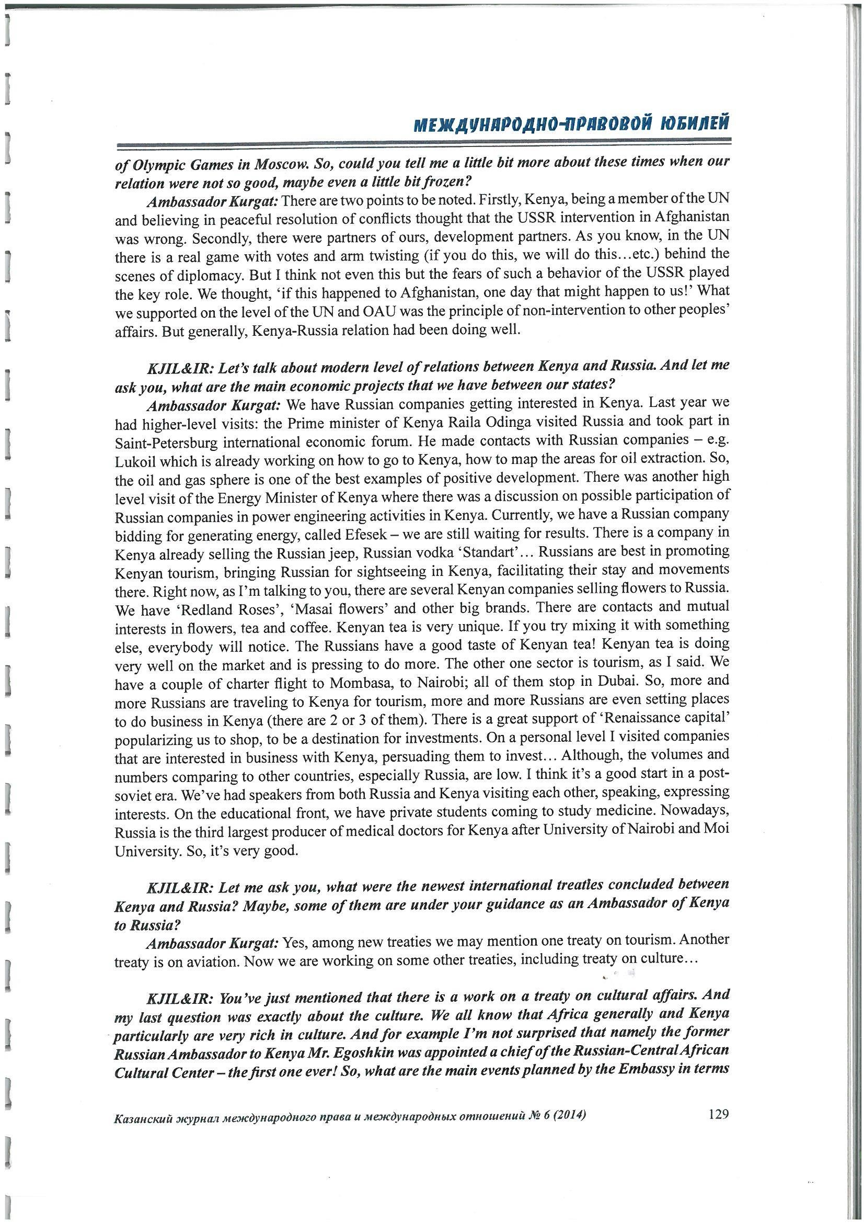
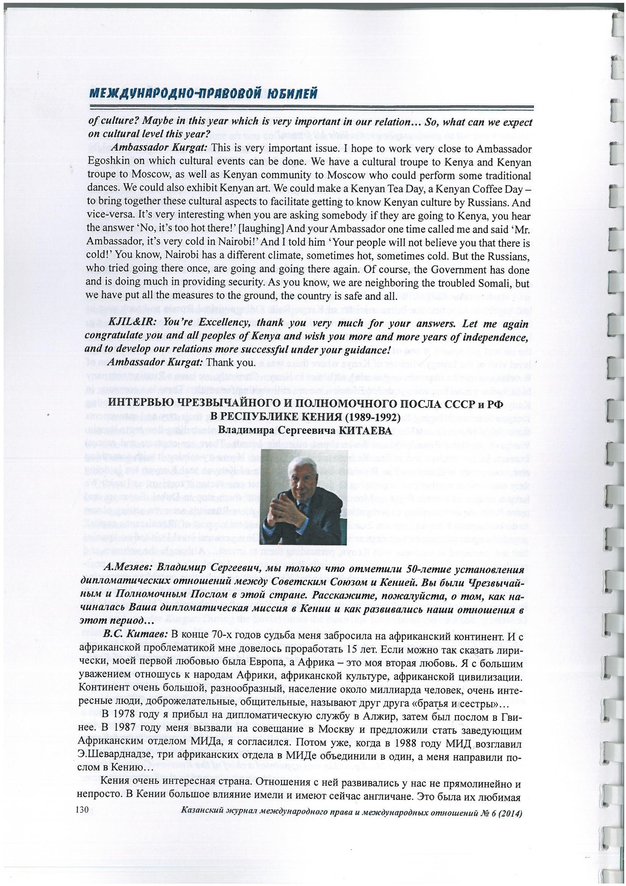

Source: Kurgat, P (2014). Interview of Ambassador Extraordinary and Plenipotentiary of the Republic of Kenya to the Russian Federation, Historical chapter of the Kenya – Russian Diplomatic Relations. Kazan Journal of International Relations NO. 6 ISBN 928.5.93 - 593 - 195 -7.

