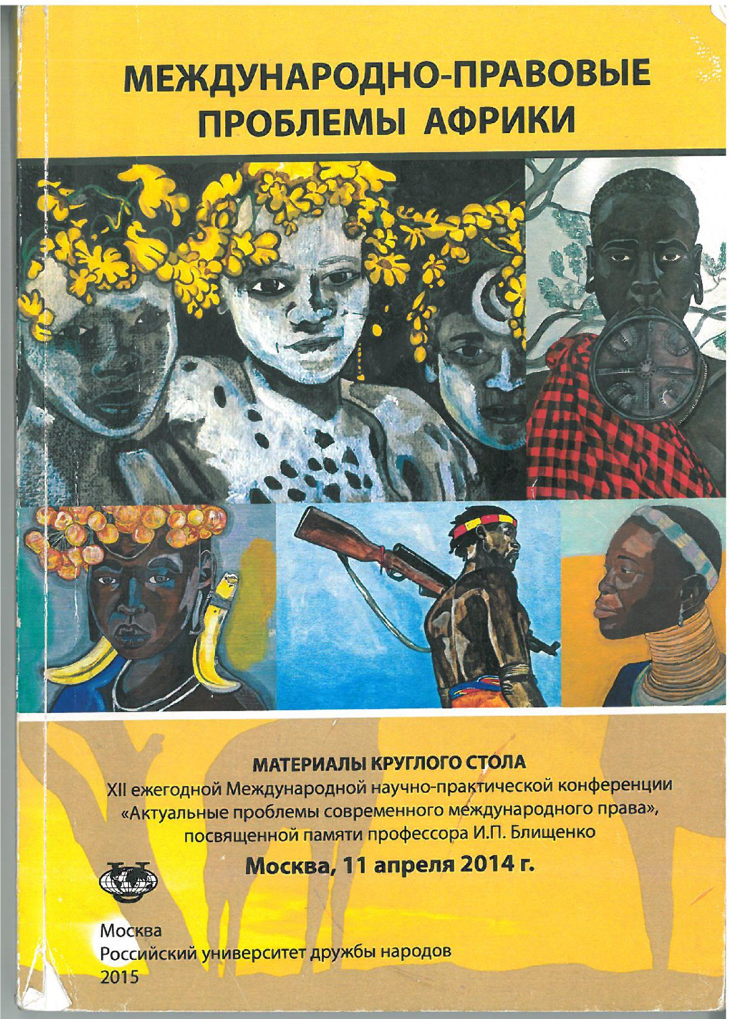
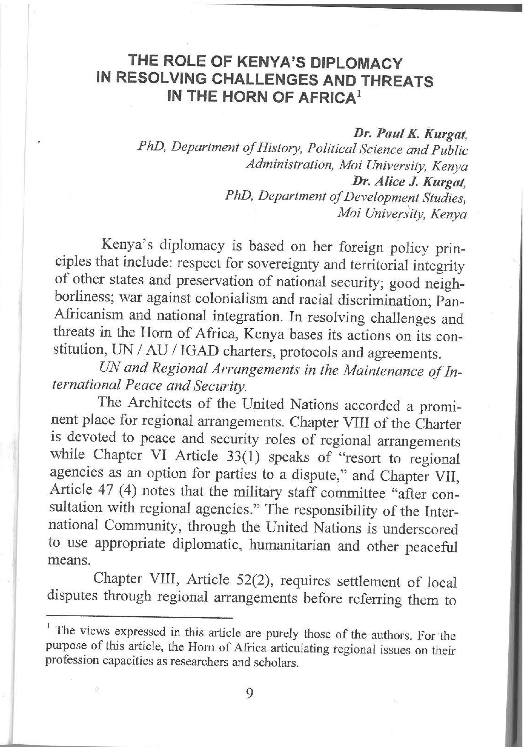
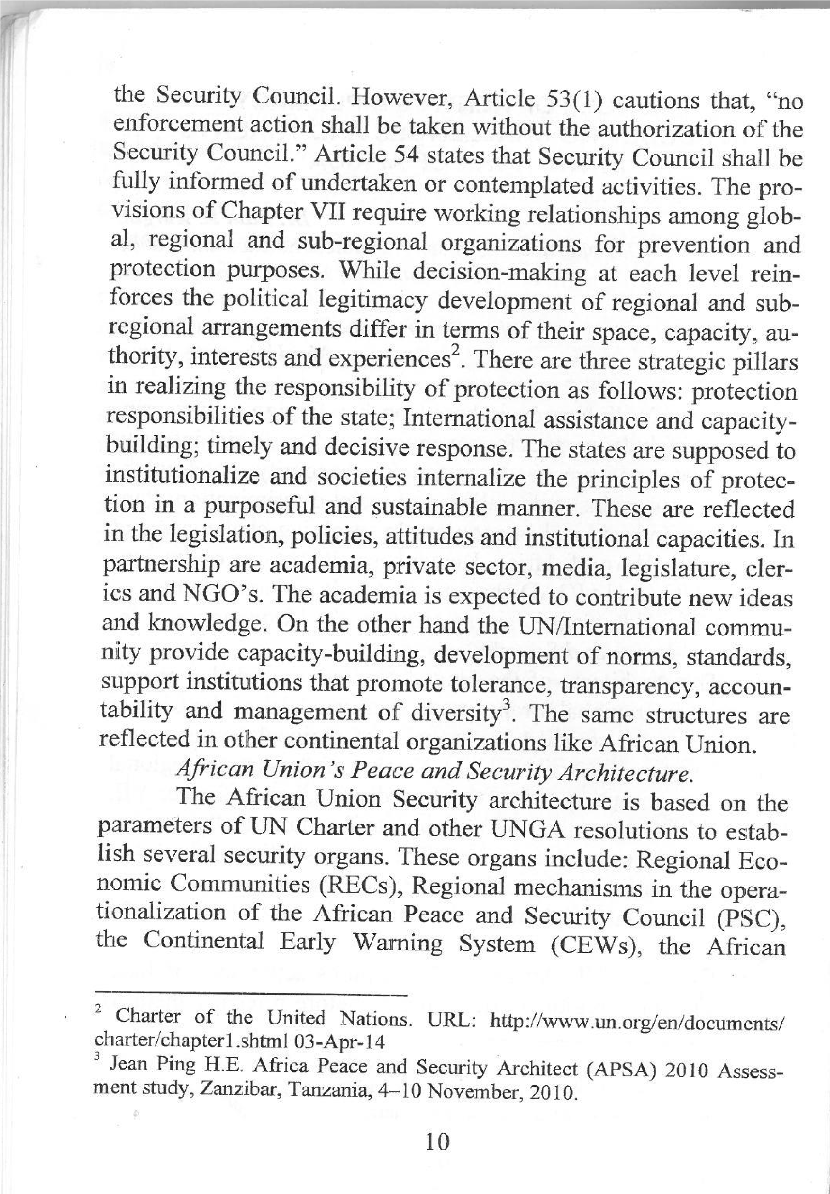
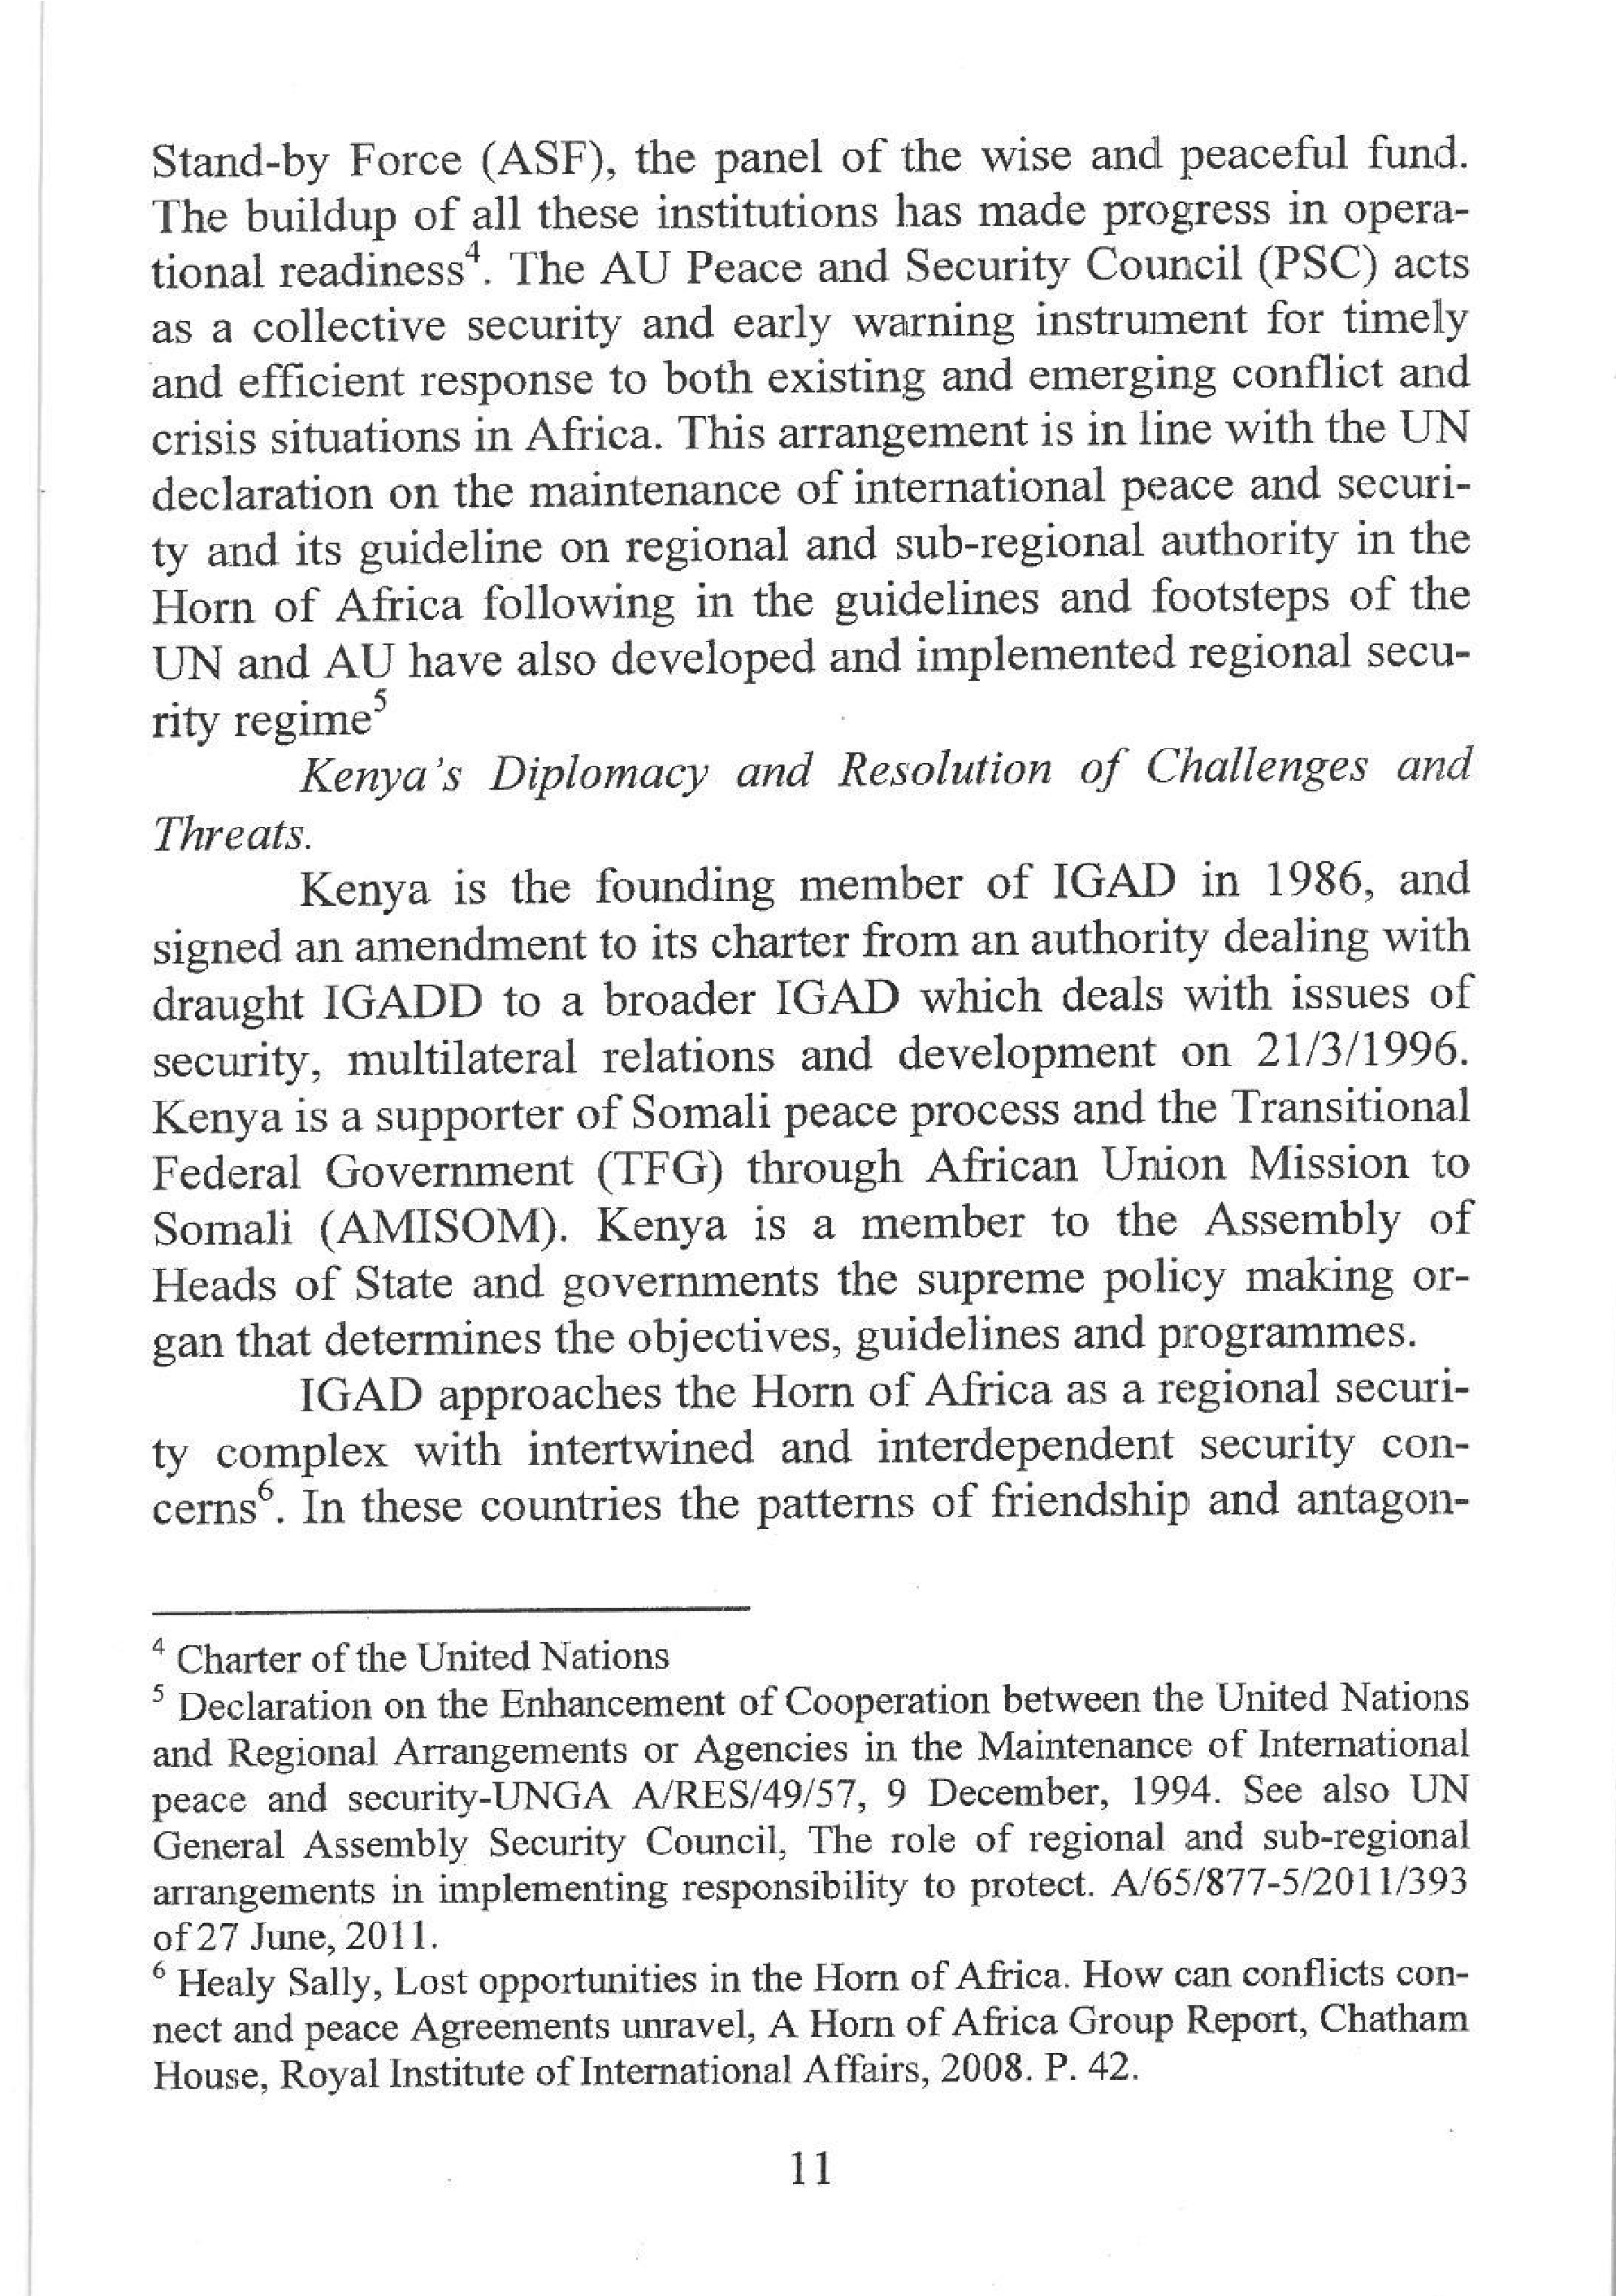
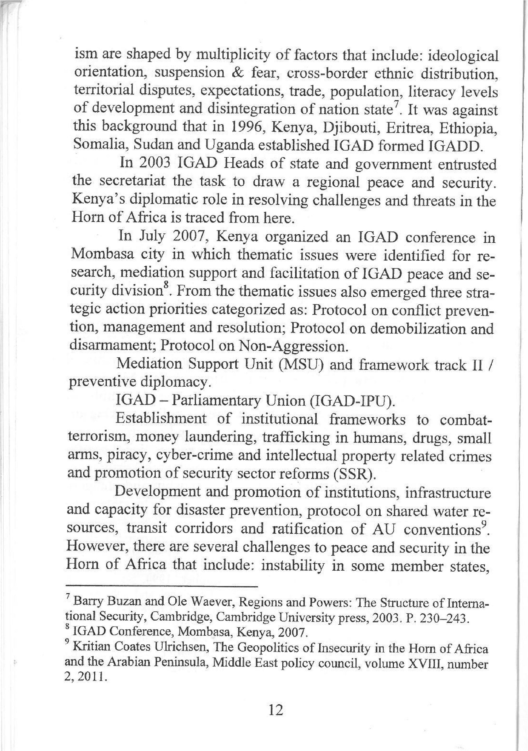
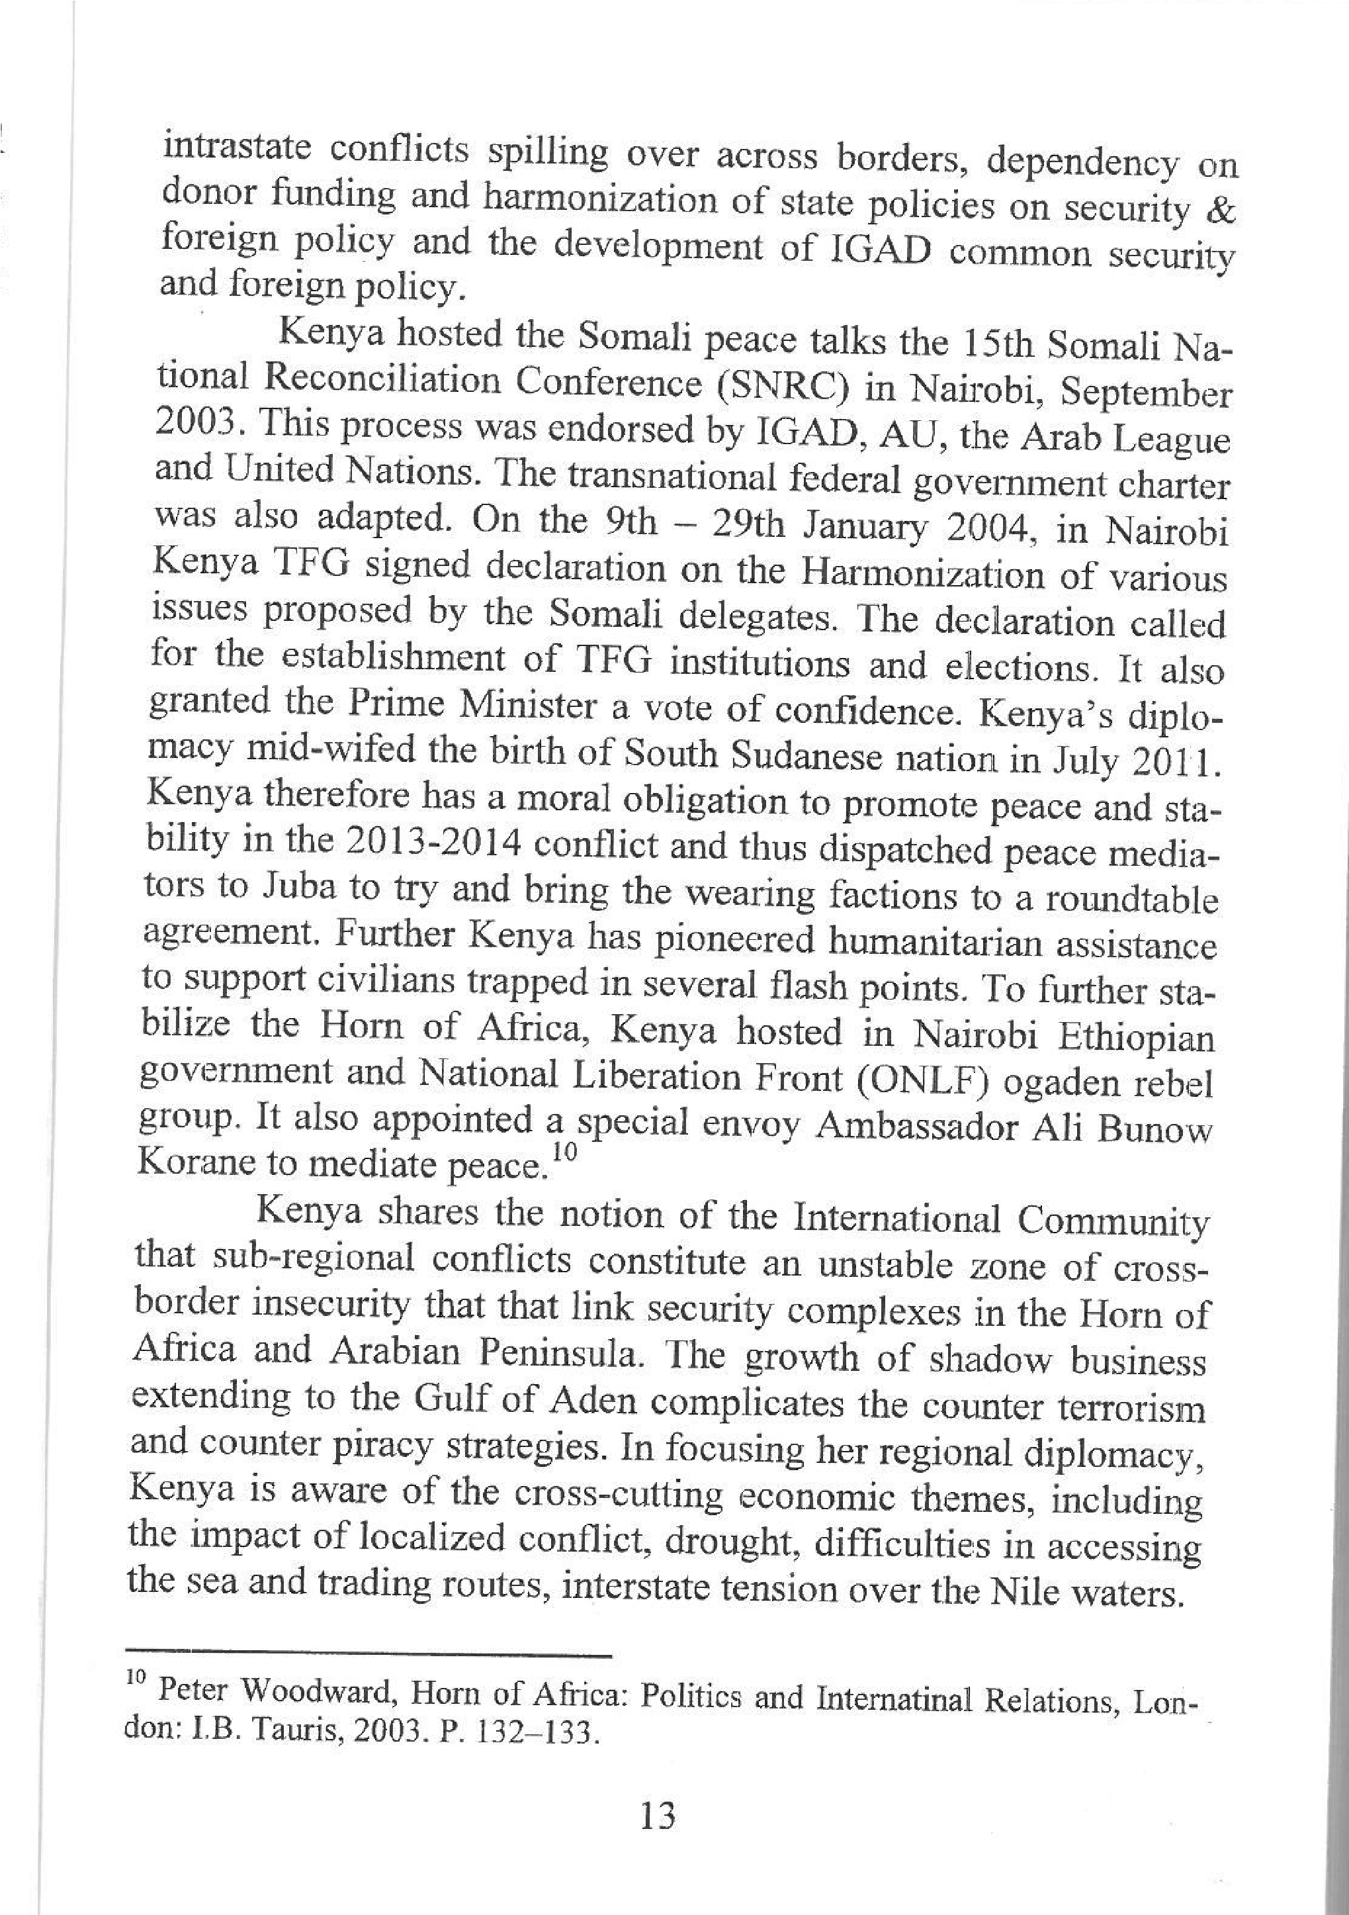
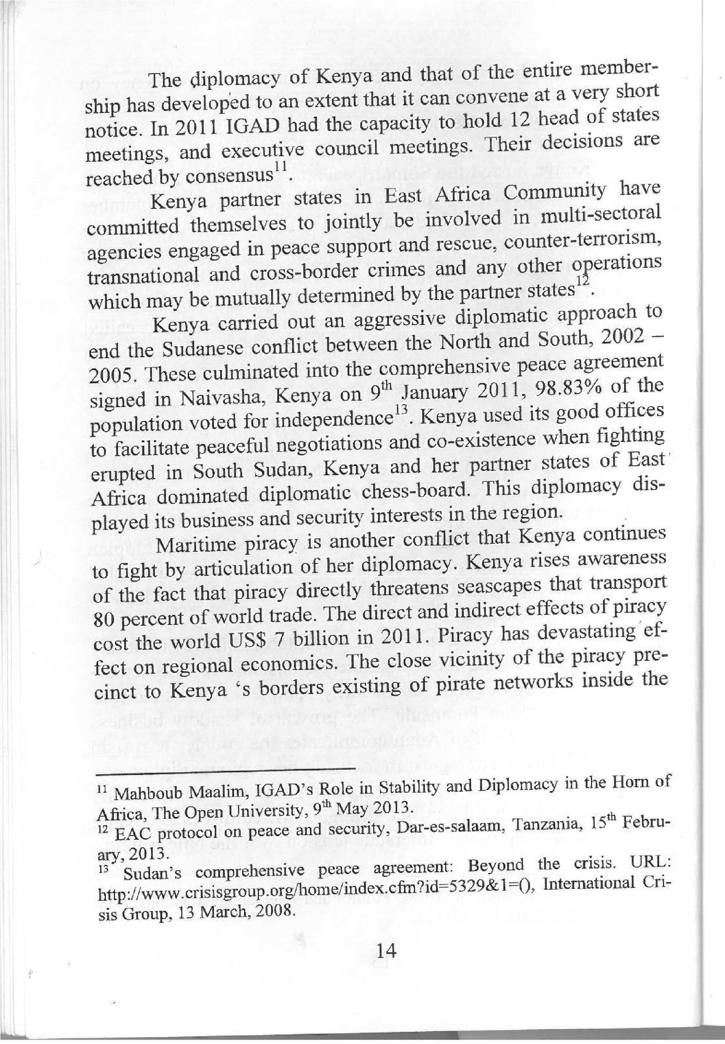

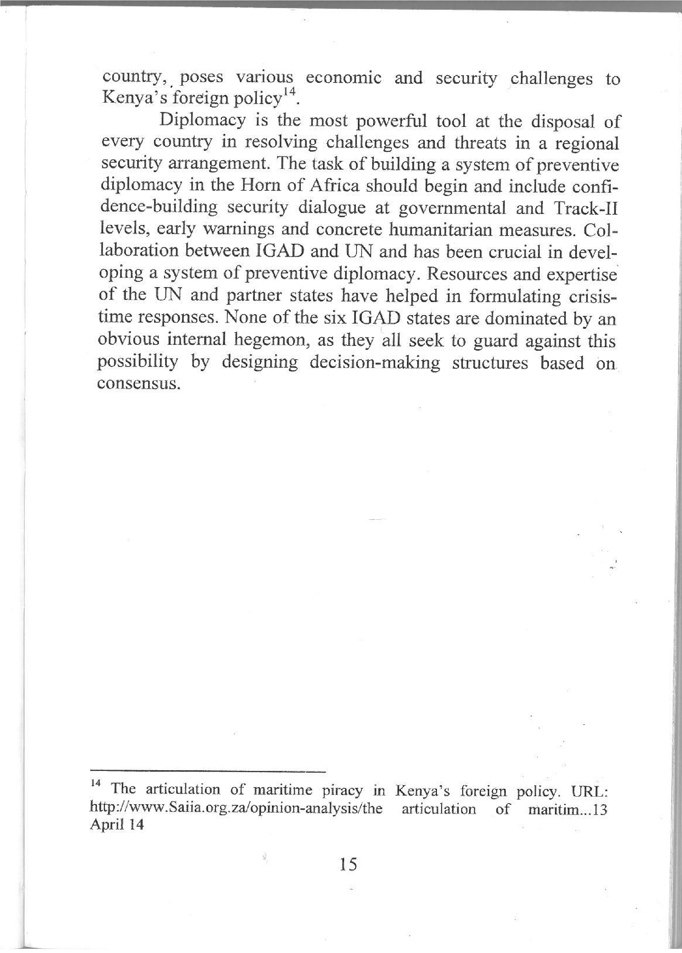

Source: Kurgat, P. K., and Kurgat, A. J (2014). The Role of Kenya’s Diplomacy in resolving challenges and threats in the Horn of Africa in A. Abashitze, A. M. Kisleva and Solnsev (eds), Meshdunarodnie – Problemi Afriki. Moscow: Rasiskii Universitet drushbi narodov. ISBN.ISBN 978 5209 – 06215 – 8.

