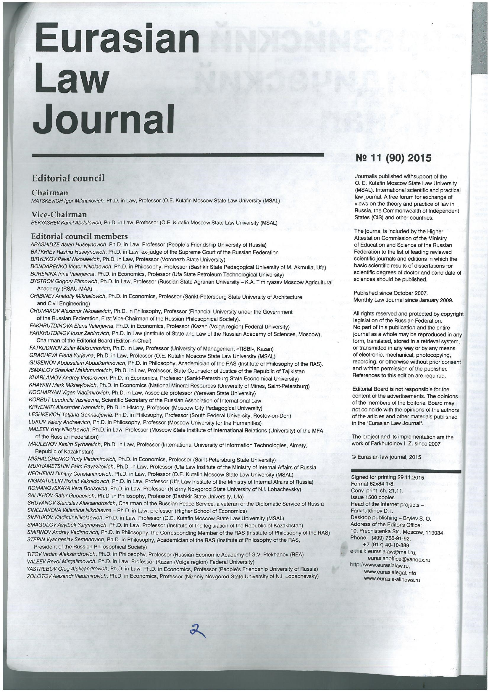
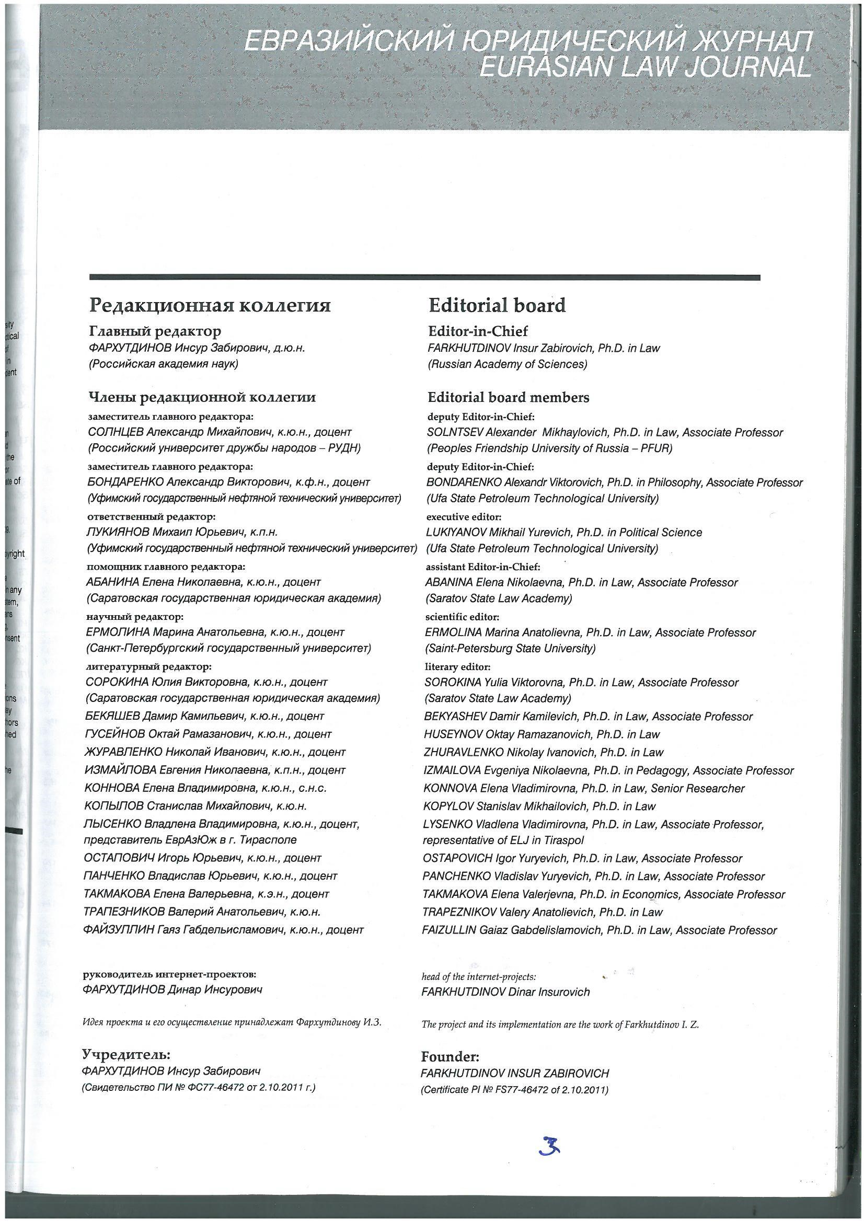
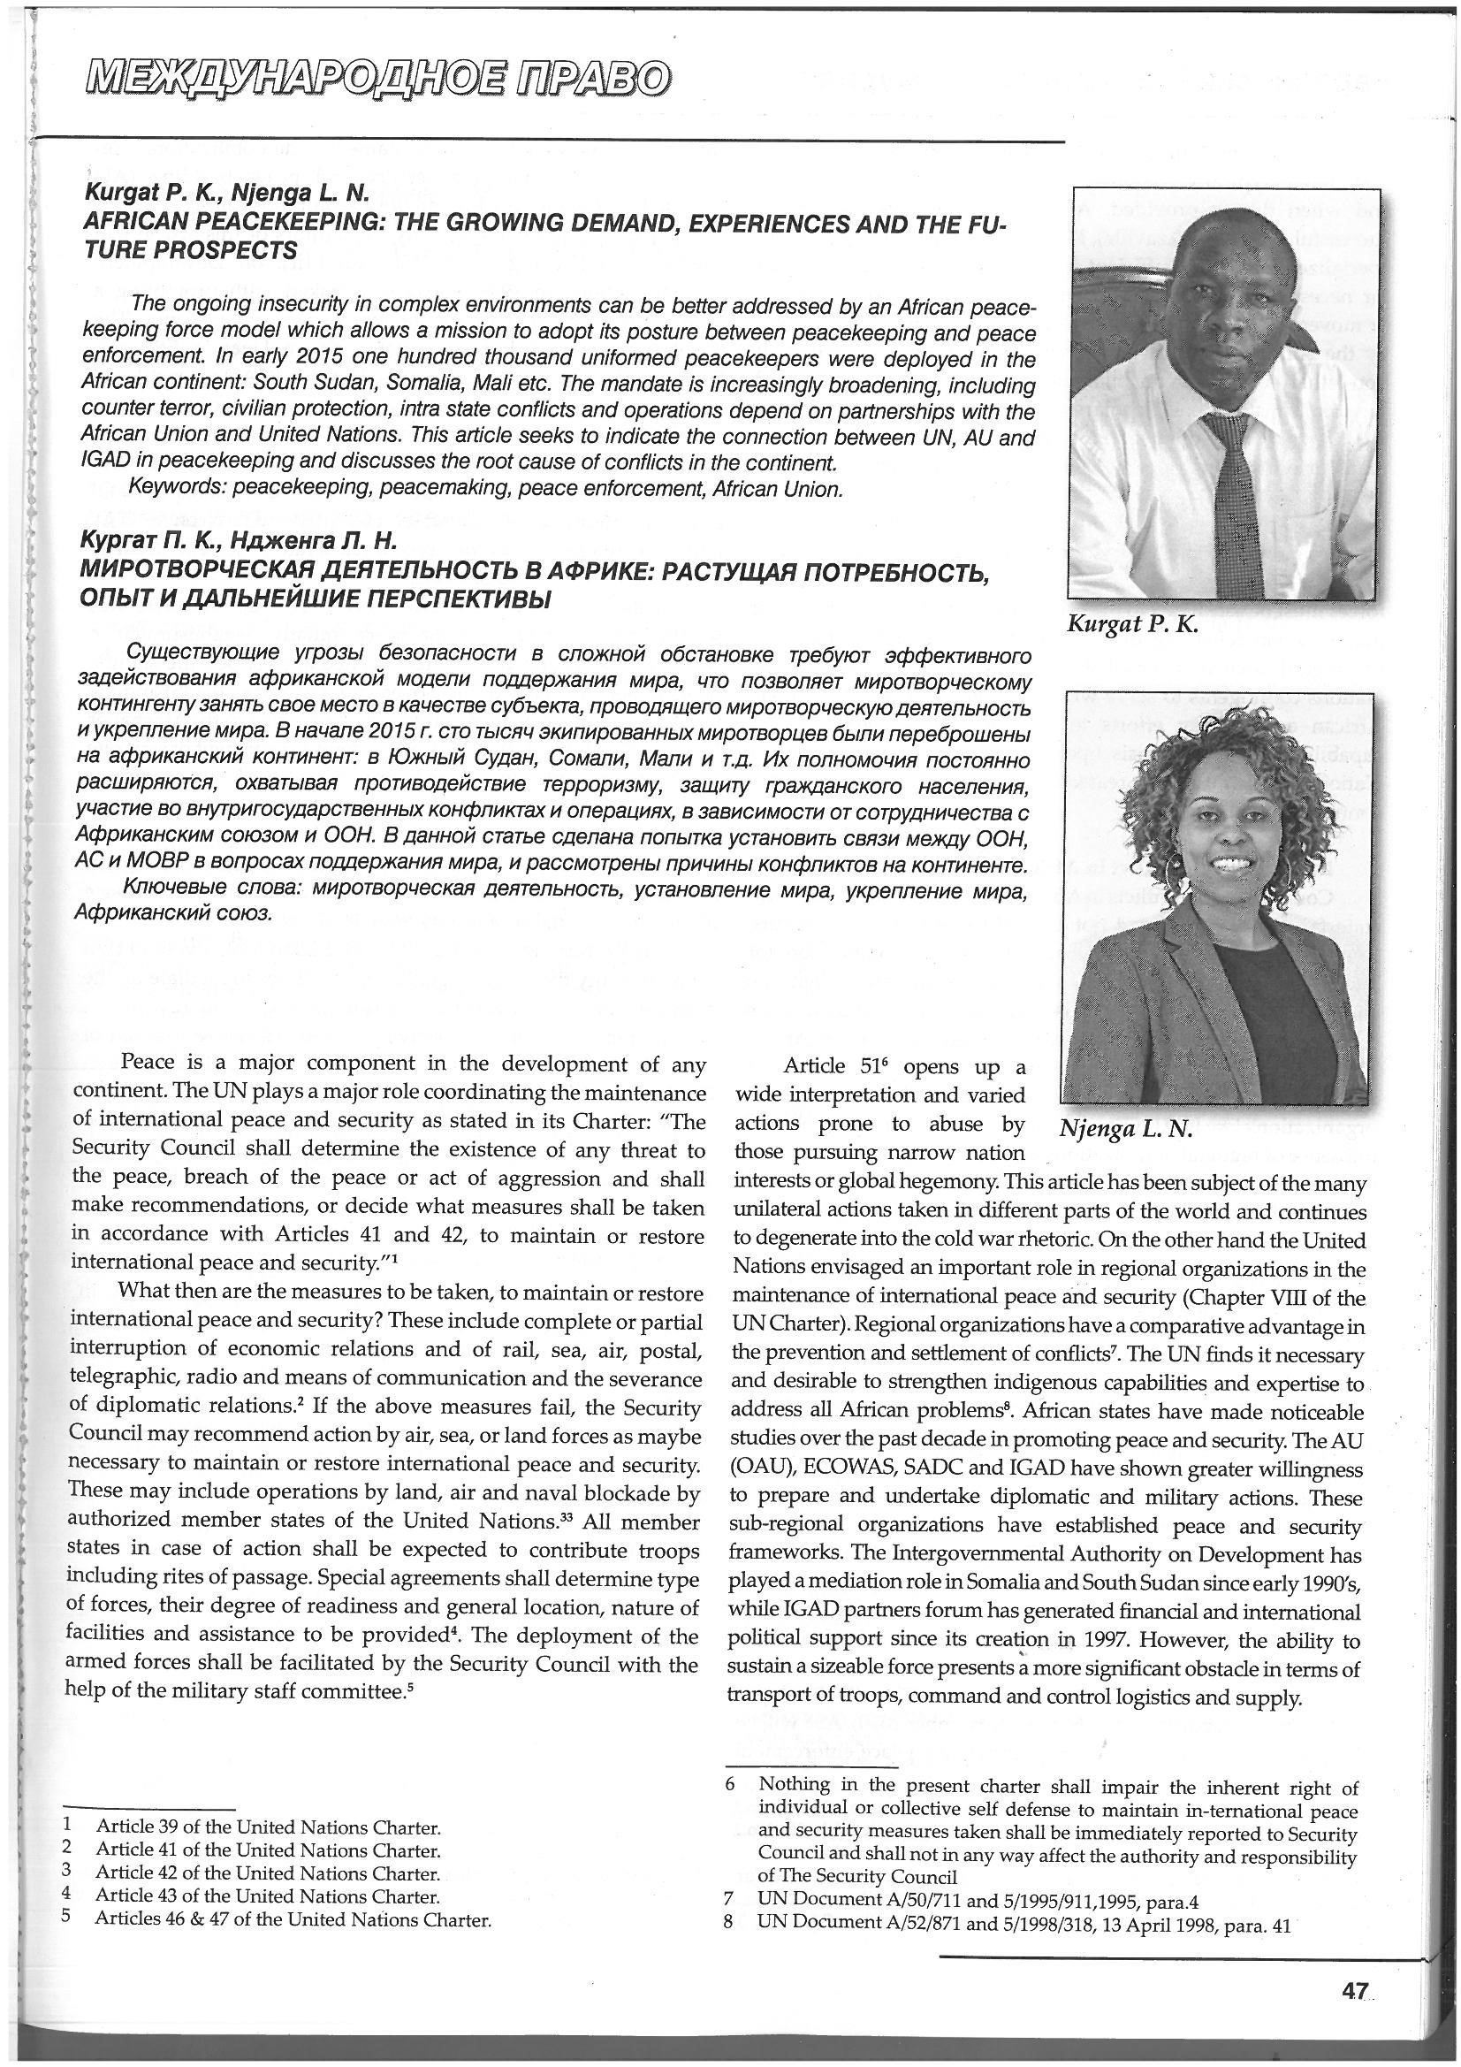
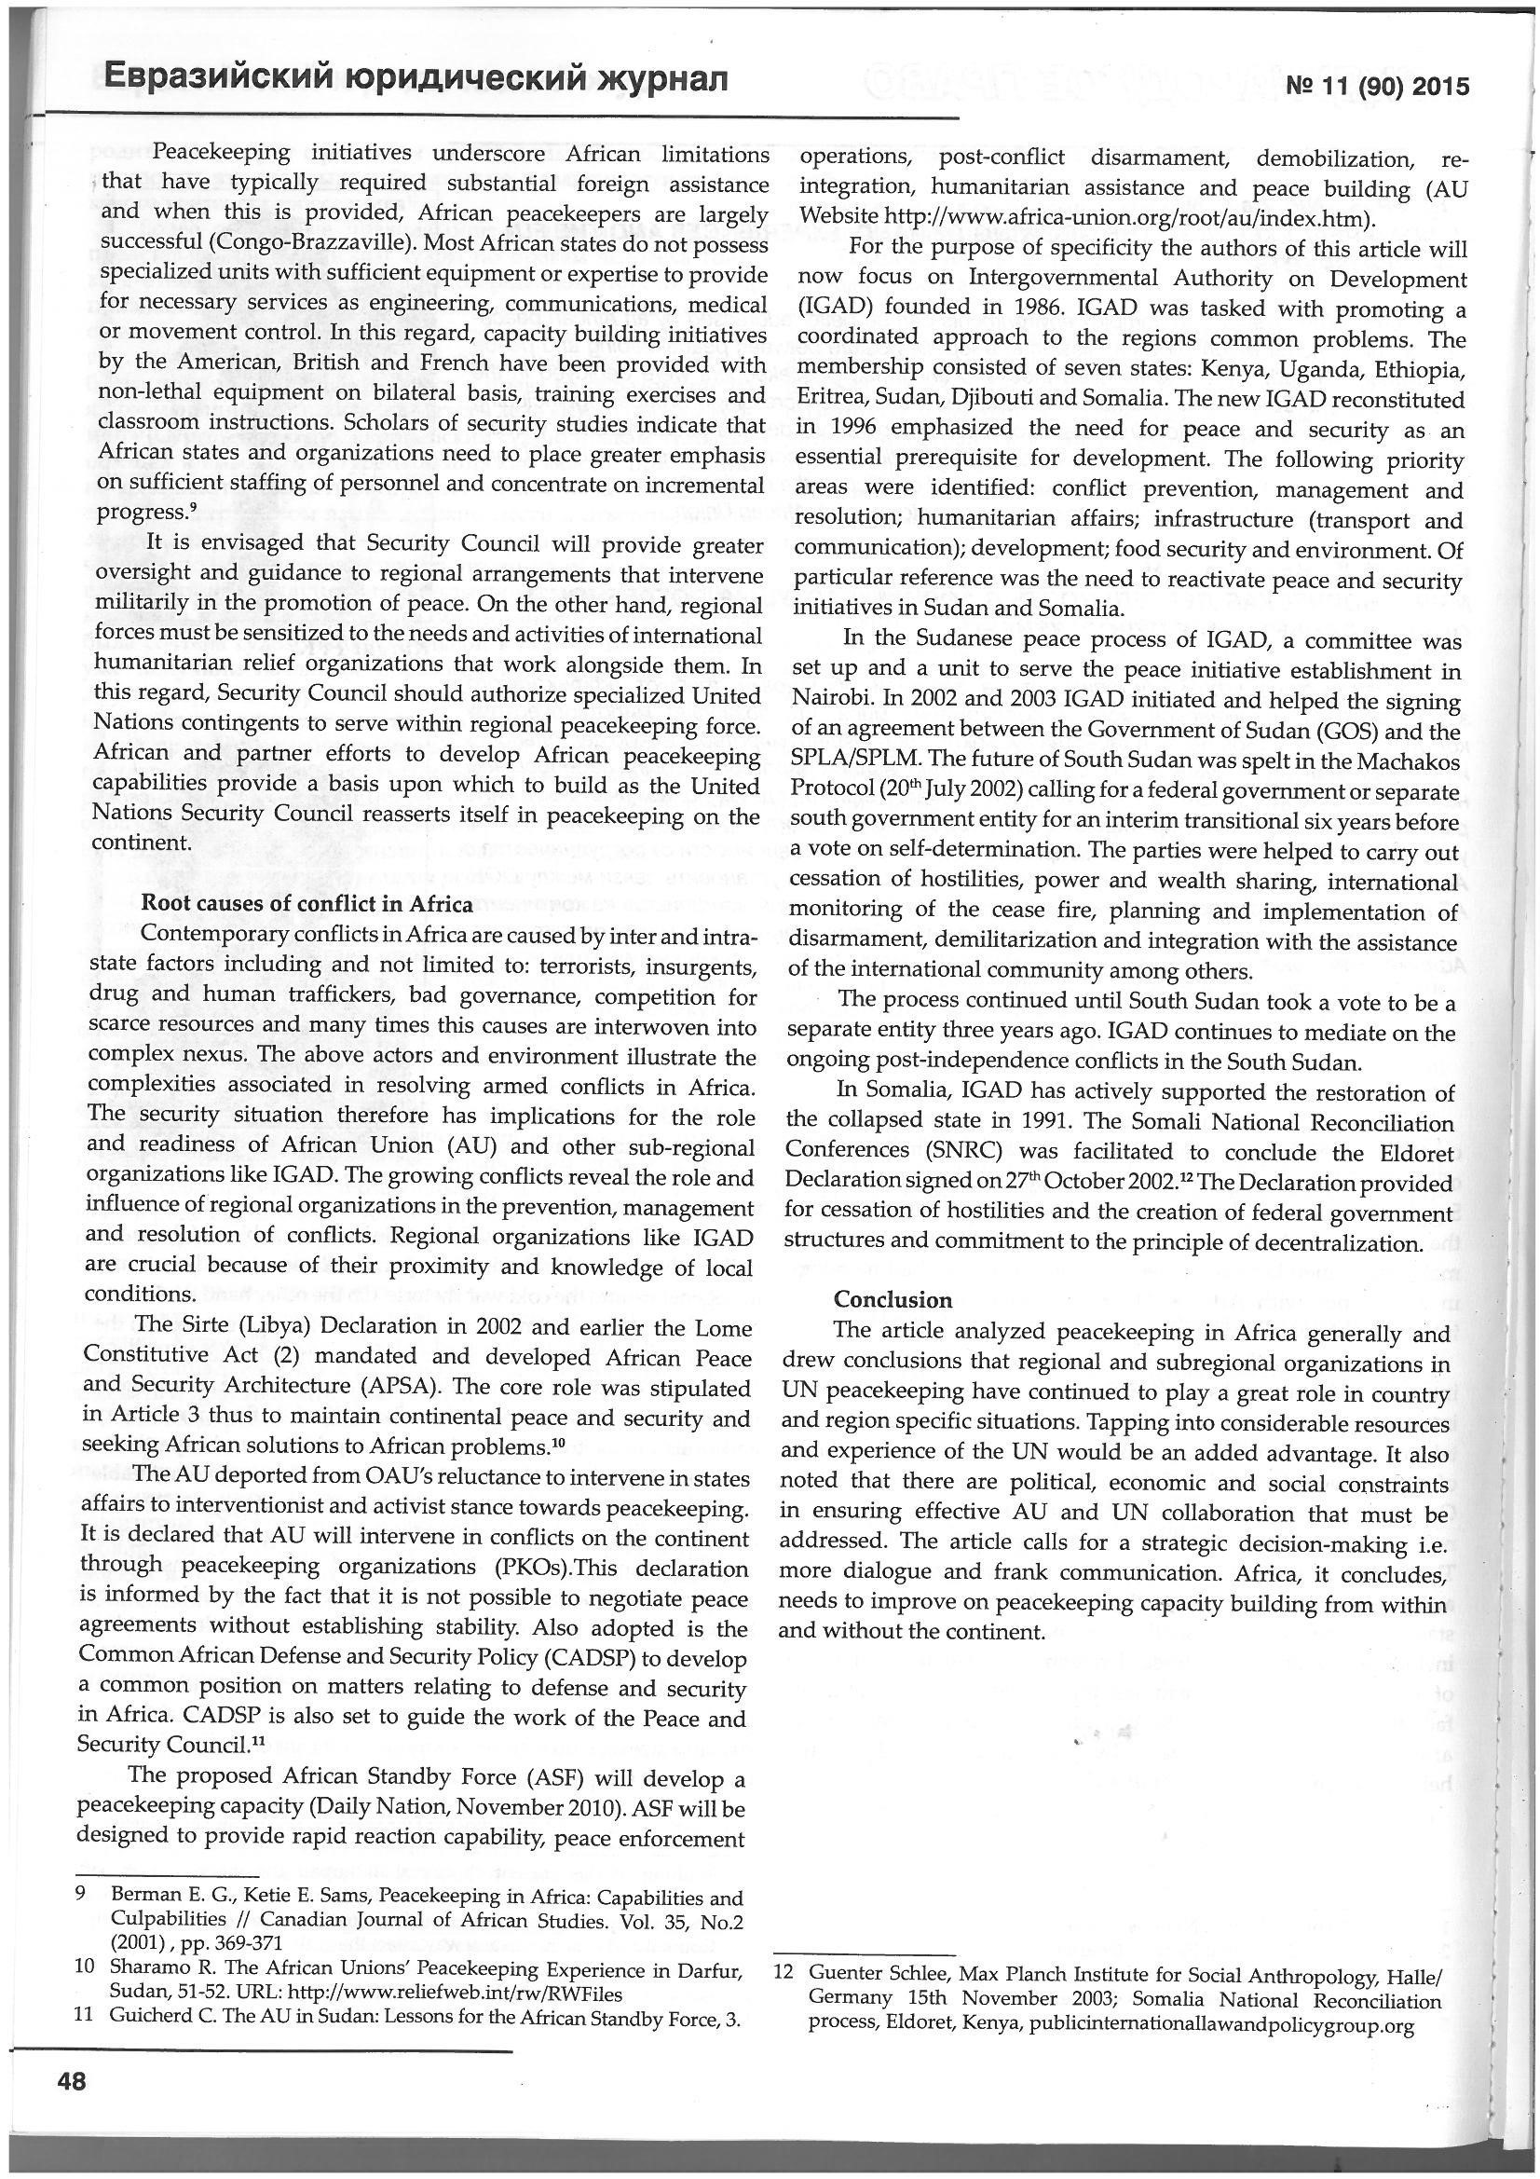

Source: Kurgat, P.K., and Njenga, L.N. (2016).African Peacekeeping: The Growing Demand, experiences and the future Prospects. Eurasian Law Journal, no.11 (90), 46-48,(online) http:www.eurasialaw.ru

