SONOGRAPHIC FEATURES OF ANTERIOR NECK MASSES IN PATIENTS PRESENTING AT MOI TEACHING AND REFERRAL HOSPITAL-ELDORET, KENYA.

BY

DANIEL ACHOKI IKOBE,

SM/PGR/04/13

A research thesis presented to Moi University School of Medicine in partial fulfillment for the award of the degree of
Master of Medicine in Radiology and Imaging
@2018

Sonographic features of anterior neck masses in patients presenting at Moi Teaching and Referral Hospital-Eldoret, Kenya.

Principal Researcher
Achoki Daniel (MBChB), (Nbi)
Registrar in Radiology and Imaging,
Moi University, School of Medicine.
Supervisors
Prof. G.D. Onditi Elias, MBCHB (NRB), MMED RAD (NRB),
Specialist Radiologist and Associate Professor of Radiology
and Imaging,
Moi University School of Medicine,
Eldoret.
Dr. T. Sisenda, MBCHB (NRB), MMED (NRB),
Consultant E.N.T Surgeon and Lecturer, Department of Surgery,
College of Health Sciences,
School of Medicine,
Moi University,
Eldoret.

DECLARATION

Student’s Declaration:
I declare that this thesis is my original work. It has not been presented elsewhere for academic purposes or otherwise. This research work was carried out in pursuant of a degree in Master of Medicine in Radiology and Imaging course at the Moi University, School of Medicine. No part of this work may be reproduced without permission of the author.
Dr. Achoki Daniel (SM/PGR/04/13)
Signature…………………………………… Date…………………………

Supervisors’ Declaration:
This thesis has been submitted for consideration with our approval as supervisors.
Prof G.D. Onditi Elias, Department of Radiology and Imaging, School of Medicine, Moi University.
Signature…………………………………… Date…………………………
Dr. T. Sisenda, Department of Surgery, School of Medicine, Moi University.
Signature…………………………………… Date…………………………

ACKNOWLEDGEMENTS

Prima facie, I am grateful to God for the good health and wellbeing that were necessary to complete this book. I wish to express my sincere gratitude to my supervisors, Prof G.D Onditi Elias and T. Sisenda, for sharing their expertise, valuable guidance and for the continuous encouragement extended to me.
I take this opportunity to express indebtedness to Dr. Oirere P.K for assistance in data analysis and to all ultrasound technicians who assisted with the data collection. I also thank my family for the unceasing encouragement, support and attention.
I also place on record, my sense of gratitude to one and all, who directly or indirectly, have lent their hand in this venture.

DEDICATION
Every challenging work needs self-effort as well as guidance of elders especially those who are very close to our heart. My humble effort I dedicate to my loving parents whose affection, love, encouragement and prayers have always kept me motivated.

TABLE OF CONTENTS
DECLARATION III
ACKNOWLEDGEMENTS IV
DEDICATION V
TABLE OF CONTENTS VI
LIST OF TABLES X
LIST OF FIGURES XI
LIST OF ABBREVIATIONS XII
ABSTRACT XIII
CHAPTER ONE: INTRODUCTION 1
1.1 Background 1
1.2 Problem Statement 3
1.3 Research Questions 4
1.4 Justification 4
1.5 Objectives 5
1.51 Broad Objective 5
1.52 Specific Objectives 5
CHAPTER TWO: LITERATURE REVIEW 6
2.1 Introduction 6
2.2 Differential diagnosis of anterior neck masses 7
2.3 Thyroid nodules sonography 7
2.4 Sonographic features of anterior cervical lymphadenopathy 10
CHAPTER THREE: METHODOLOGY 13
3.1 Study design 13
3.2 Study site 13
3.5 Study population 14
3.6 Sampling Technique 14
3.7 Eligibility Criteria 14
3.7.1 Inclusion criteria 14
3.7.2 Exclusion criteria 14
3.8 Sample size 14
3.9 Data management and analysis 14
3.9.1 Activities 14
3.9.2 Quality Control 15
3.9.3 Data collection 15
3.9.4 Data analysis 15
3.10 Ethical considerations 16
3.11 Study recruitment schema 18
CHAPTER FOUR: RESULTS 19
4.1 Demographics of the participants 19
4.2 Sonographic features of anterior neck 20
4.21 Thyroid masses 20
4.22 Lymphnodal masses 21
4.3 Distribution of anterior neck masses by cytological diagnosis 23
4.4 Sonographic features of anterior neck masses 30
4.41. Thyroidal masses 30
4.42 Significance testing of sonographic findings differentiating benign from malignant thyroid nodules 40
4.43 Lymphadenopathy 44
4.44. Significance testing of sonographic findings differentiation benign from neoplastic lymphadenopathy 47
4.35. Other lesions 49
CHAPTER FIVE: DISCUSSION 50
5.1 Cytological diagnosis 50
5.2 Thyroid nodule sonography 52
5.3 Cervical lymphadenopathy sonography 54
CHAPTER SIX: CONCLUSIONS AND RECOMMENDATIONS 56
6.1 Conclusions 56
6.2 Recommendations 57
REFERENCES 58
APPENDIX I: CONSENT FORMS 64
APPENDIX I1: DATA COLLECTION FORM 68
APPENDIX III: IREC APPROVAL 71
APPENDIX 1V: MTRH APPROVAL 72

LIST OF TABLES
Table 1: Sonographic features of thyroid masses 20
Table 2:Sonographic features of cervical lymphadenopathy 22
Table 3: Sonographic features of benign and malignant thyroid masses 31
Table 4:Analysis of the sonographic features of benign and malignant thyroid masses 42
Table 5: Sonographic features of Benign and Malignant Lymphadenopathy 44
Table 6: Sonographic features of Benign and Malignant Lymphadenopathy 48

LIST OF FIGURES
Figure 1: Distribution of study participants by age group 19
Figure 2: Origin of anterior neck masses seen at MTRH 23
Figure 3: Benign and Malignant Thyroid masses seen at MTRH 24
Figure 4: Spectrum of benign thyroid masses seen at MTRH 25
Figure 5: Malignant Thyroid Lesions seen at MTRH 26
Figure 6: Benign and Neoplastic Lymphadenopathy cases seen at MTRH 27
Figure 7: Distribution of Benign Lymphadenopathy 28
Figure 8: Distribution of Neoplastic Lymphadenopathy 28
Figure 9: Summary of cytological diagnosis 29
Figure 10: Benign Vs Malignant thyroid nodules: Composition and Echogenicity 34
Figure 11: Benign Vs Malignant Thyroid nodules: Margins and Calcification 34
Figure 12 Benign Vs Malignant Thyroid nodules: Color Doppler vs Halo 35
Figure 13: Colloid Goiter 36
Figure 14: Thyroid Cyst 37
Figure 15: Follicular Adenoma 38
Figure 16: Colloid Goiter 39
Figure 17: Colloid Goiter 39
Figure 18: Thyroiditis 40
Figure 19: Benign Vs Malignant Lymphadenopathy: Echogenicity and Shape 46
Figure 20: Benign vs Malignant Lymphadenopathy: Color doppler and Hilus 47

LIST OF ABBREVIATIONS
KNH | Kenyatta National Hospital
MTRH | Moi Teaching and Referral Hospital
FNAC | Fine needle aspiration cytology
MMed | Master of Medicine
USS | Ultrasound scan
Ca | Cancer

ABSTRACT

SONOGRAPHIC FEATURES OF ANTERIOR NECK MASSES IN PATIENTS PRESENTING AT MOI TEACHING AND REFERRAL HOSPITAL-ELDORET, KENYA.
Background anterior neck masses are caused by a variety of conditions, some of which canbe life threatening. Due to the superficial nature of most anterior neck lumps, they are initially investigated by high frequency (7.5-15MHz) ultrasonography. Theultrasonographic features of the various neck lumps; with special emphasis on the thyroid
gland; once characterized and documented shall assist in prompt diagnosis of the various
pathologies thus improving treatment outcomes.
Objective: This study sought to correlate the cytopathological diagnoses with the sonographic appearances of anterior neck masses in patients presenting at Moi Teaching and Referral Hospital (MTRH).
Methods: This is a cross sectional study done at the ultrasound suite of MTRH between
August 2014 and August 2015. The study population was persons over 18 years of age who presented with anterior neck masses. This was a census study where all (380) participants who met the inclusion criteria were studied. Non-consenting or participants who had undergone intervention; such as surgery or radiotherapy; were not included. Descriptive statistics such as frequencies, means and standard deviation were used to summarize the data.
Results: Majority of the anterior neck masses arose from the thyroid gland with 269 (71%)
cases, followed by lymph nodal masses at 102 (27%). Other anterior neck masses constituted 2% (n=9) of the lesions. Statistically significant findings of benignity in thyroid lesions were iso-echogenicity, well defined margins and peripheral flow on color Doppler interrogation. Malignant thyroid lesions on the other hand demonstrated micro-calcifications, marked hypoechogenicity and internal flow on color doppler. Statistically significant findings of neoplastic cervical lymphadenopathy were round shape, absence of central echogenic hilus and peripheral vascularity. Benign nodes on the other hand were mainly ovoid, with a central echogenic hilus and demonstrated hilar vascularity
Conclusion: Differentiation of benign and malignant thyroid and lymph-nodal masses can be done by ultrasonography based on the grey scale and color Doppler appearances.
Recommendation: Ultrasonographic workup should lay emphasis on differentiation of benign and malignant anterior neck masses. Those that appear sonographically neoplastic should warrant further work-up.

CHAPTER ONE: INTRODUCTION

Background
Anterior neck lumps are common and are caused by a variety of conditions. Sometimes these lumps can be obvious and noticed by inspection of the neck, while at other times they are puny and may only be discerned on physical examination or by diagnostic imaging. Some lumps in the neck can have no symptoms. Other times, especially when an infection is involved, there may be tenderness when it is palpated.
The causes of anterior neck masses are usually benign. However, the lump may be the presentation of a more serious infirmity such as malignancy or chronic infection and therefore thorough assessment and diagnosis are essential.
The differential diagnoses of anterior neck masses are divided according to structure of origin. Since there are many potential causes of neck masses, it is important to proceed in a logical and cost effective manner for the proper diagnosis. High resolution sonography has become an invaluable imaging modality after clinical examination. It is easily tolerated by patients, lacks ionizing radiation and is inexpensive. It shows the origin of the lesion and is able to reliably distinguish cystic from solid lesions. In this study, masses arising from the thyroid gland accounted for the majority of cases followed by lymph nodal masses, thus the lesions were classified into thyroid masses, lymph nodal masses and other anterior neck masses.
Imaging of anterior neck masses may include ultrasound, CT scan, MRI scan and even nuclear medicine scan by use of radioactive medication. Due to the superficial nature of most anterior neck lumps however, they are initially investigated by high frequency (7.5-15 MHz) ultrasonography, (Rumack, Wilson, & Charboneau, 2005) which permits visualization of more subtle anatomical and pathological details. Ultrasound is also relatively inexpensive, widely available and a non-invasive method of investigation. It enables detection of thyroidal and extra thyroidal masses, definition of their boundaries, vascularity and relationship to the great vessels. (Barki, 1992). It provides valuable diagnostic information with a high degree of diagnostic accuracy and useful in preparative evaluation of patients as accurate diagnosis of neck masses is critical to minimizing patient morbidity and mortality. Ultrasound can also provide reliable real time guidance for fine-needle aspiration cytology (FNAC) or core biopsy.On the basis of sonographic findings, selection of additional imaging modalities including CT and MRI imaging can be done more judiciously. (Dietmar, 2000)
This study helps pinpoint and characterize the specific lesions seen on high frequency ultrasonography of the neck in MTRH. It also evaluates the sonographic features of lesions that are benign and suspicious using cytopathology as gold standard. This will enable faster and more accurate sonographic diagnosis of the various pathologies thus improving treatment outcomes. It will also provide guidance for establishment of preventive, curative and rehabilitative protocols as far as management of these patients is concerned.

Problem Statement
The diagnostic evaluation of anterior neck masses involves clinical evaluation, laboratory work up, imaging studies and pathological assessment. Ultrasonography is the commonest imaging modality used in evaluation of these lesions while pathological assessment is considered the gold standard. However, not all these lesions undergo pathological assessment, moreover, ultrasonography is relatively inexpensive, widely available and a non-invasive method of investigation. It is therefore paramount that the sonographic appearances of these lesions be compared with the gold standard to improve diagnostic accuracy of ultrasound assessment. However, no local studies have been done to elucidate the imaging findings of anterior neck masses while using pathological assessment as gold standard.
This study will describe the sonographic appearances of anterior neck masses andcompare this with their cytopathological diagnosis. This will assist in producing more accurate ultrasonographic diagnosis that clinicians can use to initiate management thus reducing diagnostic delay and improving outcomes. This study will also help elucidate the characteristics of lesions that appear sonographically suspicious and thus require urgent further diagnostic workup.

Research Questions

This study sought to answer the following questions: amongst the patients presenting with anterior neck masses at MTRH, Eldoret, Kenya:
- What are the grey scale and color Doppler sonographicappearances of these masses?
- What are the cytopathological diagnoses of these lesions?
- How do the sonographic features compare with the cytopathological diagnoses?

1.4 Justification
Ultrasonography was used because the superficial nature of most anterior neck lumps allowsinitial investigation by high frequency (7.5-15 MHz) ultrasonography.(Rumack et al., 2005)This permits visualization of more subtle anatomical and pathological details. Ultrasound is also relatively inexpensive, widely available and a non-invasive method of investigation. It enables detection of thyroidal and extra thyroidal masses, definition of their boundaries, vascularity and relationship to the great vessels. (Barki, 1992) Ultrasound can also provide reliable real time guidance for fine-needle aspiration cytology (FNAC) or core biopsy.
Anterior neck masses are a common cause of morbidity in our set up. Their management is dependent on early and accurate diagnosis, which is made primarily by clinical evaluation and sonography. This study identifies the ultrasonographic features of the anterior neck masses using cytopathology as gold standard. The findings will enable faster, more accurate sonographic diagnosis as imaging patterns will be identified for the various masses.All in all, this study will assist in producing more accurate sonographic diagnosis that can be used in initiating management and in return reducing diagnostic delay and improving treatment outcomes. The findings will also add to the scholarly knowledge in the field and improve the practice of radiology as far as anterior neck mass pathology is concerned.

Objectives

1.51 Broad Objective

To determine the sonographic features of anterior neck masses, their cytopathological diagnosis and to compare the sonographic features and cytopathological diagnosis.

Specific Objectives
The following were the specific objectives of this study:
- To describe the sonographic features of anterior neck masses in patients presenting at MTRH.
- To determine the cytopathological diagnoses of anterior neck masses in patients presenting at MTRH.
- To compare the sonographic features and cytopathological diagnoses of anterior neck masses in patients presenting at MTRH.

CHAPTER TWO: LITERATURE REVIEW

2.1 Introduction
The anterior triangle of the neck is an inverted triangle with its apex inferior to its base. Theapexis at the suprasternal notch, its base is the lower body of the mandible whileits posterior boundary is the anterior margin of the sternocleidomastoid muscles.(Gray & Leonard, 1983) Masses arising from within the anterior triangle of the neck are referred to as anterior neck masses in this study.
Anterior neck lumps are common and are caused by a variety of conditions. For example, thyroid nodules are prevalent and it is estimated that 2-6% of adults have palpable enlargement of the thyroid and ten times more have impalpable nodules with numerous studies suggesting a prevalence of 19-35% with ultrasound and 8-65% in autopsy data. (Dean & Gharib, 2008). The etiology is usually benign, however, the lump may be the presentation of a more serious infirmity such as malignancy or chronic infection and therefore thorough assessment and diagnosis are essential.
Histopathological diagnosis is considered the gold standard in diagnosis of anterior neck masses. However, fewer cases do require this invasive technique as most cases are either diagnosed by ultrasound or fine needle aspiration cytology. In this study, cytopathology was used as gold standard. This is because studies conducted prior indicate and confirm that FNAC is highly accurate and has a low rate of false negative and false positive diagnoses in thyroid lesions (Esmaili & Taghipour, 2012), which comprise the majority of anterior neck masses.For instance, Esmaili et al 2012 found the sensitivity, specificity and accuracy of FNAC to be 91.6%, 100% and 97% respectively in diagnosis of thyroid diseases.(Esmaili & Taghipour, 2012). The technique is also easy to perform, cost effective, minimally invasive with few complications. It helps reduce the cost of care and avoidance of unnecessary surgery in patients with benign lesions, thereby improving the overall quality of life for patients with thyroid nodules.

2.2 Differential diagnosis of anterior neck masses
The differential diagnoses of anterior neck masses are divided according to structure of origin. In this study, masses arising from the thyroid gland accounted for the majority of cases followed by lymph nodal masses, thus the lesions were classified into thyroid masses, lymph nodal masses and other anterior neck masses.

2.3 Thyroid nodules sonography
About 7% of thyroid nodules are malignant.(E. Papini et al., 2002) It is therefore of paramount importance to differentiate between benignnodules and those nodules suspicious of malignancy on ultrasonography after which FNAC is indicated for suspicious lesions.
There are various ultrasound features used in assessment of thyroid nodules. These include echogenicity, calcifications, composition, margins, hypoechoic halo, Doppler flow, nodularity and shape.
Echogenicity of a thyroid nodule is described while comparing with the rest of the normal thyroid tissue. Hypoechogenicity of a thyroid nodule, compared to the normal thyroid, has been described as a suspicious feature. Marked hypoechogenicity has a sensitivity of 41.1% and a specificity of 92.2% in detecting malignancy(Moon et al., 2008). In 90% of the cases, closely packed cell content that reduces acoustic impedance is responsible for the sonographic appearance.Most benign lesions appear isoechoic with sensitivity and specificityof 56.6% and 88.1% respectively.(Moon et al., 2008). However, as the size of the lesion increases, it may become hyperechoic owing to numerous interfaces between the cells and colloid that increases the acoustic impedance.(Rumack et al., 2005) Some studies have shown diffuse hyperechogenicity has a 100% specificity for benignity.(Bonavita et al., 2009)
Microcalcifications, which appear as tiny punctate hyperechogenic foci, with or without acoustic shadows,almost always warrants an FNAC. The specificity of microcalcifications in detecting malignancy is 96.1% while its sensitivity is 9.7%.(Moon et al., 2008). Coarse, highly reflective calcifications with associated acoustic shadows or egg shell calcification is associated with benignity.(Rumack et al., 2005)
A large cystic component is a benign sonographic feature. As a matter of fact, many if not all cystic thyroid lesions are hyperplastic nodules that have undergone extensive liquefactive degeneration. Several studies have shown that the “cyst within colloid” appearance has a 100% specificity for benignity.(Bonavita et al., 2009; Virmani & Hammond, 2011) A cystic component occurs in 13-26% of all thyroid malignancies, but a predominant cystic appearance is uncommon. Chant et al showed that three of 50 papillary thyroid carcinoma had this predominant cystic appearance, which may be mistaken for cystic change in a hyperplastic nodule.(Hoang, Lee, Lee, Johnson, & Farrell, 2007)
A halo or hypoechoic rim around a thyroid nodule is highly suggestive of benignity with a specificity of 95%(Lu, Chang, Hsiao, & Kuo, 1994). However, a halo is absent at ultrasound in more than half of all benign thyroid nodules(Propper, Skolnick, Weinstein, & Dekker, 1980). Moreover, 10-24% of papillary carcinomas have either a complete or incomplete halo.(Lu et al., 1994)
Nodules can be classified according to their contours as ill-defined, smooth or irregular with jagged edges.(Hoang et al., 2007) The reported sensitivity of ill-defined and irregular margins to malignancy ranges widely from 53-89% and 7-97% respectively. Some papillary thyroid carcinomas have misleadingly well demarcated margins at ultrasound.(B. K. Chan, T. S. Desser, I. R. McDougall, R. J. Weigel, & R. B. Jeffrey, Jr., 2003) The specificity of ill-defined margins is variable with 15-59% of benign nodules having poorly defined margins. Studies have shown that unless frank invasion of the capsule is demonstrated, the ultrasound appearance of the nodule margin alone is unreliable basis for determining malignancy or benignity.(Hoang et al., 2007)
Vascular flow within a thyroid nodule can be detected with color or power Doppler ultrasound. 69-74% of all thyroid malignancies show marked intrinsic hypervascularity, which is flow in the central part of the nodule that is greater than that in the surrounding thyroid parenchyma.(B. K. Chan et al., 2003) Frates et al showed that solid hypervascular thyroid nodules have a high likely hood of malignancy (at 42%). However, the color characteristics cannot be used to rule out malignancy because 14% of solid non hypervascular nodules were malignant. Perinodular flow, which is defined as the presence of vascularity around at least 25% of the circumference of the nodule is more characteristic of benign thyroid lesions but has also been found in 22% of thyroid malignancies.(B. K. Chan et al., 2003)
The shape of a thyroid nodule is a potentially useful ultrasonographic feature that has not been extensively described in literature. Kim et al found that a solid thyroid nodule that is taller than it is wide (greater anteroposterior than transverse dimension) has 93% specificity for malignancy.(Kim et al., 2002)
Although most patients with nodular hyperplasia have multiple thyroid nodules, the presence of multiple nodules should never be dismissed as a sign of benignity(Hoang et al., 2007). In a study of 68 consecutive biopsy proven cases of papillary thyroid carcinoma, 48 of the cancers were found in multinodular thyroids.(Jun, Chow, & Jeffrey, 2005) In another series 13 carcinomas were found in 207 multinodular thyroids.(E. Papini et al., 2002)
The size of a thyroid nodule is not helpful for distinguishing a malignant nodule from a benign nodule. The nodule size should be precisely documented for the purpose of follow up. Although malignancy is believed to grow more prominently than benignancy, even benign nodules can grow with time and about 90% of benign nodules have demonstrated an increase in volume by 15% over a 5 year follow up period.(Moon et al., 2011)

2.4 Sonographic features of anterior cervical lymphadenopathy
It is important to differentiate between benign and malignant causes which influences management and prognosis. Various sonographic features may be used to determine which nodes may be malignant therefore warranting FNAC.Gray scale and Doppler sonographic features are used to help distinguish between benign and malignant nodes. The useful grey scale features include size, shape, internal architecture, intra-nodal necrosis, absence of hilar structure and calcification. On the other hand useful Doppler features are distribution of vascularity and intra-nodal resistance.(A. Ahuja & Ying, 2003)
Van den Brekel et al.(van den Brekel et al., 1990) suggested that the optimal size criterion for ultrasound assessment of cervical metastatic nodes varies with the patient population, and the most acceptable size criterion in minimal axial diameter for the patient population selected randomly is 10 mm for anterior cervical nodes. Using nodal size as the assessment criterion, one should note that when a lower cut-off point of nodal size is used in differentiating malignant from benign nodes, the sensitivity increases whilst the specificity decreases.(van den Brekel et al., 1990) However, size cannot be used as an absolute criterion as inflammatory nodes can be as large as malignant ones.(Ying, Ahuja, & Metreweli, 1998)
A high frequency (13MHz) ultrasonographic examination of the neck found that 67% of 1000 healthy volunteers had hypoechoic lymph nodes with an echogenic central hilum. The longitudinal-transverse diameter ratio was greater than or equal to 2 in 86.2% of cases.(Bruneton, Balu-Maestro, Marcy, Melia, & Mourou, 1994). Metastatic and tuberculous nodes commonly appear as round lesions whilst normal or reactive nodes are usually oval.(Solbiati, Cioffi, & Ballarati, 1992) The presence of a central echogenic hilus within lymph nodes is usually considered a sign of benignity. Solbiati et al found that only 4% of metastatic nodes showed an echogenic hilus and Rubaltelli et al and Vassallo et al noted that 84 to 92% of benign nodes have an echogenic hilus. (Solbiati et al., 1992; Vassallo, Wernecke, Roos, & Peters, 1992) Metastatic (69-95%), lymphomatous (72-73%) and tuberculous (76-86%) nodes tend to have an absent hilus, whereas normal nodes as alluded to earlier have an echogenic hilus.(Evans, Ahuja, & Metreweli, 1993; Ying, Ahuja, Evans, King, & Metreweli, 1998) Tuberculous and metastatic nodes are usually hypoechoic when compared to adjacent muscles.(Ying, Ahuja, Evans, et al., 1998) However, metastatic nodes from papillary carcinoma of the thyroid tend to be hyperechoic.(A. T. Ahuja, Chow, Chick, King, & Metreweli, 1995) Therefore, when hyperechoic nodes are detected, sonologists should look at the thyroid for a primary tumor.
Nodal calcification is common in metastatic nodes from papillary and medullary carcinoma of the thyroid.(A. T. Ahuja et al., 1995)2300 neck CT scans with cervical lymphadenopathy were studied by Barbara L. Eisenkraft and Peter M.Som and found cervical nodal calcification to be rare with only 26 (1%) showing nodal calcification. 31% of the calcifiednodes were from patients with benign disease while 46% were from patients with malignancies.(Eisenkraft & Som, 1999)
Color Doppler combined with analysis of spectral waveforms is useful in differentiating benign from malignant cervical lymphadenopathy(Na et al., 1997a). A study conducted to determine the usefulness of color Doppler sonography found that unlike nodes with benign disease, 98% of nodes with malignant disease and 100% of tuberculous nodes showed abnormal pattern of node vascularity.(Na et al., 1997a) Normal and reactive lymphnodes tend to show hilar vascularity or appear apparently avascular . Metastatic nodes tend to have peripheral or mixed (peripheral and hilar) vascularity.(H. J. Steinkamp et al., 1999)

CHAPTER THREE: METHODOLOGY

3.1 Study design
A cross-sectional study design was used. Patients with anterior neck masses presenting to the MTRH ultrasound suite, who had been referred for imaging, were assessed for eligibility. Those who met the inclusion criteria were interviewed, biodata taken and real time ultrasound scanning with a high frequency transducer done, reported, recorded and FNAC suggested. Those who had an FNAC done were included in the final analysis. Data was collected over a 12-monthstudy period from 25th August 2014 to 24th August 2015.

3.2 Study site
The studywas carried out in the ultrasound suite of MTRH Radiology and Imaging department in conjunction with the cytopathology laboratory. The hospital is located in Eldoret, a town in Western Kenya which is the capital and largest town in Uasin Gishu county. MTRH is the second largest public referral hospital in Kenya and provides curative, preventive and rehabilitative health services. MTRH also serves as a Teaching hospital for Moi University, College of health sciences, Eldoret Medical Training College (MTC) and Baraton School of Nursing.
The total population that uses the health facility is about 400,000 inhabitants, and a referral population of 13 million from northern and western Kenya. The hospital has a total bed capacity of 800 distributed through the various specialties. MTRH was selected as the study site due to its diversity in patient population and diagnoses.

3.5 Study population
The study was carried out in adults over 18 years who presented with anterior neck masses at MTRH. The target population included both inpatients and outpatients.

3.6 Sampling Technique
This was a census study where all participants who met the inclusion criteria were studied.

3.7 Eligibility Criteria

3.7.1 Inclusion criteria
- Patients with anterior neck masses who were referred for ultrasound evaluation.
- Adults above 18 years of age.
- Those who had an FNAC performed subsequently.

3.7.2 Exclusion criteria
- Those who have undergone prior intervention e.g. surgery, radiotherapy.

3.8 Sample size
This was a census study where all participants who met inclusion criteria were studied. (N=380).

3.9 Data management and analysis

3.9.1 Activities
During the study period, the investigator worked in conjunction with five experienced sonologists in real time scanning of patients with anterior neck masses.
The machines used were Aloka’s prosound Alpha 7 and Phillips HD 11XE. A 7.5MHz frequency linear transducer, which provided high resolution images, was used with the patient in supine position. Morphological characteristics were studied using gray scale imaging while color Doppler images were used to show vascularity of the lesions. Images were obtained in multiple planes including transverse, sagittal and coronal.

3.9.2 Quality Control
Images were described by the researcher along with oneother qualified senior radiologist. The findings were then entered in the data collection forms by the researcher for later analysis.

3.9.3 Data collection
Prior to data collection, informed consent was obtained from prospectivestudy participants. (Appendix I). Data was collected using a structured data collection tool divided into four sections. (Appendix II). The tools were filled by the investigator and later transferred to a computer database. Collected data was only available to the Investigator and the supervisors.

3.9.4 Data analysis
Before analysis the data was cleaned by the principal researcher and an independent researcher to correct errors and mistakes made during entry.To facilitate analysis, data collected was converted to numerical codes and de-identified for privacy of the patient.
The ultrasound features of the benign and malignant anterior neck masseswasanalyzed using the Z score test of statistical significance to determine which of the ultrasonographic features was significant for malignancy or benignity.
Z score calculator for 2population proportions was used. Population 1 was that of benign nodules (n₁) while population 2 was that of malignant nodules. (n₂). The sonographic feature being analyzed was represented by x₁ from population 1 and x₂ from population 2.
The null hypothesis stated that there is no difference between the two population proportions i.e. there is no sonographic difference between benign and malignant anterior neck masses. µ_{o}: P₁-P₂=0
The alternative hypothesis, µ_{1,}stated that there is a difference between the two population proportions i.e there is a sonographic difference between benign and malignant anterior neck masses.
The significance level used was 0.05. (α=0.05)
The formula for a z statistic for the two population proportions thus used was:
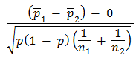

Where p₁=Proportion from the first population, p₂ =Proportion from the second population
p = Overall proportion = $\frac{x1+x2}{ n1+n2}$
The results of this analysis were presented in tables with the value of Z and P shown.The null hypothesis was either rejected (ns) or accepted (s). (α=0.05)

3.10 Ethical considerations
This study posed no risk to the health of the study participants. Approval to carry out the study was sought from the Institutional Research and Ethics Committee (IREC), with a formal approval number1246 (Appendix III), before the commencement of data collection. Permission to access patient records in MTRH was sought from the administration. (Appendix IV)
A written consent form explaining the rationale and benefits of the study to the public health system was used to seek informed consent from potential interviewees. It also explained the procedure and purpose of the research project. Participation in the study was on a voluntary basis, the participants were at liberty to withdraw from the study at any stage without being penalized. There were no incentives for participating. The interviews were conducted in a confidential manner. Participant names were not recorded. No study participant would be identified by name in any report or publication derived from information collected from the study.
Permission to access patients records in MTRH was sought from the administration. All patient reports were kept confidential and the data obtained was password protected. Collected data was only available to the investigator and the supervisors.

3.11 Study recruitment schema

CHAPTER FOUR: RESULTS

4.1 Demographics of the participants
During the study period,a total of 380 participants met the inclusion criteria and were thus incorporated into the study. Subsequently, their data was analyzed.
The youngest participant was 18 years old while the eldest was 87. The mean age of the study participants was 42.7 years with a standard deviation of 14.84 years. Majority of the participants were aged 40-49 years (n=105). The median and modal ages were 42 and 45 years respectively.

Figure 1: Distribution of study participants by age group

The majority of participants were females at 75% (n=284) while the males were 28% (n=96). This translates to a Male: Female ratio of 1: 2.95.

4.2 Sonographic features of anterior neck

4.21 Thyroid masses

The table below shows distribution of sonographic features of anterior neck masses. Most lesions were solid, Isoechoic, well defined with no calcifications seen.
Table 1: Sonographic features of thyroid masses
 | SONOGRAPHIC FEATURE | NO | %
1 | COMPOSITION
 | Solid | 162 | 60%
 | Mixed solid and cystic | 87 | 32%
 | Purely cystic | 20 | 7%
2 | ECHOGENICITY
 | Hyperechoic | 48 | 18%
 | Isoechoic | 158 | 59%
 | Hypoechoic | 23 | 9%
 | Marked hypoechogenicity | 4 | 1%
 | Anechoic | 20 | 7%
 | Heterogenous | 16 | 6%
3. | MARGINS
 | Well defined | 238 | 88%
 | Ill defined | 31 | 12%
4 | CALCIFICATION
 | Eggshell | 12 | 4%
 | Coarse | 56 | 21%
 | Microcalcifications | 2 | 1%
 | No calcification | 199 | 74%
5 | COLOR DOPPLER
 | Peripheral flow | 182 | 68%
 | Internal flow | 25 | 9%
 | No detectable flow | 62 | 23%
6 | HYPOECHOIC RIM
 | Present | 62 | 23%
 | Absent | 207 | 77%

4.22 Lymphnodal masses

The table below shows the sonographic features of lymph-nodal masses encountered in the study. Most of the nodes were round, with no nodal calcification, had a central echogenic hilum with hilar vascularity on color Doppler interrogation
Table 2: Sonographic features of cervical lymphadenopathy

 | SONOGRAPHIC FEATURE | NO | %
1. | SHAPE
 | Ovoid | 48 | 47%
 | Round | 54 | 53%
2 | NODAL CALCIFICATION
 | Present | 0 | 0%
 | Absent | 102 | 100%
3 | ECHOGENIC HILUS
 | Present | 65 | 64%
 | Absent | 37 | 36%
4. | COLOR DOPPLER
 | Hilar vascularity | 49 | 48%
 | Peripheral vascularity | 28 | 27%
 | Mixed | 15 | 15%
 | No flow detected | 10 | 10%
5 | ECHOGENICITY
 | Hyperechoic | 48 | 47%
 | Isoechoic | 19 | 19%
 | Hypoechoic | 35 | 34%

4.3 Distribution of anterior neck masses by cytological diagnosis
In this study, masses arising from the thyroid gland accounted for the majority of cases at 71% (n=269) followed by lymph nodal masses27% (n=102), thus the lesions were classified into thyroid masses, lymph nodal masses and other anterior neck masses which constituted 2% of the lesions (n=9).

Figure 2: Origin of anterior neck masses seen at MTRH
The anterior neck masses that originated from the thyroid gland were further categorized into benign or malignant based on their specific cytological diagnosis. The benign lesions constituted 96% (n=258) of the masses while malignant lesions constituted 4% (n=11) of the thyroid masses.

Figure 3: Benign and Malignant Thyroid masses seen at MTRH
Colloid goiter, follicular thyroid adenoma, Hürthle cell adenoma, thyroid cysts and thyroiditis were the spectrum of benign thyroid lesions seen in this study. The number of lesions seen were 198 for colloid goiter (76.7%), 25 for follicular thyroid adenoma (9.7%), 20 thyroid cysts (7.8%), 14 cases of thyroiditis (5.4%) and only one case of Hürthle cell adenoma (0.4%)

Figure 4: Spectrum of benign thyroid masses seen at MTRH
Malignant thyroid lesions seen were anaplastic thyroid cancer (n=3) and papillary thyroid carcinoma. (n=8)

Figure 5: Malignant Thyroid Lesions seen at MTRH
There were 102 cases of lymphadenopathy. These were divided into benign and neoplastic causes. The benign cases constituted 60% (n=61) while the neoplastic cases were 40% (41).

Figure 6: Benign and Neoplastic Lymphadenopathy cases seen at MTRH
Benign lymph nodal masses constituted two categories of lesions. These were reactive lymphadenitis (70%) n=43 and tuberculous lymphadenitis (30%) n=18.

Figure 7: Distribution of Benign Lymphadenopathy

Neoplastic lymphadenopathy cases included lymphatic metastases n=27 (66%), Hodgkins lymphoma n=4 (10%)and Non-Hodgkins Lymphoma n=10 (24%).

Figure 8: Distribution of Neoplastic Lymphadenopathy
Other anterior neck masses encountered in the study wereabscesses (n= 5) and lipomata (n=4).
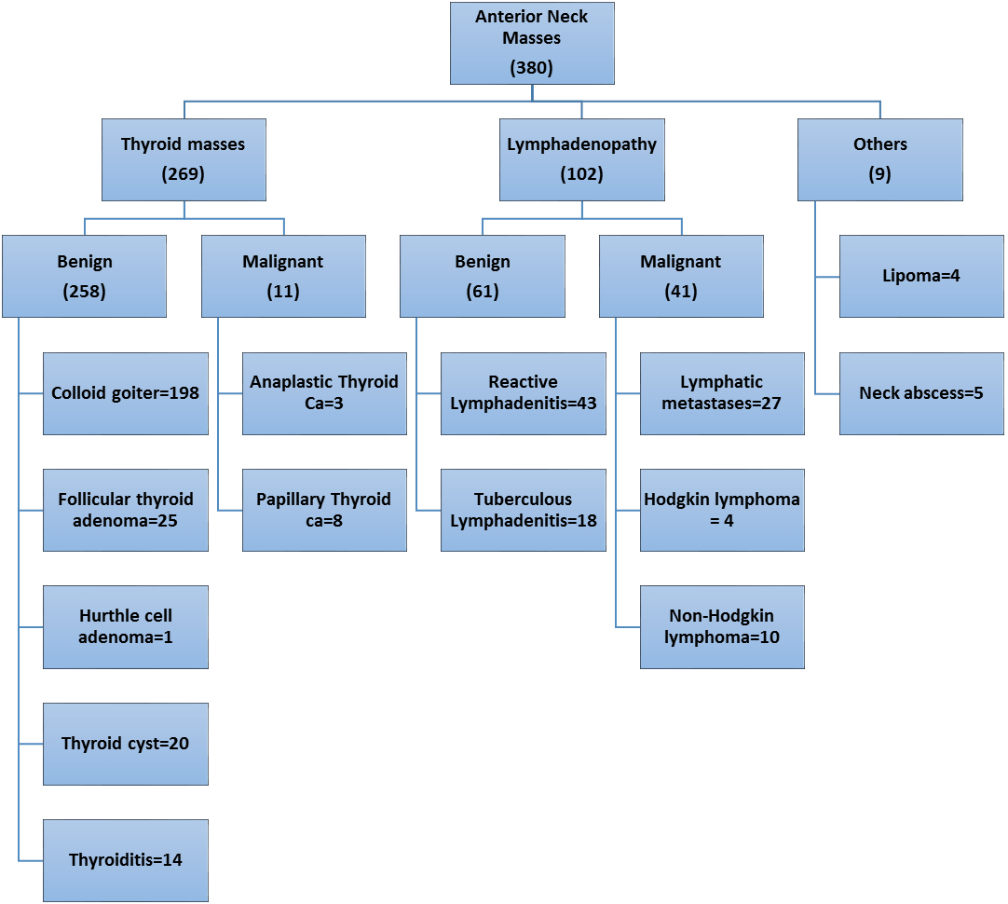
Figure 9: Summary of cytological diagnosis

4.4 Sonographic features of anterior neck masses
The lesions as seen on physical examinationwere categorized into Thyroidal masses, Lymph-nodal masses and other masses.

4.41. Thyroidal masses

The Thyroidal masses were then further categorized into benign and malignant masses based on the various cytopathological diagnoses. The ultrasonography features of these lesions was then elucidated and summarized as in table 5 below.
The various ultrasound features that were used in assessment of thyroid nodules were, composition, echogenicity, margins, Calcification, Doppler flow and the presence or absence of a hypoechoic rim.
The composition of the thyroid lesion was either solid, mixed solid and cystic or purely cystic. Based on echogenicity, the lesion was either hyperechoic, isoechoic or hypoechoic compared to normal thyroid tissue. Purely cystic lesions were considered anechoic, while those lesions that were solid and cystic had their solid component evaluated. Markedly hypoechoic thyroid lesion indicated that a lesion is hypoechoic in relation to the adjacent strap muscles.
Calcification was either egg shell, coarse, micro-calcification or no calcification seen. Egg shell calcification refers to calcification seen at the periphery of a nodule while micro-calcification is defined as punctate echogenic foci without posterior shadowing. Doppler flow analysis was also categorized into; peripheral flow, internal flow or no detectable flow. Finally, the lesions were classified based on the presence or absence of a halo (hypoechoic rim).
Table 3: Sonographic features of benign and malignant thyroid masses

 | SONOGRAPHIC FEATURE |  | BENIGN NODULES | % | MALIGNANT NODULES | %
1 | Composition
 |  | Solid | 155 | 60% | 7 | 64%
 |  | Mixed solid and cystic | 83 | 32% | 4 | 36%
 |  | Purely cystic | 20 | 8% | 0 | 0%
 |  |  | 258 | 100% | 11 | 100%
2 | Echogenicity
 |  | Hyperechoic | 48 | 19% | 0 | 0%
 |  | Isoechoic | 158 | 61% | 0 | 0%
 |  | Hypoechoic | 18 | 7% | 5 | 45%
 |  | Marked Hypoechogenicity | 0 | 0% | 4 | 36%
 |  | Anechoic (Purely cystic) | 20 | 8% | 0 | 0%
 |  | Heterogenous | 14 | 5% | 2 | 18%
 |  |  | 258 | 100% | 11 | 100%
3 | Margin
 |  | Well defined | 235 | 91% | 3 | 27%
 |  | Ill defined | 23 | 9% | 8 | 73%
 |  |  | 258 | 100% | 11 | 100%
4 | Calcification
 |  | Eggshell | 12 | 5% | 0 | 0%
 |  | Coarse | 56 | 22% | 0 | 0%
 |  | Microcalcifications | 0 | 0% | 2 | 18%
 |  | No calcification | 190 | 74% | 9 | 82%
 |  |  | 258 | 100% | 11 | 100%
5 | Color Doppler
 |  | Peripheral flow | 181 | 70% | 1 | 9%
 |  | Internal flow | 15 | 6% | 10 | 91%
 |  | No detectable flow | 62 | 24% | 0 | 0%
 |  |  | 258 | 100% | 11 | 100%
6 | Hypoechoic Rim (Halo)
 |  | Present | 62 | 24% | 0 | 0%
 |  | Absent | 196 | 76% | 11 | 100%
 |  |  | 258 | 100% | 11 | 100%

Majority of the thyroid lesions, both benign and malignant, were mainly solid in composition with the benign lesions at 60% (n=155) while the malignant at 64%. (n=7) This was closely followed by those lesions that were both mixed solid and cystic with benign lesions having 32% (n=83) while malignant lesions were 36% (n=4). 8% (n=20) of the benign nodules were purely cystic. None of the malignant nodules presented as anentirely cystic nodule.
Most of the benign lesions were either isoechoic (61%, n=158) or hyperechoic (19%,n=48) in comparison to the adjacent normal thyroid tissue while most of the malignant lesions were either hypoechoic (45%, n=5) or markedly hypoechoic 36%, n=4). More malignant nodules showed a heterogeneous echo-pattern at 18% (n=2) while only 5% (n=14) of the benign lesions showed heterogeneity. None of the malignant lesions demonstrated hyper or iso-echogenicity

Figure 10: Benign Vs Malignant thyroid nodules: Composition and Echogenicity

Nearly all of the benign nodules had well defined margins (91%, n=235) while the contrary was seen in the malignant nodules (73%,,n=8).
Most of the lesions, both benign (74%, n=190) and malignant (82%, n=9) did not have calcifications within the nodules. When present, the benign lesions had mainly coarse calcifications (22%, n=56) while the malignant lesions had microcalcifications (18%, n=2). 5% (n=12) of the benign lesions also demonstrated eggshell calcification. None of the malignant nodules had eggshell or coarse calcifications.

Figure 11: Benign Vs Malignant Thyroid nodules: Margins and Calcification
Most of the benign lesions (70%, n=181) demonstrated peripheral flow while the malignant ones demonstrated internal flow (91%, n=10). 24% (n=62) of the benign lesions had no detectable color flow while none of the malignant lesions showed this feature.
All malignant lesions (100%, n=11) had no hypoechoic rim, either complete or incomplete, while 76% (n=196) of the benign nodules also had no hypoechoic rim. However, 24% (n=62) of the benign lesions had an either complete or incomplete halo while none of the malignant nodules demonstrated this feature.

Figure 12 Benign Vs Malignant Thyroid nodules: Color Doppler vs Halo

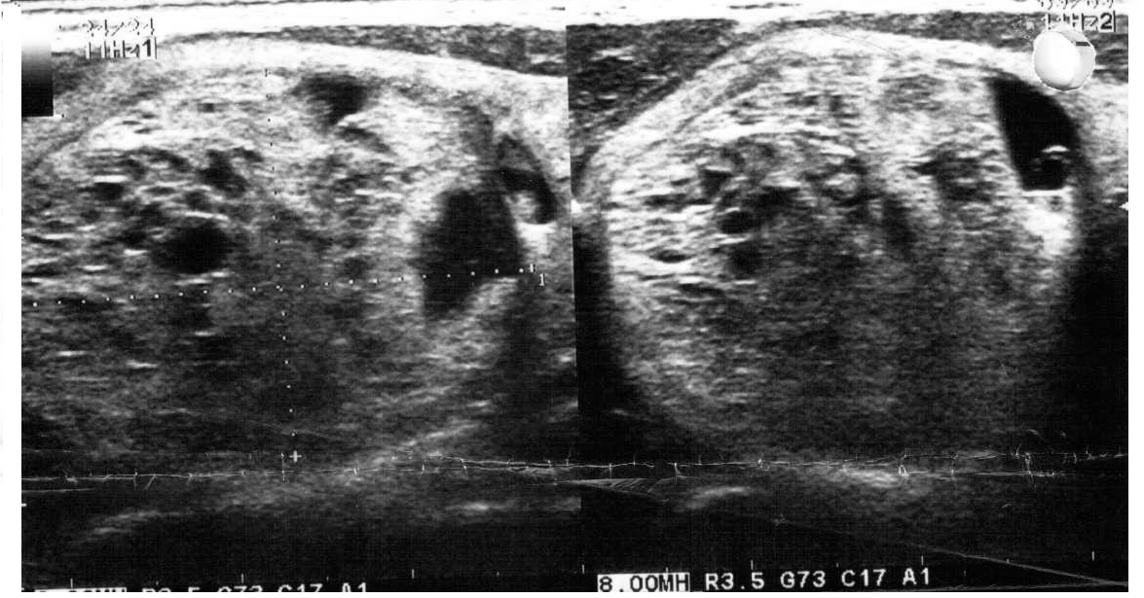

Figure 13: Colloid Goiter
Image of a 34-year-old female with a right lobe thyroid nodule. USS shows a well circumscribed isoechoic solid mass with areas of cystic degeneration. (mixed solid and cystic) An incomplete thin hypoechoic rim (halo) is present.No calcifications seen.Cytological diagnosis was colloid goiter.

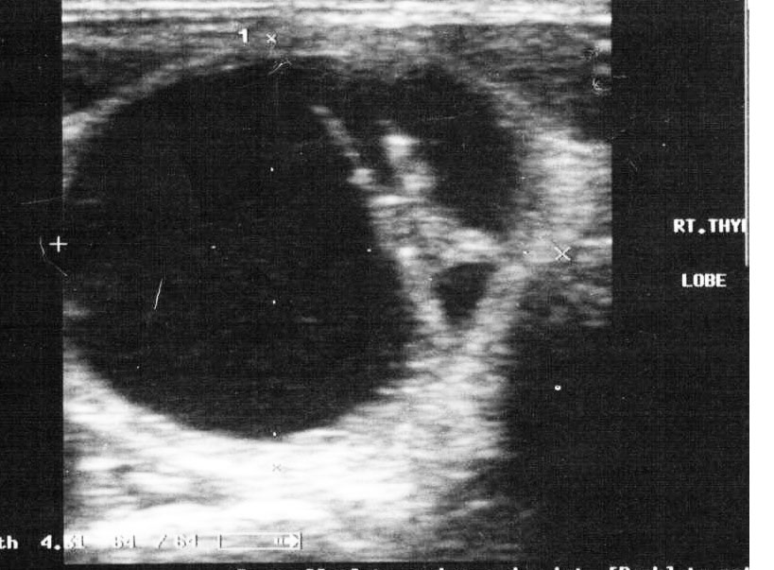

Figure 14: Thyroid Cyst
: 67-Year-old male with Right thyroid nodule. USS shows a well circumscribed anechoic lesion. Posterior acoustic enhancement characteristic of fluid filled structures also noted. The lesion is well circumscribed. Cytological diagnosis was a benign thyroid cyst.

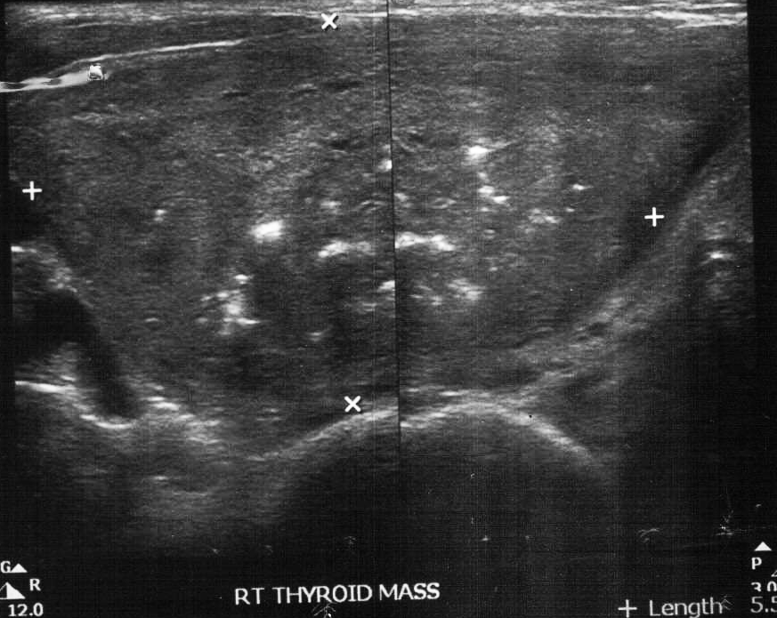

Figure 15: Follicular Adenoma
45 year old female with a right thyroid mass. Ultrasound shows a solidwell delineated nodule with areas of coarse calcification. The lesion was isoechoic to normal thyroid tissue. The patient also had thyroidectomy, the specimen had a capsule that was not invaded in all examined sections. Final histological diagnosis was follicular adenoma.

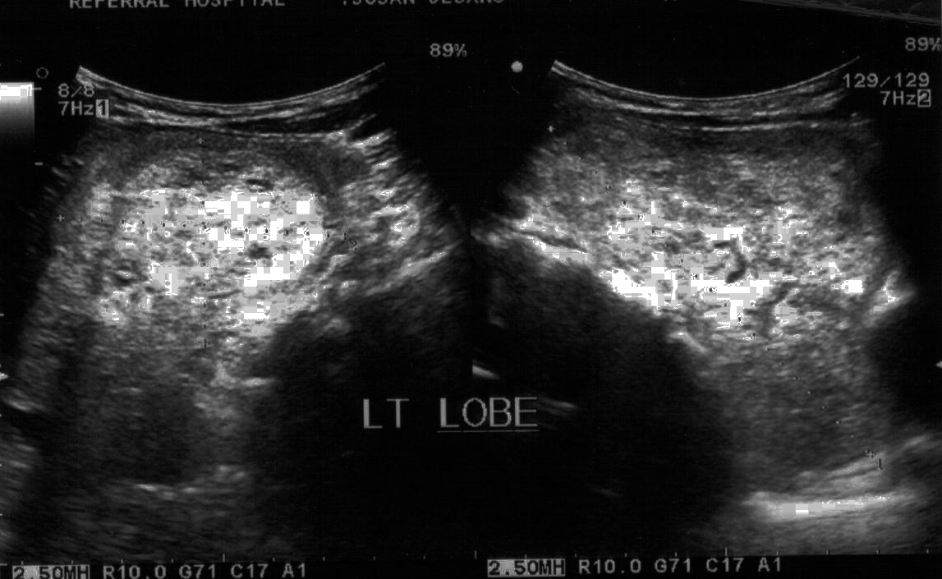

Figure 16: Colloid Goiter
45-year-old female with a left thyroid nodule. Ultrasound shows the lesion to be hyperechoic. It also demonstrates a hypoechoic rim (halo). No areas of calcification noted. Cytology reported as colloid goiter.

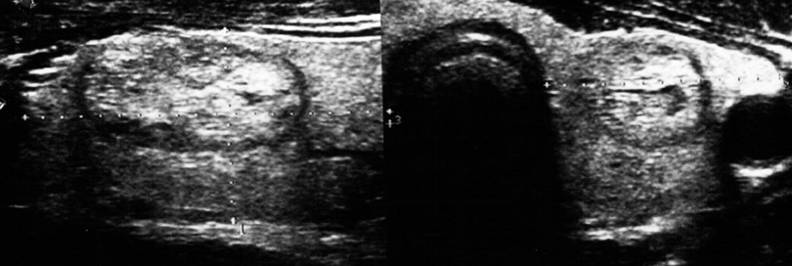
Figure 17: Colloid Goiter
42 year old female with left thyroid lobe nodule. The lesion is isoechoic to normal thyroid tissue. No areas of calcification seen. Its margins are well defined with a hypoechoic halo surrounding the nodule. Cytology reported as colloid goiter.
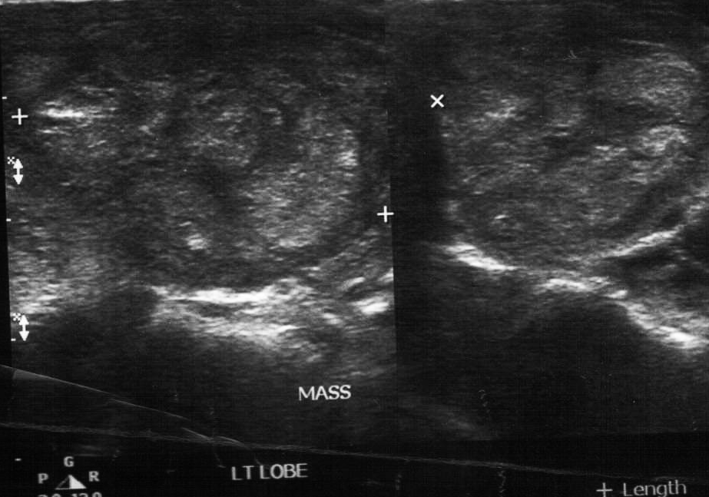

Figure 18: Thyroiditis
53 year old female with Left thyroid nodule. The lesion is heterogenous in echogenicity. It is well delineated. Cytological diagnosis was thyroiditis.

4.42Significance testing of sonographic findings differentiating benign from malignant thyroid nodules

Z score calculator for 2 population proportions was used to evaluate the significance of the difference between the sonographic features of benign and malignant thyroid nodules.
The null hypothesis states that there is no difference between the two population proportions i.e. there is no sonographic difference between benign and malignant thyroid nodules. µ_{o}: P₁-P₂=0
The alternative hypothesis, µ_{1,}states that there is a difference between the two population proportions i.e there is a sonographic difference between benign and malignant thyroid nodules.
The significance level used is 0.05.
Presented in table 4 is a summary of the Z and P values. In the table, the null hypothesis is either rejected (ns) or accepted (s).

Table 4:Analysisof the sonographic features of benign and malignant thyroid masses

 | SONOGRAPHIC FEATURE |  | BENIGN NODULES | MALIGNANT NODULES | VALUE OF Z | P VALUE | Null hypothesis
1 | Composition
 |  | Solid | 155 | 7 | -0.2362 | 0.81034 | ns
 |  | Mixed solid and cystic | 83 | 4 | -0.2912 | 0.77182 | ns
 |  | Purely cystic | 20 | 0 | 0.9598 | 0.33706 | ns
 |  |  | 258 | 11
2 | Echogenicity
 |  | Hyperechoic | 48 | 0 | 1.5783 | 0.1141 | ns
 |  | Isoechoic | 158 | 0 | 2.1604 | 0.03078 | s
 |  | Hypoechoic | 18 | 5 | -4.4695 | <.00001 | s
 |  | Marked Hypoechogenicity | 0 | 4 | -9.7588 | <.00001 | s
 |  | Anechoic (Purely cystic) | 20 | 0 | 0.9598 | 0.33706 | ns
 |  | Heterogenous | 14 | 2 | -1.7517 | 0.08012 | ns
 |  |  | 258 | 11
3 | Margin
 |  | Well defined | 235 | 3 | 6.4911 | <.00001 | s
 |  | Ill defined | 23 | 8 | -6.4911 | <.00001 | s
 |  |  | 258 | 11
4 | Calcification
 |  | Eggshell | 12 | 0 | 0.7318 | 0.4654 | ns
 |  | Coarse | 56 | 0 | 1.7365 | 0.8186 | ns
 |  | Microcalcifications | 0 | 2 | -6.8746 | <.00001 | s
 |  | No calcification | 190 | 9 | -0.6052 | 0.54186 | ns
 |  |  | 258 | 11
5 | Color Doppler
 |  | Peripheral flow | 181 | 1 | 4.2401 | <.00001 | s
 |  | Internal flow | 15 | 10 | -9.5197 | <.00001 | s
 |  | No detectable flow | 62 | 0 | 1.8534 | 0.6432 | ns
 |  |  | 258 | 11
6 | Hypoechoic Rim (Halo)
 |  | Present | 62 | 0 | 1.8534 | 0.6432 | ns
 |  | Absent | 196 | 11 | -1.8534 | 0.6432 | ns
 |  |  | 258 | 11

The sonographic features that were significantly associated with benignity than malignancy in thyroid nodules included:Isoechogenicity, Well defined margins and peripheral flow on color doppler interrogation. Those features that were significantly associated with malignancy in thyroid nodules were hypoechogenicity, marked hypoechogenicity, ill- defined margins, microcalcifications and internal flow on color Doppler interrogation.

4.43 Lymphadenopathy

Lymph nodal masses were also categorized into benign and malignant based on the cytological diagnosis. Their sonographic features were then studied and summarized in table 6 below.
The sonographic features used were echogenicity, shape, nodal calcification, color Doppler findings and echogenic hilus. The nodes were either hyperechoic, isoechoic or hypoechoic in comparison to the adjacent strap muscles. The shape was categorized as either round (spherical) or ovoid. A node was considered avascular when no flow was detected by color Doppler scanning. When flow was detected, it was categorized as either hilar, peripheral or mixed vascularity.
Table 5: Sonographic features of Benign and Malignant Lymphadenopathy

 | SONOGRAPHIC FEATURE |  | BENIGN LYMPHADENOPATHY | % | MALIGNANT LYMPHADENOPATHY | %
1 | Echogenicity (Relative to adjacent Muscles)
 |  | Hyperechoic | 48 | 79% | 0 | 0%
 |  | Isoechoic | 12 | 20% | 7 | 17%
 |  | Hypoechoic | 1 | 2% | 34 | 83%
 |  |  | 61 | 100% | 41 | 100%
2 | Shape
 |  | Ovoid | 45 | 74% | 3 | 7%
 |  | Round | 16 | 26% | 38 | 93%
 |  |  | 61 | 100% | 41 | 100%
3 | Nodal Calcificaton
 |  | Present | 0 | 0% | 0 | 0%
 |  | Absent | 61 | 100% | 41 | 100%
 |  |  | 61 | 100% | 41 | 100%
4 | Color Doppler
 |  | Hilar vascularity | 49 | 80% | 0 | 0%
 |  | Peripheral vascularity | 0 | 0% | 28 | 68%
 |  | Mixed (Hilar and peripheral) | 2 | 3% | 13 | 32%
 |  | Avascular | 10 | 16% | 0 | 0%
 |  |  | 61 | 100% |  | 100%
5 | Presence of central echogenic hilus
 |  | Present | 59 | 97% | 6 | 15%
 |  | Absent | 2 | 3% | 35 | 85%
 |  |  | 61 | 100% |  | 100%

79% (n=59) of the benign lymph nodes were hyperechoic relative to adjacent strap muscles. On the other hand, the malignant lymph nodes were mainly hypoechoic at 83% (n=41).
74% (n=45) of the benign lesions were ovoid in shape while 93% (n=38) of the malignant ones were spherical. None of the lymph nodes showed intranodal calcification.

Figure 19: Benign Vs Malignant Lymphadenopathy: Echogenicity and Shape

Most of the benign nodes (97%, n=9) had maintained their central echogenic hilus while majority of the malignant nodes (85%, n-35) had lost this feature. The malignant nodes also demonstrated a mainly peripheral vascular flow on color Doppler (68%, n=28) while the benign nodes showed hilar vascularity mainly. (80%,n=49).

Figure 20: Benign vs Malignant Lymphadenopathy: Color doppler and Hilus

4.44.Significance testing of sonographic findings differentiation benign from neoplastic lymphadenopathy

Z score calculator for 2 population proportions was used to evaluate the significance of the difference between the sonographic features of benign and neoplastic anterior cervical lymphadenopathy.
The null hypothesis states that there is no difference between the two population proportions i.e. there is no sonographic difference between benign and neoplastic anterior cervical lympnodes. µ_{o}: P₁-P₂=0
The alternative hypothesis, µ_{1,} states that there is a difference between the two population proportions i.e there is a sonographic difference between benign and neoplastic anterior cervical lymph nodes.
The significance level used is 0.05.
Presented in table 6 is a summary of the Z and P values. In the table, the null hypothesis is either rejected (ns) or accepted (s).
Table 6: Sonographic features of Benign and Malignant Lymphadenopathy

 | SONOGRAPHIC FEATURE |  | BENIGN LYMPH NODES | MALIGNANT LYMPH NODES | Value of Z | P value | Null hypothesis
1 | Echogenicity
 |  | Hyperechoic | 48 | 0 | 7.8064 | <.00001 | s
 |  | Isoechoic | 12 | 7 | 0.3306 | 0.7414 | ns
 |  | Hypoechoic | 1 | 34 | -8.473 | <.00001 | s
 |  |  | 61 | 41
2 | Shape
 |  | Ovoid | 45 | 3 | 6.5926 | <.00001 | s
 |  | Round | 16 | 38 | -6.5926 | <.00001 | s
 |  |  | 61 | 41
3 | Nodal calcification
 |  | Present | 0 | 0 | NaN
 |  | Absent | 61 | 41 | NaN
 |  |  | 61 | 41
4 | Color doppler
 |  | Hilar vascularity | 49 | 0 | 7.9614 | <.00001 | s
 |  | Peripheral vascularity | 0 | 28 | -7.577 | <.00001 | s
 |  | Mixed (Hilar and peripheral) | 2 | 13 | -3.9747 | .00008 | s
 |  | Avascular | 10 | 0 | 2.7298 | .00634 | s
 |  |  | 61 | 41
5 | Presence of central echogenic hilus
 |  | Present | 59 | 6 | 8.4542 | <.00001 | s
 |  | Absent | 2 | 35 | -8.4542 | <.00001 | s
 |  |  | 61 | 41

The sonographic features that were significantly associated with benignity than malignancy in cervical lymphadenopathy were: Hilar vascularity, ovoid shape and presence of a central echogenic hilum. Those features that were significantly associated with malignancy in cervical lymphnodes were peripheral vascularity on color Doppler interrogation, absent central echogenic hilum and round shape.

4.35. Other lesions

The other anterior neck masses encountered were lipomas (4) and abscesses (5). All the lipomata had well circumscribed margins with no detectable flow on color doppler. They also did not demonstrate any areas of calcification. They were mainly hyperechoic (75%, n=3) with (25%, n=1) demonstrating mixed echogenicity.
All the anterior neck abscesses demonstrated an irregular ill delineated outline with peripheral flow seen on color Doppler assessment. They also had a hypoechoic necrotic center with floating internal debris seen. There were no areas of calcification noted.

CHAPTER FIVE: DISCUSSION

5.1 Cytological diagnosis

71% (Majority) of the anterior neck masses arose from the thyroid gland, 27% arose from the lymph nodes while 2% constituted other lesions. This is similar to a 13 year study conducted by Irani et al (Irani, Zerehpoosh, & Sabeti, 2016) where 1208 patients who had neck masses (including anterior neck masses) were resected for pathological assessments. In all age groups, thyroid gland lesions were the commonest (35.7%) followed by lymphadenopathy (34.6%).
Of the thyroidal masses, 96% were benign while 4% were malignant as per the cytological diagnosis. This is similar to prior studies that show that thyroid cancer occurs in about 5-15% of thyroid nodules.(Megwalu, 2017). A study conducted at Kijabe hospital over a three year period to review the spectrum of thyroid diagnoses likely to be encountered by surgeons working in East African hospitals found that out of two hundred and twenty thyroidectomies, there was an overall malignancy rate of 11.7%.(Hill, Mwangi, & Wagana, 2004). In Tinkur Anbessa teaching and referral hospital (Addis Ababa University), histopathological evaluation was done on seven hundred and eighty patients with thyroid disease of which 79% were found to be benign while 21% were malignant on histology(Tsegaye & Ergete, 2003). At Kenyatta National Hospital, a study was done to determine the pattern of thyroid nodules diagnosed by FNAC. Overall, 88.1% of patients had benign FNAC results, 2.4% had a malignant and a suspicious result while 7.1% were non diagnostic.(Sang, Sekadde-Kigondu, & Muchiri, 2007)
Of the malignant thyroid masses seen in this study, 73% were papillary thyroid ca while 27% were anaplastic thyroid ca. This is consistent with the fact that papillary thyroid cancers are the most common malignancy of the thyroid gland. According to the American cancer society, papillary thyroid cancers account for 80-85% of thyroid tumors.(Sosa & Udelsman). Hill, et al study done at Kijabe Mission hospital found 26cases of thyroid tumors, 15 (57.6%) were papillary while 11(42.4%) were anaplastic thyroid ca.(Hill et al., 2004).
The spectrum of benign thyroid masses seen at MTRH is similar to that seen in Kijabe. The commonest benign thyroid lesion seen in this study was colloid goiter at 77%, this was followed by follicular thyroid adenoma at 10%. Hill et al study on histology of thyroid masses at Kijabe had similar findings with Colloid goiter constituting 68.6 % of benign thyroid masses while follicular thyroid adenoma was 30.7 %.(Hill et al., 2004). At Kenyatta National hospital, Fine needle aspiration cytology of thyroid nodules had colloid goiter as the commonest diagnosis at 83.3% .(Sang et al., 2007)
In this study, cervical lymphadenopathy consisted of benign and neoplastic causes. The benign lesions seen were reactive lymphadenitis (70%) and tuberculous (30%) lymphadenitis. The neoplastic causes of cervical lymphadenopathy were metastases (66%), Non-Hodgkins lymphoma (24%) and Hodgkins lymphoma (10%). Nat et al conducted a study, at Samsung Medical Center,SouthKorea, looking at the differential diagnosis of cervical lymphadenopathy. In this study, 148 consecutive patients with cervical lymphadenopathy were examined with Doppler sonography then histological evaluation subsequently done. Their pathological diagnosis closely follows our findings at MTRH where benign causes of cervical lymphadenopathy were reactive lymphadenitis (62%) and tuberculous lymphadenitis (38%). Neoplastic causes seen by Nat et al were lymphoma (23%) and metastases (77%). (Na et al., 1997b)

5.2 Thyroid nodule sonography
Thyroid nodule echogenicity was compared to normal thyroid tissue. Most of the benign thyroid nodules in this study demonstrated iso-echogenicity (61%) followed by Hyperechogenicity (19%). On the other hand, malignant thyroid nodules demonstrated Hypoechogenicity (45%), marked hypoechogenicity (36%) and heterogeneity (18%). A study conducted in Italy from January 1991 to September 2004 found that out of 7455 thyroid nodules, a hypoechoic appearance was significantly more frequent in malignant than in benign nodules.(Cappelli et al., 2007). At Samsung Hospital University in South Korea, a retrospective study was conducted on 849 nodules to evaluate the diagnostic accuracy of ultrasound for depiction of benign and malignant thyroid nodules using tissue diagnosis as the reference standard. This study found that marked hypoechogenicity was a statistically significant finding of malignancy with a sensitivity of 41.4% and a specificity of 92.2%. In the same study, Iso-echogenicity was a statistically significant finding of benign nodules with a sensitivity of 56.6% and a specificity of 88.1%.(Moon et al., 2008). Bonavita et al evaluated the morphologic features predicitive of benign thyroid nodules using fine needle aspiration cytology after ultrasound evaluation. They found that diffuse hyperechogenicity had a 100% specificity for benignity.(Bonavita et al., 2009) In our study, none of the malignant lesions demonstrated hyperechogenicity. Isoechogenicity was a statistically significant finding in benign nodules while hypoechogenicity and marked hypoechogenicity were significantly found in malignant thyroid nodules.
In this study, those benign thyroid nodules that demonstrated calcification mainly had Coarse calcification or egg shell calcification. On the other hand, malignant nodules demonstrated microcalcifications. Moon et al found that micro-calficication was a statistically significant finding of malignancy in thyroid nodules with a sensitivity of 44.2% and a specificity of 90.8%.(Moon et al., 2008). This is similar to Capelli et al study that found that the presence of micro-calcification was significantly more frequent in malignant than in benign nodules.(Cappelli et al., 2007). In our study, microcalcifications was significantly more frequent in malignant than in benign nodules with a p value of <0.00001.
Majority of benign thyroid nodules demonstrated peripheral flow (70%) while malignant nodules demonstrated internal flow (91%). In this study, statistical evaluation showed that peripheral flow was significantly more frequent in benign nodules while internal flow was more frequent in malignant thyroid nodules. This is similar to a study conducted by Chan et al which found that 69-74% of all thyroid malignancies demonstrated marked intrinsic hypervascularity, which is flow in the central part of the nodule that is greater than that in the surrounding thyroid parenchyma.(B. K. Chan, T. S. Desser, I. R. McDougall, R. J. Weigel, & R. B. Jeffrey, 2003). A study conducted in Rome to correlate the sonographic and colour-Doppler findings of thyroid nodules with the results of ultrasound guided fine needle aspiration biopsy found that 74.2% of malignant thyroid nodules demonstrated intra-nodular vascular pattern on color Doppler. (Enrico Papini et al., 2002). Frates et al conducted a similar study to determine whether color Doppler sonography can aid in the prediction of malignancy in thyroid nodules. They concluded that solid hypervascular thyroid nodules have a high likelihood of malignancy(Frates, Benson, Doubilet, Cibas, & Marqusee, 2003)

5.3 Cervical lymphadenopathy sonography

82% of benign cervical nodes demonstrated hilar vascularity(p<0.00001) while 68% of neoplastic nodes demonstrated peripheral vascularity(p<0.00001).Nat et al conducted a study to evaluate the usefulness of color Doppler sonography in differentiating benign from malignant cervical lymphadenopathy found that 94% of benign lymphadenopathy demonstrated central hilar vascularity, radial symmetric vascularity and no peripheral vascularity. Peripheral vascularity was observed in 98% of nodes with neoplastic disease.(Na et al., 1997b)
74% of benign lymphadenopathy cases were ovoid in shape while 93% of neoplastic cervical lymph nodes were round in shape. Statistical analysis showed that these findings were significant in differentiation of benign from malignant lymphadenopathy. This is similar to findings of a study conducted by H. J. Steinkamp that evaluated the ratio of long to short axis diameter of cervical lymphadenopathy as a predictor of malignancy. In this study, 730 enlarged cervical lymph nodes in 285 patients were examined with ultrasound. The short and long axis diameters of each enlarged node were measured and the ratio calculated. Definite diagnoses of the nodes were then obtained by histological examination following neck dissection. They found that nodes presenting with a more circular shape were diagnosed correctly as neoplastic with 95% accuracy.(H J Steinkamp et al., 1995)
In MTRH, 97% of benign lymph nodes had an echogenic hilus while 85% did not (p<.001). Solbiati et al found that only 4% of metastatic nodes showed an echogenic hilus and Rubaltelli et al and Vassallo et al noted that 84 to 92% of benign nodes have an echogenic hilus. (Solbiati et al., 1992; Vassallo et al., 1992) Metastatic (69-95%), lymphomatous (72-73%) and tuberculous (76-86%) nodes tend to have an absent hilus, whereas normal nodes have an echogenic hilus.(Evans et al., 1993; Ying, Ahuja, Evans, et al., 1998)

CHAPTER SIX: CONCLUSIONS AND RECOMMENDATIONS

6.1 Conclusions
- Statistically significant findings of benignity in thyroid nodules seen were isoechogenicity, well defined margins and peripheral flow on color Doppler interrogation while significant findings of malignancy were hypoechogenicity, marked hypoechogenicity, ill-defined borders, microcalcification and internal flow on color Doppler interrogation.
- Ultrasonographic features of benign lymphadenopathy seen were:Ovoid shape, Presence of central echogenic hilus and hilar vascularity on color Doppler interrogation while Ultrasonographic features of neoplastic lymphadenopathy seen were, round shape, loss of central echogenic hilus and peripheral vascularity on color Doppler interrogation.
- Differentiation of benign and malignant thyroid and lymph-nodal masses can thus be done on ultrasonography based on the imaging characteristics.
- Cytopathological diagnosis showed that masses arising from the thyroid gland account for the majority of anterior neck masses, followed by lymph nodal masses. It also showed that most benign thyroid nodules were colloid goiter while the malignant ones were papillary thyroid ca.

6.2 Recommendations
- Further ultrasonographic workup should lay emphasis on differentiation of benign and malignant thyroid nodules. Similarly, differentiation of benign and neoplastic causes of cervical lymphadenopathy should be done on sonography based on their grey scale and color Doppler appearances. Those that appear sonographically neoplastic should warrant further work-up. Those with predominantly sonographically benign features should be followed up.

REFERENCES
Ahuja, A., & Ying, M. (2003). Sonography of Neck Lymph Nodes. Part II: Abnormal Lymph Nodes. Clinical Radiology Journal, 58(5), 359-366. doi: http://dx.doi.org/10.1016/S0009-9260(02)00585-8
Ahuja, A. T., Chow, L., Chick, W., King, W., & Metreweli, C. (1995). Metastatic cervical nodes in papillary carcinoma of the thyroid: ultrasound and histological correlation. Clinical Radiology Journal, 50(4), 229-231.
Barki, Y. (1992). Ultrasonographic evaluation of neck masses--sonographic patterns in differential diagnosis. Israel Journal of Medical Sciences, 28(3-4), 212-216.
Bonavita, J. A., Mayo, J., Babb, J., Bennett, G., Oweity, T., Macari, M., & Yee, J. (2009). Pattern Recognition of Benign Nodules at Ultrasound of the Thyroid: Which Nodules Can Be Left Alone? American Journal of Roentgenology, 193(1), 207-213. doi: 10.2214/AJR.08.1820
Bruneton, J. N., Balu-Maestro, C., Marcy, P. Y., Melia, P., & Mourou, M. Y. (1994). Very high frequency (13 MHz) ultrasonographic examination of the normal neck: detection of normal lymph nodes and thyroid nodules. Journal of Ultrasound in Medicine, 13(2), 87-90.
Cappelli, C., Castellano, M., Pirola, I., Cumetti, D., Agosti, B., Gandossi, E., & Agabiti Rosei, E. (2007). The predictive value of ultrasound findings in the management of thyroid nodules. QJM: An International Journal of Medicine, 100(1), 29-35. doi: 10.1093/qjmed/hcl121
Chan, B. K., Desser, T. S., McDougall, I. R., Weigel, R. J., & Jeffrey, R. B. (2003). Common and Uncommon Sonographic Features of Papillary Thyroid Carcinoma. Journal of Ultrasound in Medicine, 22(10), 1083-1090. doi: 10.7863/jum.2003.22.10.1083
Chan, B. K., Desser, T. S., McDougall, I. R., Weigel, R. J., & Jeffrey, R. B., Jr. (2003). Common and uncommon sonographic features of papillary thyroid carcinoma. Journal of Ultrasound in Medicine, 22(10), 1083-1090.
Dean, D. S., & Gharib, H. (2008). Epidemiology of thyroid nodules. Best Practice and Research. Clinical Endocrinology and Metabolism, 22(6), 901-911. doi: 10.1016/j.beem.2008.09.019
Eisenkraft, B. L., & Som, P. M. (1999). The spectrum of benign and malignant etiologies of cervical node calcification. Americal Journal of Roentgenology, 172(5), 1433-1437. doi: 10.2214/ajr.172.5.10227533
Esmaili, H. A., & Taghipour, H. (2012). Fine-Needle Aspiration in the Diagnosis of Thyroid Diseases: An Appraisal in Our Institution. International Scholarly Research Notices Pathology, 2012, 4. doi: 10.5402/2012/912728
Evans, R. M., Ahuja, A., & Metreweli, C. (1993). The linear echogenic hilus in cervical lymphadenopathy--a sign of benignity or malignancy? Clinical Radiology Journal, 47(4), 262-264.
Frates, M. C., Benson, C. B., Doubilet, P. M., Cibas, E. S., & Marqusee, E. (2003). Can Color Doppler Sonography Aid in the Prediction of Malignancy of Thyroid Nodules? Journal of Ultrasound in Medicine, 22(2), 127-131. doi: 10.7863/jum.2003.22.2.127
Gray, H., & Leonard, C. H. (1983). The concise Gray's anatomy. Secaucus, N.J.: Chartwell Books.
Hill, A. G., Mwangi, I., & Wagana, L. (2004). Thyroid disease in a rural Kenyan hospital. East African Medical Journal Volume 81, 81(12), 631-633.
Hoang, J. K., Lee, W. K., Lee, M., Johnson, D., & Farrell, S. (2007). US Features of Thyroid Malignancy: Pearls and Pitfalls. RadioGraphics, 27(3), 847-860. doi: 10.1148/rg.273065038
Irani, S., Zerehpoosh, F., & Sabeti, S. (2016). Prevalence of Pathological Entities in Neck Masses: A Study of 1208 Consecutive Cases (Vol. 8).
Jun, P., Chow, L. C., & Jeffrey, R. B. (2005). The sonographic features of papillary thyroid carcinomas: pictorial essay. Ultrasound Q, 21(1), 39-45.
Kim, E. K., Park, C. S., Chung, W. Y., Oh, K. K., Kim, D. I., Lee, J. T., & Yoo, H. S. (2002). New sonographic criteria for recommending fine-needle aspiration biopsy of nonpalpable solid nodules of the thyroid. AJR Americal Journal of Roentgenology, 178(3), 687-691. doi: 10.2214/ajr.178.3.1780687
Lu, C., Chang, T. C., Hsiao, Y. L., & Kuo, M. S. (1994). Ultrasonographic findings of papillary thyroid carcinoma and their relation to pathologic changes. Journal of the Formosan Medical Association, 93(11-12), 933-938.
Megwalu, U. C. (2017). Risk of Malignancy in Thyroid Nodules 4 cm or Larger. Endocrinology and Metabolism, 32(1), 77-82. doi: 10.3803/EnM.2017.32.1.77
Moon, W.-J., Baek, J. H., Jung, S. L., Kim, D. W., Kim, E. K., Kim, J. Y., . . . Park, S. W. (2011). Ultrasonography and the Ultrasound-Based Management of Thyroid Nodules: Consensus Statement and Recommendations. Korean Journal of Radiology, 12(1), 1-14.
Moon, W.-J., Jung, S. L., Lee, J. H., Na, D. G., Baek, J.-H., Lee, Y. H., . . . Lee, D. H. (2008). Benign and Malignant Thyroid Nodules: US Differentiation—Multicenter Retrospective Study. Radiology, 247(3), 762-770. doi: 10.1148/radiol.2473070944
Na, D. G., Lim, H. K., Byun, H. S., Kim, H. D., Ko, Y. H., & Baek, J. H. (1997a). Differential diagnosis of cervical lymphadenopathy: usefulness of color Doppler sonography. American Journal of Roentgenology, 168(5), 1311-1316. doi: 10.2214/ajr.168.5.9129432
Na, D. G., Lim, H. K., Byun, H. S., Kim, H. D., Ko, Y. H., & Baek, J. H. (1997b). Differential diagnosis of cervical lymphadenopathy: usefulness of color Doppler sonography. American Journal of Roentgenology, 168(5), 1311-1316. doi: 10.2214/ajr.168.5.9129432
Papini, E., Guglielmi, R., Bianchini, A., Crescenzi, A., Taccogna, S., Nardi, F., . . . Pacella, C. M. (2002). Risk of malignancy in nonpalpable thyroid nodules: predictive value of ultrasound and color-Doppler features. Journal of Clinical Endocrinology and Metabolism, 87(5), 1941-1946. doi: 10.1210/jcem.87.5.8504
Papini, E., Guglielmi, R., Bianchini, A., Crescenzi, A., Taccogna, S., Nardi, F., . . . Pacella, C. M. (2002). Risk of Malignancy in Nonpalpable Thyroid Nodules: Predictive Value of Ultrasound and Color-Doppler Features. The Journal of Clinical Endocrinology & Metabolism, 87(5), 1941-1946. doi: 10.1210/jcem.87.5.8504
Propper, R. A., Skolnick, M. L., Weinstein, B. J., & Dekker, A. (1980). The nonspecificity of the thyroid halo sign. Journal of Clinical Ultrasound, 8(2), 129-132.
Rumack, C. M., Wilson, S. R., & Charboneau, J. W. (2005). Diagnostic ultrasound. St. Louis: Elsevier Mosby.
Sang, C. K., Sekadde-Kigondu, C., & Muchiri, L. (2007). Fine needle aspiration cytology of thyroid nodules at Kenyatta National Hospital, Nairobi. East African Medical Journal, 84(3), 117-120.
Solbiati, L., Cioffi, V., & Ballarati, E. (1992). Ultrasonography of the neck. Radiologic Clinics of North America, 30(5), 941-954.
Sosa, J. A., & Udelsman, R. Papillary Thyroid Cancer. Surgical Oncology Clinics, 15(3), 585-601. doi: 10.1016/j.soc.2006.05.010
Steinkamp, H. J., Cornehl, M., Hosten, N., Pegios, W., Vogl, T., & Felix, R. (1995). Cervical lymphadenopathy: ratio of long- to short-axis diameter as a predictor of malignancy. The British Journal of Radiology, 68(807), 266-270. doi: 10.1259/0007-1285-68-807-266
Steinkamp, H. J., Teichgraber, U. K., Mueffelmann, M., Hosten, N., Kenzel, P., & Felix, R. (1999). Differential diagnosis of lymph node lesions. A semiquantitative approach with power Doppler sonography. Investigative Radiology journal, 34(8), 509-515.
Tsegaye, B., & Ergete, W. (2003). Histopathologic pattern of thyroid disease. East African Medical Journal Volume 80, 80(10), 525-528.
van den Brekel, M. W., Stel, H. V., Castelijns, J. A., Nauta, J. J., van der Waal, I., Valk, J., . . . Snow, G. B. (1990). Cervical lymph node metastasis: assessment of radiologic criteria. Radiology, 177(2), 379-384. doi: 10.1148/radiology.177.2.2217772
Vassallo, P., Wernecke, K., Roos, N., & Peters, P. E. (1992). Differentiation of benign from malignant superficial lymphadenopathy: the role of high-resolution US. Radiology, 183(1), 215-220. doi: 10.1148/radiology.183.1.1549675
Virmani, V., & Hammond, I. (2011). Sonographic Patterns of Benign Thyroid Nodules: Verification at Our Institution. American Journal of Roentgenology, 196(4), 891-895. doi: 10.2214/AJR.10.5363
Ying, M., Ahuja, A., & Metreweli, C. (1998). Diagnostic accuracy of sonographic criteria for evaluation of cervical lymphadenopathy. Journal of Ultrasound in Medicine, 17(7), 437-445.
Ying, M., Ahuja, A. T., Evans, R., King, W., & Metreweli, C. (1998). Cervical lymphadenopathy: sonographic differentiation between tuberculous nodes and nodal metastases from non-head and neck carcinomas. Journal of Clinical Ultrasound, 26(8), 383-389.

APPENDIX I: CONSENT FORMS
English Version
Investigator: My name is Dr. Achoki Daniel, duly registered by the Kenya Medical Practitioners and Dentists Board to practice as a medical officer. I am a registrar pursuing a Master’s degree in Radiology and Imaging at Moi University’s Medical School. I would like to recruit you/your next of kin into my research which is to study ultrasonographic characteristics in patients presenting with anterior neck lumps.
Purpose: This study will seek to describe the patterns of ultrasonographic findings among patients with anterior neck lumps and also correlate the findings with cytopathology.
Procedure: All patients who have anterior neck lumps and from whom informed consent has been given will be assessed. They will undergo a non-invasive procedure in which an ultrasound probe will be applied around the neck region on the particular swelling after application of a non-toxic ultrasound gel. The patients will be interviewed for biodata and clinical examination will be carried out and recorded on data collection forms. Data collecting material will be kept confidential throughout the research period and subjects’ identities shall never be revealed. Participants shall then be voluntarily subjected to a minimally invasive procedure, similar to an injection, where material will be taken from the anterior neck mass for examination under the microscope after which a final diagnosis will be given.
Benefits: There will be no direct benefits of participating in this study. Study subjects will be accorded same quality of management as non-study subjects
Risks: There are no anticipated risks to the participants attributable to this study.
Confidentiality: All information obtained in this study will be treated with utmost confidentiality and shall not be divulged to any unauthorized person
Rights to Refuse: Participation in this study is voluntary, there is freedom to refuse to take part or withdraw at any time. This study has been approved by the Institutional Research and Ethics Committee (IREC) of Moi University/Moi Teaching and Referral Hospital.
Sign or make a mark if you agree to take part in the study.
Patient/Next of Kin: ………………….………. Investigator: …………….………..
Date:……………………………………………………………………………………....

Kiswahili Version
Mpelelezi:Jina langu ni Daktari Achoki Daniel niliyehitimmu na kusajiliwa na Bodi ya Madaktari na Madaktari wa meno ya Kenya. Kwa wakati huu, natafuta shahada ya uzamili katika Radiology na Imaging katika Chuo Kikuu cha Moi. Ningependa kukuhusisha katika utafiti wangu ambao utajaribu kuonyesha jinsi uvimbe kwa shingo unaonekana kwa matokeo ya ultrasound.
Kusudi:Utafiti huu utajaribu kueleza jinsi uvimbe upande wa mbele ya shingo inavyoonekana kwa machine maarufu ya ultrasound na vile kuonekana huo unaambatana na magonjwa ya shingo ambayo yamejulikana na kama kuna usawa au tofauti yoyote kati ya wagonjwa kwenye mtaa wa Eldoret.
Utaratibu:Wagonjwa wote ambao wana uvimbe upande wa mbele kwenye shingo watasajiliwa katika utafiti huu baada ya kuombwa ruhusa rasmi. Baadaye wataonekana na kifaa maalum ya ultrasound kwa kuweka kipima kwenye uvimbe baada ya kupaka mafuta isiyo na madhara yoyote kwenye shingo. Wagonjwa pia watahojiwa na kuangaliwa kama wana matatizo mengino yoyote. Wagonjwa kwa kumalizia, wataenda kwa kituo kingine ambacho sindano itadungwa kwenye uvimbe ili kutoa sampuli ya tishu ambayo itawekwa kwenye darubini itakayopeana utambuzi maalum. Mahojiano yata rekodiwa kwenye makaratasi ya utafiti. Utambulizi wa wagonjwa waliohusika utawekwa siri.
Faida: Kutakuwa hakuna faida moja kwa moja ya kushiriki katika utafiti huu. Wanaofanyiwa utafiti watakuwa nahaki nakupewa ubora sawa na wale ambao hawatofanyiwa utafiti huo.
Hatari: Hakuna hatari ya kutarajia kwa washiriki inatokana na utafiti huu.
Usiri: Habari zote zilizopatikana katika utafiti huu wa kutibiwa zitawekwa kwa usiri mkubwa na wala haitatolewa kwa mtu yeyote asiye husika na utafiti.
Haki ya kukataa: Kushiriki katika utafiti huu ni hiari yako, kuna uhuru wa kukataa kuchukua sehemu au kutoka wakati wowote. Utafiti huu imekuwa kupitishwa na Utafiti wa Taasisi na Kamati ya Maadili (IREC) ya Chuo Kikuu cha kufundishia Moi na Hospitali ya Rufaa.

Kusaini au kufanya alama kama unakubali kushiriki katika utafiti.
Mjongwa/ Mlezi: ...............................................Mpelelezi: .....................................................
Tarehe: .........................................................

APPENDIX I1: DATA COLLECTION FORM

BIODATA:
Date: Serial Number

Age: Sex: Male
Female
ULTRASONOGRAPHIC FINDINGS
- Echogenicity(Thyroid nodules
Hypoechoic Isoechoic Hyperechoic

Marked Hypoechogenicity Anechoic Heterogenous
- Margins (Thyroid nodules)
Margins: Well defined Poorly defined
- Shape (Lymphnodes)
Shape: Oval Round

- Halo (Thyroid nodules)

Halo:Present Absent

- Calcification (Thyroid nodules)
Calcification:
Eggshell Coarse Microca++ None

- Composition (thyroid nodules)
Composition:
Solid Mixed solid and cystic Purely cystic
- Color Doppler pattern (Thyroid nodules)
Peripheral flow: Internal flow No detectable flow
- Color Doppler pattern (Lymph nodes)
Hilar vascularity Peripheral flow Mixed Avascular:
- Central echogenic hilus (Lymphnodes)
Present Absent
- Echogenicity relative to adjacent muscles (Lymphnodes)
Hyperechoic Isoechoic Hypoechoic
- Nodal calcification (Lymphnodes)
Present Absent
- Other Masses
Echogenicity: (Relative to adjacent muscles) ____________
Margins: _________________
Calcification: __________________
Color Doppler assessment___________
FNAC DIAGNOSIS
……………………………………………………………………………………………………………………………………………………………………………………………………………………………………………………………………………………………

APPENDIX III: IREC APPROVAL
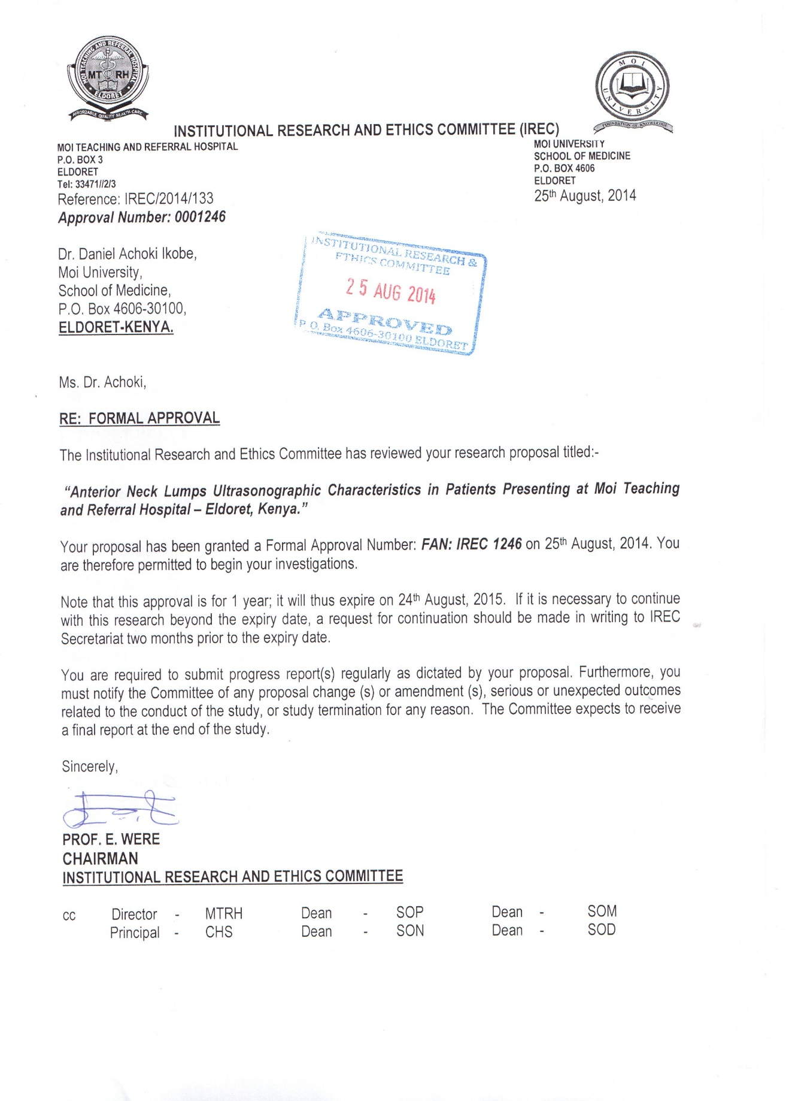

APPENDIX 1V: MTRH APPROVAL
